

**BOCNY Trade Finance Verification**

**User Specification Requirement**

|  |  |
| --- | --- |
| Serial number of demand: |  |
| Current version: | X.Y.Z |
| Sponsor department: |  |
| Compiled by: | (Name of compiler required*)* |
| Audited by: |  |
| Signed and issued by: | *(Member of the General Manager’s Office of business units/departments)* |
| Date of signature: | 2018/07/18 |

© Bank of China All Rights Reserved

**Log Sheet of Document Change**

|  |  |  |  |  |
| --- | --- | --- | --- | --- |
| **Date** | **Document Version No.** | **Revision marks** | **Revision note** | **Author** |
| March 28, 2018 | V1.0.0 | A | Added | IBM China hands to IBM US |
| April 13, 2018 | V1.0.2 | M | Modified | Received from Bank of China |
| May 18, 2018 | V1.0.3 | M | Modified | Revised by IBM per BRD Review Sessions |
| July 18, 2018 | V1.0.4 | M | Modified | Revised by TSD business team |

**Revision marks: A** – Added; **M** – Modified; **D** – Deleted

Contents

BOCNY Trade Finance Verification 1

User Specification Requirement 1

Chapter 1. Overview 9

1.1. Background 9

1.1.1. The system will follow the logic to answer the Transaction Risk Mitigation Check List questions, and part of the questions semi-auto and manual answer will be required. 10

1.1.2. Availability of BoC resources within 21 working hours of request by development team of feedback for each Sprint within 24 hours of Sprint delivery. 11

1.1.3. Project timeline, especially when it will have impacts to Business Team’s resource allocation, must be pre-approved by the Business Team 11

1.1.4. Development will follow an iterative methodology. Bank of China will support this methodology by supporting environments, conducting system integrating testing, and reviewing/identifying defects for Sprint outputs including GUI and system functionality. 11

1.1.5. Bank of China New York will be required to ensure the availability of the key participants at the kick-off meeting and provide development team project participants appropriate workspace, computers, network and internet access. As for developers, this should include physical space and internet resources for at least 30 persons. 11

1.1.6. The completed system may require local and/or foreign regulatory approval before Go-Live event. 11

1.1.7. Information such as price and or company data may be limited online, and manual search may be necessary. 11

1.1.8. The development team software has not yet reached its end-of-support date. 11

1.1.9. This service outlined in this SOW do not include the provision of any hardware equipment, software program, hardware equipment maintenance or warranty, software program maintenance or warranty, user (exits) modifications, data handling/conversion, performance tuning, or product exploitation. 11

1.1.10. Bank of China New York and the development team are expected to have appropriate resources available during this timeframe to provide necessary actions and responses for completing project. 11

1.1.11. Help the development team obtain an understanding of the business problem, the data, and the current process/practice, and provide business requirements. In reverse, help TSD team to solve the business problem, provide professional opinion, understand system function and manipulation. 11

1.1.12. Provide the necessary operating environment for all equipment delivered, in accordance with the equipment manufacturer’s specifications. 11

1.1.13. This solution assumes Bank of China will use Fircosoft for all OFAC checks and due diligence, replacing Bridger Insights. All subject to changes during the development of the FircoSoft project, which is expected concluded in September 2018. 12

1.1.14. The proposed solution will not have a management reporting functionality in this phase. 12

1.1.15. The BoC Trade Finance AML system will adopt the GLS developed look and feel, similar to the AML Intelligence Solution. 12

1.1.16. Utilization of architectural components listed in the Technical Solution Document will be used, and development team retains the right to change an architectural component due to functionality or environment requirements. 12

1.1.17. BoC will provide the Excel files which will be maintained in the UI interface in the future. Previously, “Jack” was to provide this information. 12

1.1.18. BoC will provide access to an information source where Trade Finance customer information can be retrieved. 12

1.1.19. The system is being built for U.S. branches. 12

1.1.20. This newly-built Trade Finance tool will require use of and access to paid API’s. 12

1.1.21. Test preparation and execution for system and user acceptance testing. 12

1.1.22. A decrease in development and testing resources by 50% after Sprint 9, as planned by the development team. 12

1.1.23. Requirement stability and sign-off prior to the beginning of development. 12

1.1.24. Bank of China support and owning of Regulatory Compliance Validation and Post-Go Live Monitoring. 12

1.1.25. Acquisition and installation of architectural components in Bank of China’s environment. 12

1.1.26. Configuration of space in Bank of China’s source code management repository. 12

1.1.27. Provision of deployment automation and DevOps environment. 12

1.1.28. Provision of System Testing and UAT Servers (web, application, and database). 12

1.1.29. Provision of Bank of China Java script library and visual design standards. 12

1.1.30. A development and testing environment are necessary for the migration of code builds to Bank of China during Sprints. 13

1.1.31. Approval, acquisition and installation of recommended architectural components. 13

1.1.32. TSD is responsible for submitting business requirements but not technical requirements in this BRD. 13

1.1.33. The Trade Finance AML System (TF AML) should be reviewed by an independent party before being putting into production. This compliance focused review, should be conducted by the LCD or a consultant firm agreed upon by the LCD, is to confirm the limitations, the architecture, the accuracy rates, the efficiency of the System. More importantly the review is to test the evidences returned by the TF AML and logic behind those evidences are sufficient to answer Transaction Risk Mitigation Check List 35 questions, either manually, semi-automatically or automatically. The reason for such a review is because although all answers or results from the TF AML are supposed to be reviewed and judged manually, when employing an automated system, sooner or later, human will inevitably rely on the system, and hence a level of comfort must be obtained from the system before implementation. 13

1.3. Brief introduction to feasibility 13

1.4. Basic definition 14

Chapter 2. Business Operation Flow 15

2.1. Business operation flow brief 15

2.2. Business flowchart 25

2.3.Business operation flow Description 26

Chapter 3. Functional Description 35

3.1. Functional classification 35

3.2. Functional description 37

3.2.1 Login Page 38

~~1..1.~~~~AS-IS~~ 38

1..2. Enhancement 40

3.2.1.1. Brief introduction to function 40

3.2.1.2. Detailed description 42

3.2.1.3. Interface requirements 45

3.2.2 Home Page 47

~~1..1. AS-IS~~ 48

1..2. Enhancement 48

3.2.2.1. Brief introduction to function 50

3.2.2.2. Detailed description 51

3.2.2.3. Interface requirements 52

3.2.3 Operations Analyst: Case List Page 54

1..1. AS-IS 54

1..2. Enhancement 55

3.2.3.1. Brief introduction to function 55

3.2.3.2. Detailed description 56

3.2.3.3. Interface requirements 61

3.2.4 Admin 63

1..1. AS-IS 63

1..2. Enhancement 64

3.2.4.1. Brief introduction to function 64

3.2.4.2. Detailed description 64

3.2.4.3. Interface requirements 68

3.2.5 Operations Analyst: Create Case Page 70

1..1. AS-IS 70

1..2. Enhancement 72

3.2.5.1. Brief introduction to function 73

3.2.5.2. Detailed description 74

3.2.5.3. Interface requirements 75

3.2.6 Operations Analyst: Case Verification Page 78

1..1. AS-IS 78

1..2. Enhancement 81

3.2.6.1. Brief introduction to function 84

3.2.6.2. Detailed description 86

3.2.6.3. Interface requirements 96

3.2.7 Operations Analyst: Case Questions Check Page 123

1..1. AS-IS 124

3.2.7.1. Brief introduction to function 125

3.2.7.2. Detailed description 125

3.2.7.3. Interface requirements 129

3.2.8 Operations Analyst: Evidence Management Page 130

1..1. AS-IS 130

1..2. Enhancement 134

3.2.8.1. Brief introduction to function 135

3.2.8.2. Detailed description 136

3.2.8.3. Interface requirements 140

3.2.9 Operations Analyst: Details 141

3.2.9.1. Brief introduction to function 141

3.2.9.2. Detailed description 143

3.2.9.3. Interface requirements 152

3.2.10 All Forms 153

3.2.10.1. Brief introduction to function 153

3.2.10.2. Detailed description 154

3.2.10.3. Interface requirements 164

3.2.11 Operations Manager 170

3.2.11.1. Brief introduction to function 170

3.2.11.2. Detailed description 170

3.2.11.3. Interface requirements 176

3.2.12 Compliance Supervisor 180

3.2.12.1. Brief introduction to function 180

3.2.12.2. Detailed description 180

3.2.12.3. Interface requirements 186

3.2.13 Compliance Analyst 190

3.2.13.1. Brief introduction to function 190

3.2.13.2. Detailed description 191

3.2.13.3. Interface requirements 197

3.2.14 BSA Officer 198

3.2.14.1. Brief introduction to function 198

3.2.14.2. Detailed description 199

3.2.14.3. Interface requirements 201

3.2.15 LCD Department 203

3.2.15.1. Brief introduction to function 203

3.2.15.2. Detailed description 203

3.2.15.3. Interface requirements 206

3.2.16 35Q logic 208

1..1. AS-IS 208

3.2.15.1. Brief introduction to function 227

3.2.15.1. Detailed description 227

3.2.17 Future Development 250

1..2. Enhanced Due Diligence 250

3.2.18 Case Process Enhancement 252

~~3.2.18.1.~~~~Case List for Review Page~~ 252

~~3.2.18.2.~~~~Case Review Page~~ 256

~~3.2.18.3. Case Assignment Page~~ 260

~~3.2.18.4.~~~~Case Sign-Off Page~~ 261

~~3.2.18.5.~~~~Case Return Page~~ 262

~~4.2.18.6.~~~~Case Refer to Next Page~~ 263

~~4.2.18.7.~~~~Upload Evidence Button~~ 265

~~4.2.18.8.~~~~Operations Analyst: Special Approval Form Page~~ 265

~~4.2.18.9.~~~~Compliance Analyst: Supplementary Notes Page~~ 266

~~4.2.18.10.~~~~Compliance Analyst: TSD Case Review Check List Form Page~~ 268

~~4.2.18.11.~~~~Compliance Supervisor: TSD Case Review Check List Form Page~~ 269

~~4.2.18.12.~~~~BSA Officer: TSD Case Review Check List Form Page~~ 270

~~4.2.18.13.~~~~BSA Officer: Unusual /Suspicious Activities Form Page~~ 271

~~4.2.18.14.~~~~LCD Officer: Review & Feedback Page~~ 272

~~4.2.18.15.~~~~Administrator: Exception Process Page~~ 275

3.2.19 Operations Analyst: Case Summary Report Page 276

1..1. AS-IS 276

1..2. Enhancement 278

3.3. Requirements for customer information 279

3.4. Requirements for channel 279

3.5. Requirements related to the core system 279

3.5.1 Technical Enhancement 279

3.5.1.1. Workflow Control 279

3.5.1.2. Add Audit Trail 279

3.5.1.3. File Management 280

3.5.2 Interface Requirements 280

3.5.2.1. Hardware 280

3.5.2.2. Access 281

3.6. Requirements for report and accounting 281

Form 1: Service & Insurance (#6) 281

Form 2: Metal (#7) 284

Form 3: Oil & Petro (#8) 286

Form 4: Shipping & Ship Building (#9) 288

3.7. Regulatory requirements 289

3.8. Requirements for data downloading 289

1..1. AS-IS 289

1..2. Enhancement 290

3.9. Relevant computing methods and calculation formulas *If there are special or complicated computing methods or calculation formulas in terms of transaction processing, please describe in details, and the background knowledge of computing methods or calculation formulas shall also be explained in details.* 294

Chapter 4. Other Requirements 295

4.1. Post evaluation 295

4.1.1 Post evaluation 295

4.1.2 Post evaluation data acquisition 295

4.2. Data quality requirements 295

4.3. Business indicators 295

4.4. Security indicator (for branch) 299

4.5. Suggestions on development mode 299

4.6. Requirements for time and resources 299

4.7 Other requirements _Non-Functional Requirements 300

4.7.1 Availability 300

4.7.2 Maintanance, Back-up and Recovery 300

4.7.3 Capacity Planning 300

4.7.4 Data Retention 301

4.7.5 Disaster Recovery 301

4.7.6 Reliability and Stability 302

4.7.7 Regulatory Compliance 302

4.7.8 Security Requirements 302

4.7.9 System Management Requirements 303

4.7.10 User Management Requirements 304

4.7.11 Coding Standards 305

4.7.12 Monitoring 305

References 305

4.8. Business Workflow Forms 306

4.8.1. #1 Transaction Risk Mitigation Check List 306

4.8.2. #2 Special Approval Form 310

4.8.3. #3 Compliance Section Supplementary Notes 311

4.8.4. #4 TSD Case Review Check List 312

4.8.5. #5 Referral Form of Unusual /Suspicious Activities (offline) 315

4.8.6. #10 Case-by-case transaction worksheet (online for inward collection & offline for export L/C collection) 316

4.9. Transaction Documents Fields 319

4.10. File Management Structure Design 320

4.11. New Function & Enhancement List 321

4.13. Trade Finance User Requirements Specifications 327

Chapter 1. Overview

1.1. Background

* *Introduction*

This document is one of the formal deliverables of the Bank of China’s New York Branch on the "Trade Finance AML Intelligence Screening Project ". It describes the requirement of the TSD department of the New York Branch for trade financing business transactions in accordance with regulatory and internal control regulations and analyze how to use the IT application and business intelligence technology to support the information verification and compliance inspection business, and detailed function specifications are also included.

This document will be the baseline of the future design, development, test and acceptance after confirmed by TSD department of Bank of China New York branch.

The readers of this document include:

* Business personnel, Manager of TSD department of Bank of China New York branch
* BA, SA of the project team
* Application system operations and maintenance support personnel of BOC IT department
* Operations management personnel of Information Center of America
* *Background:*

Bank of China U.S. Branches Trade Services Department (“BOC TSD”) mitigates AML risks by performing extensive due diligence checks on transactions, including OFAC check, Negative news check, Price check, Vessel movement check, Company information check, etc. After manually performing these checks, TSD operations unit will fill out Transaction Risk Mitigation Check List for every transaction. With large transaction volume and timing requirement, there is a strong need for TSD to have a tool to reduce manual work to standardize and improve efficiency of transaction monitoring.

Trade Finance AML Intelligence Screening Project is setup for trade finance business. In phase 1 release 1, there is only TSD Operations Unit in the system. In phase 1 release 2, the work flow is extended from the Operations Analyst to the TSD compliance unit and LCD department. It also includes necessary enhancements to support the daily transaction compliance check, anti-money laundering monitoring, and analysis work of the business staff of the New York Branch’s TSD. BOC TSD will benefit from standardizing operations procedures and processing business with higher quality and efficiency.

* *Project Assumptions*

### The system will follow the logic to answer the Transaction Risk Mitigation Check List questions, and part of the questions semi-auto and manual answer will be required.

### Availability of BoC resources within 21 working hours of request by development team of feedback for each Sprint within 24 hours of Sprint delivery.

### Project timeline, especially when it will have impacts to Business Team’s resource allocation, must be pre-approved by the Business Team

### Development will follow an iterative methodology. Bank of China will support this methodology by supporting environments, conducting system integrating testing, and reviewing/identifying defects for Sprint outputs including GUI and system functionality.

### Bank of China New York will be required to ensure the availability of the key participants at the kick-off meeting and provide development team project participants appropriate workspace, computers, network and internet access. As for developers, this should include physical space and internet resources for at least 30 persons.

### The completed system may require local and/or foreign regulatory approval before Go-Live event.

### Information such as price and or company data may be limited online, and manual search may be necessary.

### The development team software has not yet reached its end-of-support date.

### This service outlined in this SOW do not include the provision of any hardware equipment, software program, hardware equipment maintenance or warranty, software program maintenance or warranty, user (exits) modifications, data handling/conversion, performance tuning, or product exploitation.

### Bank of China New York and the development team are expected to have appropriate resources available during this timeframe to provide necessary actions and responses for completing project.

### Help the development team obtain an understanding of the business problem, the data, and the current process/practice, and provide business requirements. In reverse, help TSD team to solve the business problem, provide professional opinion, understand system function and manipulation.

### Provide the necessary operating environment for all equipment delivered, in accordance with the equipment manufacturer’s specifications.

### This solution assumes Bank of China will use Fircosoft for all OFAC checks and due diligence, replacing Bridger Insights. All subject to changes during the development of the FircoSoft project, which is expected concluded in September 2018.

### The proposed solution will not have a management reporting functionality in this phase.

### The BoC Trade Finance AML system will adopt the GLS developed look and feel, similar to the AML Intelligence Solution.

### Utilization of architectural components listed in the Technical Solution Document will be used, and development team retains the right to change an architectural component due to functionality or environment requirements.

### BoC will provide the Excel files which will be maintained in the UI interface in the future. Previously, “Jack” was to provide this information.

### BoC will provide access to an information source where Trade Finance customer information can be retrieved.

### The system is being built for U.S. branches.

### This newly-built Trade Finance tool will require use of and access to paid API’s.

### Test preparation and execution for system and user acceptance testing.

### A decrease in development and testing resources by 50% after Sprint 9, as planned by the development team.

### Requirement stability and sign-off prior to the beginning of development.

### Bank of China support and owning of Regulatory Compliance Validation and Post-Go Live Monitoring.

### Acquisition and installation of architectural components in Bank of China’s environment.

### Configuration of space in Bank of China’s source code management repository.

### Provision of deployment automation and DevOps environment.

### Provision of System Testing and UAT Servers (web, application, and database).

### Provision of Bank of China Java script library and visual design standards.

### A development and testing environment are necessary for the migration of code builds to Bank of China during Sprints.

### Approval, acquisition and installation of recommended architectural components.

### TSD is responsible for submitting business requirements but not technical requirements in this BRD.

### The Trade Finance AML System (TF AML) should be reviewed by an independent party before being putting into production. This compliance focused review, should be conducted by the LCD or a consultant firm agreed upon by the LCD, is to confirm the limitations, the architecture, the accuracy rates, the efficiency of the System. More importantly the review is to test the evidences returned by the TF AML and logic behind those evidences are sufficient to answer Transaction Risk Mitigation Check List 35 questions, either manually, semi-automatically or automatically. The reason for such a review is because although all answers or results from the TF AML are supposed to be reviewed and judged manually, when employing an automated system, sooner or later, human will inevitably rely on the system, and hence a level of comfort must be obtained from the system before implementation.

1.2. Requirement Brief

*BoC and development team will work together to jointly define the success criteria. Below are typical examples that development team has utilized as success criteria with other clients.*

* Increase efficiency by X%, in terms of time saved in processing of each transaction, by automating Trade Finance and reducing manual effort
* Maintain digital copies of Trade Finance documents in a central repository for easy access
* Meet regulatory requirements by documenting Trade Finance analysis online and providing an audit trail of activities and approvals
* Maintain Trade Finance activities online to provide management with an understanding of work effort and case status

1.3. Brief introduction to feasibility

* *project feasibility analysis including, but not limited to: market conditions and trends, the achievement of similar products in the industry, the impact of national policies, operational status quo / questions / suggestions for improvement and business value, user usage, risks, strategic conformity market demand trends, enhance the customer experience, the regulatory requirements.*

1.4. Basic definition

* *Define and explain special terms (jargons) or abbreviations, serial numbers and codes related to the demand.*

|  |  |
| --- | --- |
| Term | Definition or Explanation |
| TFS | transaction-wise verification system |
| CASE | In an international transaction, customers need to submit relevant documents to apply for relevant financial services. |
| OA | Operations Analyst abbreviation |
| OM | Operations Manager abbreviation |
| CS | Compliance Supervisor abbreviation |
| CA | Compliance Analyst abbreviation |
| BSA | BSA Officer abbreviation |
| LCD | LCD DEPARTMENT abbreviation |

Chapter 2. Business Operation Flow

2.1. Business operation flow brief

* **Flow Status Control**

| **Step** | **Action** | **Current Status** | **Operation** | **Next Status** | **Authorized Role** |
| --- | --- | --- | --- | --- | --- |
| 1A | Create a Case | Pending Operations Analyst Review（This status will not appear on the interface） | On the list page Add New Case | Under Operations Analyst Review | Operations Analyst |
| 1B | Modify a Case | Under Operations Analyst Review | On the details page click Modify the case | Under Operations Analyst Review | Operations Analyst |
| 2 | **Input(Import PDF)** | Under Operations Analyst Review | On the details page click or list page click Input | Under Operations Analyst Review | Operations Analyst |
| 3 | **Check (Request API&Answer 35 questions&evidence summary)** | Under Operations Analyst Review | On the list page or details page Check | Under Operations Analyst Review | Operations Analyst |
| 4A | No subsequent actions, send the input directly to OM for checking | Under Operations Analyst Review | On the details page click Send to Manager | Pending Operations Manager Review | Operations Analyst |
| 4B | Create 1#Summary | Under Operations Analyst Review | On the details page click 1#Summary | Under Operations Analyst Review | Operations Analyst |
| 4C | Create 2#SAF (if needed) | Under Operations Analyst Review | On the details page click 2# SAF | Under Operations Analyst Review | Operations Analyst |
| 4D | Send the case to OM | Under Operations Analyst Review | On the details page click Send to Manager | Pending Operations Manager Review | Operations Analyst |
| 5A\7A | **Recheck the case rejected by OM** | Pending Operations Analyst Modify | On the list page click Recheck | Under Operations Analyst Modify | Operations Analyst |
| 5B | Send Rechecked case back to OM | Under Operations Analyst Modify | On the details page click Send to Manager | Pending Operations Manager Review | Operations Analyst |
| 6A | Operations Manager(OM) reviews the case | Pending Operations Manager Review | On the details page click Check to open the case to review | Under Operations Manager Review | Operations Manager |
| 7A | Identify if modification is needed | Under Operations Manager Review | Return to OA (Comments & returns to Operations Analyst ) | Pending Operations Analyst Modify | Operations Manager |
| 7B | Identify if modification needed | Under Operations Manager Review | On the details page click click Approve (Sign-off with approval) | Close Approval | Operations Manager |
| 7C | Identify if modification needed | Under Operations Manager Review | On the details page click Refer to CS（ Refer to Compliance unit to review） | Pending Compliance Supervisor Assign | Operations Manager |
| 6B\5B | Case rejected by OM and resent by OA | Pending Operations Manager Review | On the list page click Check | Under Operations Manager Review | Operations Manager |
| 8A | CASE is first seen on the list page | Pending Compliance Supervisor Assign | On the list page click or details page click Check Assign (Status is short) | Under Compliance Supervisor Assign | Compliance Supervisor |
| 8B | Assign the case to Compliance Analyst | Under Compliance Supervisor Assign | On the list page or detail page click Assign to assign to the case to Compliance Analyst | Pending Compliance Analyst Review | Compliance Supervisor |
| 9 | Compliance Analyst reviews case | Pending Compliance Analyst Review | On the list page click Check to open case to review | Under Compliance Analyst Review | Compliance Analyst |
| 10 | Identify if no Red flag & not in watch list | Under Compliance Analyst Review | On the list page click Refer to CS (Refer to Compliance Supervisor for review) | Pending Compliance Supervisor Review | Compliance Analyst |
| 11 | Compliance supervisor review | Pending Compliance Supervisor Review | On the list page click Check to enter into detail page | Under Compliance Supervisor Review | Compliance Supervisor |
| 12 | Compliance Supervisor sign & refer to LCD | Under Compliance Supervisor Review | On the list page click Refer to LCD (Compliance Supervisor sign & refer to LCD) | Pending LCD Feedback | Compliance Supervisor |
| 13A | LCD reviews | Pending LCD Feedback | On the list page click Check; LCD opens case to review | Under LCD Feedback | LCD |
| 13B | LCD feedback and refer to Compliance Analyst | Under LCD Feedback | On the details page click Refer to CA (LCD feedback and refer to Compliance Analyst) | Pending Compliance Analyst Review | LCD |
| 14A | CA reviews | Pending Compliance Analyst Review | On the list page click Check to enter into the detail page | Under Compliance Analyst Review | Compliance Analyst |
| 14B | Refer to Compliance Supervisor to review | Under Compliance Analyst Review | CA fills in #3, details page click Refer to CS (Refer to Compliance Supervisor review) | Pending Compliance Supervisor Review | Compliance Analyst |
| 15 | Compliance Supervisor opens case to review | Pending Compliance Supervisor Review | On the list page click Check to  Open case to review | Under Compliance Supervisor Review | Compliance Supervisor |
| 16A | Identify if it is a productive case and make a decision | Under Compliance Supervisor Review | On the details page click Approve (Sign-off with approval) | Close Approval | Compliance Supervisor |
| 16B | Identify if it is a productive case and make a decision | Under Compliance Supervisor Review | On the details page click Return to CA; Return to Compliance Analyst for #4 preparing | Pending Compliance Analyst Review | Compliance Supervisor |
| 17 | CASE review | Pending Compliance Analyst Review | On the list page click Check to enter into the detail page | Under Compliance Analyst Review | Compliance Analyst |
| 18/ 16B/20 | Input #4 & refer to Compliance Supervisor | Under Compliance Analyst Review | On the details page click Refer to CS | Pending Compliance Supervisor Review | Compliance Analyst |
| 19 | CS reviews | Pending Compliance Supervisor Review | On the list page click Check to enter into details page | Under Compliance Supervisor Review | Compliance Supervisor |
| 20 | BSA (Input #4 & refer to BSA Officer) | Under Compliance Supervisor Review | On the details page click Refer to BSA | Pending BSA Officer Review | Compliance Supervisor |
| 21 | BSA reviews | Pending BSA Officer Review | On the details page click Check to enter into details page | Under BSA Officer Review | BSA Officer |
| 22 | respond #4 | Under BSA Officer Review | On the details page enter into #4 and complete | Under BSA Officer Review | BSA Officer |
| 23A | Identify if further action required | Under BSA Officer Review | On the details page click Approve (Sign-off with approval) | Close Approval | BSA Officer |
| 24B | Identify if further action required | Under BSA Officer Review | Sign-off with reject | Close Reject | BSA Officer |
| 25C | Identify if needed to escalate | Under BSA Officer Review | Identify if need to escalate | Under BSA Officer Review | BSA Officer |
| 26D | Identify if further action required | Under BSA Officer Review | On the details page click Return to CS  （Return to Compliance Supervisor assign） | Pending Compliance Supervisor Assign | BSA Officer |
| 27 | Identify if needed to escalate | Under BSA Officer Review | Complete #5 and click refer to LCD (Complete #5 and refer to LCD for review offline) | Pending LCD SAR Process | BSA Officer |
| 28 | LCD open to review | Pending LCD SAR Process | LCD open case to review | Under LCD SAR Process | LCD |
| 29 | Input SAR Log #  Click SAR button | Under LCD SAR Process | After clicking Submit in the SAR pop-out window LCD Input SAR Log # | Close with SAR Control LOG# | LCD |
| 30A | Compliance Supervisor assign case (CS reassigns escalated case and ask CA for supplementary information) | Pending Compliance Supervisor Assign | Click into details page or click Assign | Under Compliance Supervisor Assign | Compliance Supervisor |
| 30B | Compliance Supervisor assign case (CS reassigns escalated case and ask CA for supplementary information) | Under Compliance Supervisor Assign | Compliance Supervisor assigns case | Pending Compliance Analyst Review | Compliance Supervisor |
| 31A | Compliance Analyst open case for further action (CA continues to process the steps after #9) | Pending Compliance Analyst Review | On the list page click Check to open a case to review | Under Compliance Analyst Review | Compliance Analyst |
| 31B | Compliance Analyst open case for further action (CA continues to process the steps after #9) | Under Compliance Analyst Review | upload additional Info as evidence | Pending Compliance Supervisor Review | Compliance Analyst |

* **There are 2 more abnormal status in addition to the above status:**

1）Case deleted – Only OA has the right to delete his or her self-created case: click Delet and enter the reasons for the deletion. After deletion, the case will not appear in the list but in the backend database for record. The status will be Deleted. The case will not be circulated

2） Case cancelled – Only OA has the right to cancel the case: click Cancel and a window will be popped to enter the reasons for this cancellation. After cancellation, the case will be listed in the list >>History List and the status cancelled. The case will not be circulated.

| **Step** | **Action** | **Current Status** | **Action Taken** | **Next Status** | **Authorized Roles** |
| --- | --- | --- | --- | --- | --- |
| 1 | Create a new case， modify a case | Pending Operations Analyst review | Submit for Operations Manager review | Pending Operations Manager review | Operations Analyst |
| 2 | Operations Manager review the case | Pending Operations manager review | Open case to review | Under Operations Manager review | Operations Manager |
| 2A | Identify if modification needed | Under Operations Manager review | Comments & returns to Operations Analyst | Pending Operations Analyst modify | Operations Manager |
| 2B | Identify if modification needed | Under Operations Manager review | Sign-off with approval | Close Approval | Operations Manager |
| 2C | Identify if modification needed | Under Operations Manager review | Refer to Compliance unit to review | Pending Compliance Supervisor assign | Operations Manager |
| 3 | Assign to Compliance Analyst | Pending Compliance Supervisor assign | Assign to Compliance Analyst | Pending Compliance Analyst review | Compliance Supervisor |
| 4 | Compliance Analyst review case | Pending Compliance Analyst review | Open case to review | Under Compliance Analyst review | Compliance Analyst |
| 5 | Identify if no Red flag & not in watch list | Under Compliance Analyst review | Refer to Compliance Supervisor for review | Under Compliance Supervisor review | Compliance Analyst |
| 6 | Compliance Supervisor sign & refer to LCD | Under Compliance Supervisor review | Compliance Supervisor sign & refer to LCD | Pending LCD feedback | Compliance Supervisor |
| 7 | LCD review | Pending LCD feedback | LCD open case to review | Under LCD review | LCD |
| 8 | LCD feedback and refer to Compliance Analyst | Under LCD review | LCD feedback and refer to Compliance Analyst | Pending Compliance Analyst review | LCD |
| 9 | Refer to Compliance Supervisor review | Pending Compliance Analyst review | Refer to Compliance Supervisor review | Pending Compliance Supervisor review | Compliance Analyst |
| 10 | Compliance Supervisor opens case to review | Pending Compliance Supervisor review | Open case to review | Under Compliance Supervisor review | Compliance Analyst |
| 10A | Identify if it is a productive case and make a decision | Under Compliance Supervisor review | Sign-off with approval | Close Approval | Compliance Analyst |
| 10B | Identify if it is a productive case and make a decision | Under Compliance Supervisor review | Return to Compliance Analyst for #4 preparing | Pending Compliance Analyst review | Compliance Supervisor |
| 11 17D | Input #4 & refer to Compliance Supervisor | Pending Compliance Analyst review | Open case to review | Under Compliance Analyst review | Compliance Analyst |
| 12 | Refer to Compliance Supervisor | Under Compliance Analyst review | Refer to Compliance Supervisor | Pending Compliance Supervisor review | Compliance Analyst |
| 13 | Input #4 & refer to BSA Officer | Pending Compliance Supervisor review | Open case to review | Under Compliance Supervisor review | Compliance Supervisor |
| 13 | Refer to BSA Officer | Under Compliance Supervisor review | Open case to review | Pending BSA Officer Review | BSA Officer |
| 14 | Complete #4 | Pending BSA Officer Review | Open case to review | Under BSA Officer review | BSA Officer |
| 15A | Identify if further action required | Under BSA Officer review | Sign-off with approval | Close Approval | BSA Officer |
| 15B | Identify if further action required | Under BSA Officer review | Sign-off with reject | Close Reject | BSA Officer |
| 15C | Identify if need to escalate | Under BSA Officer review | Identify if need to escalate | Under BSA Officer review | BSA Officer |
| 15D | Identify if further action required | Under BSA Officer review | Return to Compliance Supervisor assign | Pending Compliance Supervisor assign | BSA Officer |
| 16C | Identify if need to escalate | Under BSA Officer review | Complete #5 and refer to LCD for review offline | Pending LCD feedback | BSA Officer |
| 17C | LCD open to review | Pending LCD feedback | LCD open case to review | Under LCD SAR process | LCD |
| 18C | Input SAR Log # | Under LCD SAR process | LCD Input SAR Log # | Close with SAR control LOG# | LCD |
| 16D | Compliance Supervisor assign case | Pending Compliance Supervisor assign | Compliance Supervisor assign case | Pending Compliance Analyst review | Compliance Supervisor |
| 17D | Compliance Analyst open case for further action | Pending Compliance Analyst review | Open case to review & upload additional Info as evidence | Under Compliance Analyst review | Compliance Analyst |

* **There are two exception statuses during case handling**

1) Case Delete – If case needs to be deleted, current action handler should refer to the Operations Analyst (default original Operations Analyst) to delete directly, the Operations Analyst must add comments before delete. The case list should not be included this record. The record in DB will be marked as "deleted”. This will be tracked in the audit trail.

2) Case cancel – If case need to be cancelled, the current action handler should refer to the Operations Analyst (default original Operations Analyst) to cancel directly, the Operations Analyst must add comments before cancel. The case list could be included this record with status is "Cancelled". The record in DB is marked as "cancelled”. This operation will be tracked in the audit trail.

2.2. Business flowchart

**The Trade Finance business detail processing flow as next:**



**Form Types**:

#1: Transaction Risk Mitigation Check List

#2: Special Approval Form (Subject to change due to FircoSoft project)

#3: Compliance Section Supplementary Notes

#4: TSD Case Review Check List

#5: Referral Form of Unusual/Suspicious Activities

#6-9: EDD Forms by Business Activity (see Section 4.13 for more information)

#10: Case-by-case transaction worksheet

2.3.Business operation flow Description

* **Process Description:**

1. Customer submits physical transaction documents to the TSD Operations unit for handling and review.
2. TSD Operations Analyst will upload PDF files/scan directly to save as PDF files and creates a new transactional case in the system.
3. After case created, the Operations Analyst will name the documents type and manually input data. System will be based on the document type and classified in the respective document type’s folder
4. If the Operations Analyst needs to add/remove/delete documents during process or after case completed (provided that it will not affect the evidence result), he/she can take the appropriate actions and the relevant documents will be saved into an appropriate subfolder under the followings scenarios:
   * 1. The uploaded documents can be added to the designated position in the case
     2. If deleted documents, pop up confirmation for permanent delete or move and save into subfolder.
     3. Remove existing documents , move and save to the subfolder.
     4. Previous documents can be dragged back from subfolder to the existing documents in designated position.
     5. Can direct upload documents into appropriate subfolders.
     6. Structure of subfolders inside the transactional case.

1. Export L/C (for export only)

2. Due Diligence checklist

3. Old documents

4. Customer correspondence/info

5. Issuing bank correspondence

6. Payment

7. Others

1. If not required to add/remove/delete/replace documents to revise the case, the Operations Analyst can go into the checking process
   * 1. The tool will call API’s to retrieve evidence.
     2. The tool will interface with the T24 database system to retrieve evidence. After the completion of evidence collection from external websites, the system will process logic check by answering questions based on pre-defined 35 investigation questions and T24 data.
     3. The tool will interface with the Data Mart database system to answer the 35 questions.
     4. The tool will ultimately interact with Accuity Fircosoft. Fircosoft searches for and obtains relevant evidence for AML checks, OFAC checks (including negative news, price, vessel movement, Beneficial Ownership, and company information) supporting the business transaction from the designated external website based on manually entered transaction document data (refer to Appendix 7.2.Transaction Documents Fields: “T24-Firco Interface Porcessing New Adding Fields 20180710.docx” for a list of parties require OFAC checks).
2. When Operations Analyst confirm all the answers, the system will generate a ‘Transaction Risk Mitigation Checklist’ for review and determine whether red flags exist or not. The casewill be submitted to Operations Manager for verification and approval.
3. Operations Analyst check the Transaction Risk Mitigation Check List Summary Report to determine whether red flags exist or not.
   * 1. If no Red Flags and neither National Defense Authorization Act (NDAA), Comprehensive Iran Sanctions, Accountability, & Divestment Act of 2010 (CISADA) nor Non-Customer Case-by-Case, the case will be sent, with all relevant documents, to the Operations Manager for sign off and approval.
     2. If non red flagged transaction but involves one of the four identified EDD-required products or services and/or requires Case-by-Case form, the Operations Analyst will complete the appropriate form (Future Development) together with the relevant documents to the operations Managers for sign off but escalate to TSD compliance for approval
     3. -
     4. If one or more red flags are detected but not involve National Defense Authorization Act (NDAA), Comprehensive Iran Sanctions, Accountability, & Divestment Act of 2010 (CISADA)), and/or Non-Customer Case-by-Case, the case will be sent, with all relevant documents, to the Operations Manager for sign off and further escalate for TSD compliance for approval.
     5. If red flag transaction and/or involve one of the four identified EDD products or services or Non-customer case. The operation Analyst will complete the appropriate EDD (#6-9) and/or Case by Case form (#10) together with the relevant documents submitted to Operations Manager to sign off and further escalate to TSD compliance for approval.
4. Operations Manager opens the case to review/verify the accuracy and completeness of the case.
5. If the Operations Manager discover error occur and determines additional information is required, the case will be returned to the Operations Analyst with comments, in order to re-run the API and logic checking, or upload additional evidence and re-generate the transaction Migration check list and resubmit to Operations Manager for verification and/or approval (follow the workflow procedure).
6. Instead of returning the case to the Operation Analyst,the Operations Manager may choose to upload additional evidence, if required.The Transaction Risk Mitigation Report will be refreshed and update evidence.
7. The Operations Manager verifies the case includes the relevant case documents (i.e. Transaction Risk Mitigation Check List, and/or any relevant forms including but not limited to: special approval forms, and/or EDD form, and/or Case-by-Case forms).
8. If case does not have red flag(s) or EDD forms or Case-by-case form, Operations Manager signs off and approves the case.
9. If the case does not have red flag(s), but includes EDD or Case-by-Case forms, the Operations Manager signs off non red flag(s) and escalates to TSD Compliance Supervisor for review/approval.
10. If the case does have red flag(s), the Operations Manager signs off red flag(s) and escalates to TSD Compliance for review/approval.
11. If case does have red flag(s), but includes EDD or Case-by-Case forms, Operations Manager signs off red flag and escalates all documents accompany with appropriate form to TSD Compliance for review/approval.
12. Operations Manager submits the case to Compliance Supervisor.
    * 1. Compliance Manager receives case for review.
13. Compliance Supervisor assigns case to a Compliance Analyst for review.
14. Compliance Analyst receives the case and conducts a review, firstly he/she checks case-related data and Operations Analyst's investigation report to determine whether it needs to be escalated to the LCD immediately. If the case needs to be reported immediately, the Compliance Analyst confirm the contents of the Special Approval Form prepared by Operations Analyst, signs off on the Special Approval Form, and returns the Case to Compliance Supervisor.
15. Compliance Supervisor re-reviews the case, signs off, and approves. The case is then transferred to the LCD for processing.
16. LCD Officer logs in to the system and checks the Case and Special Approval Form application form reported from the TSD Compliance unit, then LCD OFAC team performs an OFAC check on the transaction offline (which belongs to an LCD internal process and is not supported by this system).
17. LCD Officer provides feedback and OFAC inspection results (hit or miss) for the transaction case and returns the case to the Compliance Analyst.
18. The Compliance Analyst will continue to perform follow up review processes. After Compliance Analyst completes various types of audits for the case, the Analyst completes a Supplementary Report (Supplementary Notes, Form #3) to explain the results of the analysis of the Case.
    * 1. Finally, the Analyst signs-off and submits the Case to the Compliance Supervisor for review.
19. Compliance Supervisor reviews the Case submitted by Compliance Analyst, reviews the relevant data and attached reports of the Case, and confirms whether the Supplementary Notes and analysis in Form #3 supports the case being “Productive”.
    * 1. If the case is “Non-Productive”, the Compliance Supervisor signs-off on the case.
      2. If the case is “Productive”, the Compliance Supervisor will send the case to Compliance Analyst.
      3. The Compliance Analyst will then complete the TSD Case Review Check List online (Form #4) and sends case off to Compliance Supervisor.
20. The Compliance Supervisor will provide further input on the Case Review Check List (Form #4) and submit the case to the BSA Officer for processing.
21. BSA Officer receives the Case submitted by the Compliance Supervisor and conducts a review, he/she reviews the relevant data and reports of the Case, and “TSD Case Review Check List” and fills in his/her own review comments (approval, rejection, or further investigation).
    * 1. If the BSA Officer believes no further investigation is required (e.g. existing data/evidence/reports can support the decision), sign-off will be applied based on the “TSD Case Review Check List” form. (Approve or Reject)
      2. If the BSA Officer determines further due diligence is needed, the case is returned to the Compliance Supervisor.
      3. The Compliance Supervisor will then assign the case to a Compliance Analyst.
22. The Compliance Analyst completes further verification, uploads the required additional evidence, updates Form #4 for the case as described in steps 17c and 17d.
23. If the case is considered exception and rejected, the case will be reported to LCD.
24. The BSA Officer will need to complete, report, and sign off on an Unusual/Suspicious Activities Form (#5) to submit to the LCD Unit offline.
25. When receiving the Unusual/Suspicious Activities application form submitted by the Compliance Unit, the LCD SAR Team performs SAR inspections and other related processes offline which is an LCD internal process and not supported by the system. Finally, the LCD will record the SAR inspection results of the case in the system.

* + **Business Scenario**

The Trade Finance Screening module enables intelligent verification of related transactions in multiple financial and trade business scenarios, which include the following categories:

1. New LC Import issuance/amendment
2. New LC Import drawing
3. New LC Export documents/Transfer/AOP
4. New Inward Collections Documents
5. New Outward Collections Documents
6. Funded/Unfunded Risk Participation
7. Forfeiting
8. Factoring/Supply Chain Financing
9. Short Term Financing Transaction

Above are the fields from the dropdown menu when a case is created

**Business Roles**

There are five work roles within whole TSD team and one LCD work role during Trade Finance Screening processing:

|  |  |  |  |
| --- | --- | --- | --- |
| Dept. | Unit | Roles | Permission Operations and Functions |
| TSD  Dept. | Operation  Unit | Operations Analyst | * Create Case * Upload Transaction Business Documents * Edit and input transaction document data * Case verification * Complete case Transaction Risk Mitigation Check List (35 Questions) * Generate Transaction Risk Mitigation Report * Initialize EDD form or Case by Case form if required. * Initialize special approval form if needed |
| Operations Manager | * Review Operations Analyst’s Transaction Risk Mitigation Check List. * Returns case to Operations Analyst if needed. * Or manually upload evidences * Signs-off non red flag on case if no unusual activity * Signs-off on case if no unusual activity, and escalate to TSD compliance approval if EDD form / Case by Case form required * In the event of unusual activity, including red flags, if any, accompany with EDD , Case by Case form , sign off red flag on case and escalate to Compliance Unit for review & disposition. |
| Compliance  Unit | Compliance Supervisor | * Assigns case to Compliance Analyst for review or additional action(s). * Reviews and submits to Compliance Analyst for immediate escalation to LCD. * Review Compliance Analyst report and Transaction Risk Mitigation Check List.。 * Signoff non-productive case. * Fill out Case Review Check List. * Raise productive case to BSA Officer for decision. |
| Compliance Analyst | * Review and check case report from operations unit. * Raise case to LCD team for special approval if needed. * Generate case Supplementary Notes. * Initialize Case Review Check List if necessary. * Execute additional due diligence and upload additional evidence if necessary. * Upload Evidence manually. |
| Compliance BSA Officer | * Review case and confirm Case Review Check List. * Return case to Compliance Analyst for additional due diligence process. * Sign-off transaction case (approve or reject). * Complete case unusual/suspicious activity form and refer to LCD for SAR recommendations. * Upload Evidence manually. |
| LCD  Dept. | LCD Team | LCD | * Reviews case information requiring LCD review (includes immediately escalation by Compliance Analyst and escalation by BSA Officer) * Provide comments and feedback on LCD process result to TSD in this system. |

Chapter 3. Functional Description

3.1. Functional classification

（Operations Analyst ，Operations Manager ，Compliance Supervisor ，Compliance Analyst ，BSA Officer ，LCD Department ）+Admin

|  |  |  |  |  |  |
| --- | --- | --- | --- | --- | --- |
| No# | Role | Requirement | Function Name | Priority | Requirement Description |
| 1 | OA Role | Home Page | Account Information | Low | 1.Basic information Change 2.Password Change |
| 2 | Case List Page | TO DO List | High | 1.Filter,Support branch, status, date, amount, search box  (Case ID, Clint ID, Reference NO.or Boc Reference NO.)  2.List Number of cases displayed can be changed 3. Batch selection & deletion & cancellation of CASE operation |
|  | Pending List | High | 1. Filter, same as above  2. List, same as above |
| 3 | History List | High | 1. Filter, same as above  2. List, same as above |
| 4 | Create Case Page | Create a case | High | 1.Basic information fill-in（Automatic match between name and ID; Reference NO. is unique for identification） 2. PDF upload (can upload multiple PDFs at one time) |
| 5 | Case Verification Page | PDF on the left: editting functions | Medium | 1. page turn 2. Insert and delete a page 3. Return to the previous/original stage 4. Add PDF subfolder; Delete PDF subfolder(can be retracted); Temporary folder (can be added to official) 5. PDF page number adjustment  6. Zoom-in, zoom out, rotation, and retraction |
| 6 | Dropdown menu on the right | High | 1. Collect the invoice template, bill of lading and other documents template, and input the mapping relationship. 2. Binding of documents such as bills of lading and invoices  3. Switch the documents that have been recorded, viewed and modified  4. Delete&Edit mapping relationship  5. PDF mapping relationship identification&confirmation |
| 7 | Save | Medium | 1. Remainder for unsaved operations 2. PDF operation automatic saving  3. Manually save operations |
| 8 | Submit | High | 1. The related fields are given to the third party to request API data  2. Related fields, internal comparison of relevant results 3. If there is a problem with the data (the third party account password) then it returns instructions. |
| 9 | Non-editable page | Medium | After the data is sent, the page becomes non-editable |
| 10 | Form Template | High | Multiple forms can exist, be added, or deleted |
| 11 | Case Questions Check Pase | Check Button | High | Determine whether the CASE&input information has changed; if changed, it is necessary to re-request the API interface. |
| 12 | PDF to the left | High | 1. Display  2. Zoom in, zoom out, retract, and page turn |
| 13 | 35 Questions on the left | High | 1. API gets the related fields, displays corresponding answers according to the corresponding rules, and may change. 2. Answer 35 questions manually 3. Fill in comment field |
| 14 | Evidence managment on the right | High | 1. API adjusts evidence  2. Program generates evidence 3. Manually upload evidence 4. Delete evidence |
| 15 | Save&Submit | High | Click Submit and the 35 questions answered with NO is colored by red; NO FOUND is colored by red as well |
| 16 | Export to PDF | Low | PDF generation |
| 17 | Non-editable page | Medium | After the data is sent, the page becomes non-editable |
| 18 | Evidence Management Page | Evidence managment on the right | Medium | Display all evidence on case |
| 19 | Details | Basic information | Medium | 1. State 2. Generated when cases are created |
| 20 | Log | Medium | Click on log of submitted operations; logs query needs configuration; |
| 21 | Documens Verification | Medium | 1. The Input documents will be shown here: headlines, verification results, and core information 2.Can be deleted&edited |
| 22 | Checking & Evidence | Medium | Evidence confirmation results |
| 23 | Perpare the form | High | 1. Create a form based on the situation 2.1#，2#，10# According to whether the red alert or related circumstances occur, the tree entries will appear. 3. A page that can view all cases is added to EDD form and can be edited before sending to manger  4. Circulated form has a workflow detail for review |
| 24 | send to manager | High | The case is sent to the next level and cannot be edited |
| 25 | Folder management page | Medium | File management of all files; can be downloaded by all roles |
| 26 | Admin | Admin | Relevant list management | Medium | 1. Form input/output 2. Edit function a.List of sanctions countries;b.Common Tax Havens; c.Company name suffix list;  d.Top 10 Exports  e.35 questions can be retrieved |
| 27 | Third-part account configuration | Medium | Third party account used to request API interface to third party |
| 28 | Unit configuration | Medium | Input selected fields |
| 29 | Case list | Medium | View all information of a case |
| 30 | OM | List page | TO DO List&Pending List & History List | High | Case sent by OA is displayed here |
| 31 | Details | Basic informtion | High | Status, account information same as OA; default permission: can read his or her own log and OA’s operation log |
| 32 | Confirms Case | High | 1.Lists created by OA will be shown here; subsequent roles will have this section as well; depending on their permission, create&view&check& list operation will be different  2.If a list needs to be checked, there will be a status indicator. |
| 33 | Documents Verification | Medium | 1. Documents verification page 2. Input page cannot be edited |
| 34 | Checking & Evidence | High | 1. Evidence management; can be edited 2. Check page to review if the role has the permission to edit |
| 35 | CS | List page | TO DO List&Pending List & History List | High | 1.A case sent from OM is seen the first time  2. Assign a case to CA |
| 36 | Details | Details | High | No Documens Verification section, other modules same as OM  self-owned circulation button |
| 37 | CA | List page | TO DO List&Pending List & History List | High | 1. A case assigned by CS is seen the first time |
| 38 | Details | Details | High | 1.Modules same as CS 2.Depending on #3, #4 for creation |
| 39 | BSA | List page | TO DO List&Pending List & History List | High | 1. A case sent from CS with #4 is seen the first time |
| 40 | Details | Details | High | 1.Modules same as CS 2.Depending on the situation create #5 3.Output the report of all the forms |
| 41 | LCD | List page | TO DO List&Pending List & History List | High | 1. A case sent from CS is seen the first time |
| 42 | Details | Details | High | 1.Modules same as CS 2.OFAC verification result note 3.SAR verification result note |
| 43 | Admin | Account System | Create roles | Medium | Account management system  1. Create a role, bank configuration |
| 44 | User permission configuration | Medium | 1. #1~#5，#10 permission to view/respond configuration(Note that the default permission of some roles cannot be changed) 2. Check/edit permission configuration  3. Log read permission configuration |
| 45 | All roles | Login | User login | Medium | 1.Login 2.Initial password |

The classification criteria for requirement items are now defined as follows: the requirements are classified into three levels according to a comprehensive consideration of priority, importance and urgency:

Level 1: High, refers to the basic functions that required by the users with top priority in general

Level 2: Medium, refers to the functions connected with others that required by the users with medium priority in general

Level 3: Low, refers to the independent parts that required by the users with low priority in general

High, medium and low levels can be subdivided into equal grades for further subdivision.

3.2. Functional description

**Note: All screens below are representative of the functionality that will be built, and the final screen may differ in color, shape, icon or size, but will provide the same functionality as described.**



3.2.1 Login Page

### Enhancement

* User could Change Branch with a drop-down option for Company selection when user logins in system. Only 3 branches included in this phase: New York Branch, Chicago branch, and Los Angeles branch. NYB user will handle NYB and Chicago branch business data，LAB user will handle LA branch business data. No user id should be created in Chicago branch.
* User could also switch difference branches without logout. Click “Change Branch” and select company.

3.2.1.1. Brief introduction to function

This module mainly explains the function of account creation and login process.

3.2.1.2. Detailed description

* **Account creation**（account management system）

Use a unified account management and distribution system to create accounts by administrators

Account System is configured with TFS

Step 1：Create a role

Program configuration: refer to 3.5. Business Roles create the 6 roles; In addition, an Admin role is created to perform manger-relevant operations

Step 2: Bank configuration

This phase only includes three branchs: New York Branch, Chicago branch, and Los Angeles branch. New York branch users will process the New York branch business and Chicago branch business data; Los Angeles branch users only process the Los Angeles branch business. The user ID should not be created in the Chicago branch. The system is configured and can only be created under the New York branch and Chicago branch. And the account under New York branch can be switched into other branch. There is a branch drop-down option in the TFS system (there is no need to quit the account to switch).

Step3: Create an account

An administrator creates an account in the account system manually. The system automatically sends the initial password to the user's mailbox, and the user changes his password after login.

Step4: Login and Logout log

A log can be traced if the user logon and exits (Original)

* **Account right configuration** (User Management System)

|  |  |  |
| --- | --- | --- |
| First Class Menu | Second Class Menu | Function Menu |
| Case Management | To Do List | Edit Input (Related)  Edit Input(Non-related)  Review Input |
| Edit Check(35 questions)  Edit Check(comments)  Edit Check(Evidence) |
| Reply #1  Reply #2  Reply #3  Reply #4  Reply #5  Reply #6~#9  Reply #10  Review #1  Review #2  Review #3  Review #4  Review #5  Review #6~#9  Review #10 |
| Upload Files  Download Files  Review Files |
| Review Log |
| Pending List | Review Input |
| Review #1  Review #2  Review #3  Review #4  Review #5  Review #6~#9  Review #10 |
| Upload Files  Download Files  Review Files |
| Review Log |
| Pending List | Review Input |
| Review#1  Review#2  Review#3  Review#4  Review#5  Review#6~#9  Review #10 |
| Upload Files  Download Files  Review Files |
| Review Log |
| Admin Management | List of sanctions countries | Edit  delete  Add |
| Common Tax Havens | Edit  delete  Add |
| Company name suffix list | Edit  delete  Add |
| Top 10 Exports | Edit  delete  Add |
| Customer list | Edit  delete  Add |
| List of third-party websites | Edit  delete  Add |
| Unit Configuration | Edit  delete  Add |

* **Login workflow**

Step 1: Enter account and password

Enter user account (case sensitive)

Enter password (case sensitive)

Step2: Change the intial password

1. Click login; if there is a account-password match then a window to change the initial password is popped
2. Enter new password

Password rules: at least eight characters, contain any of three of the following four characters (numbers, uppercase letters, lowercase letters, symbols on the keyboard) If permits, click confirm to finish the process

Text:【Modified password successfully,please log in with the new password.】

C．Click Cancel&X to close the window and no change is made

Step3: Enter the new password to complete the login

* **Abnormal login workflow**

Step 1: Abnormal account

A. Account does not exist. Hint：【Not this user】

B. Account is blank and the login button cannot be clicked

Step 2: Password incorrect

A. Password mismatch, Hint：【Password error, you have 2 try login times】

B．There will be a limit on the number of password errors that are set in the account management system, so when prompted for a mismatch, one will be told how many more attempts can be made. When the number of times is reached, one will not be able to log in to the system. Hint：【The number of consecutive login failures exceeds the upper limit】At this time, one needs to be re-authorized by account management system and resets the password.

C．Password is blank and the login button cannot be clicked

* **Abnormal password reset workflow**

Step 1: new password is too short

New password is less than 8 characters, Hint：““our password is too short”

Step 2: new password has the wrong format

Hint：【Your password must contain any three of “lowercase letters”,”uppercase letters”,”numbers”,”special characters”.】

Step3: The two passwords do not match

Step4: Blank，Confirm button cannot be clicked

* **Remember Me**

Step 1: If checked, the system remembers the password. But the system will only remember it for 10 days. If there is no operation for 10 days, the account can still be remembered, but the password needs to be re-entered.

Step 2: If the account is changed then the password is cleared

Step 3: Remembers the last successful account-password match

* **Forgot Password?**

Step1: contact the administrator to reset

Step2: The registered mailbox receives the new password and one needs to go through the normal login process, and sets the new password.

3.2.1.3. Interface requirements

|  |  |  |  |
| --- | --- | --- | --- |
| Name of element | Required/optional | Type | Remarks |
| Password | Required | 8~20-digit characters | password must contain any three of “lowercase letters”,”uppercase letters”,”numbers”,”special characters” |

* **Account creation**

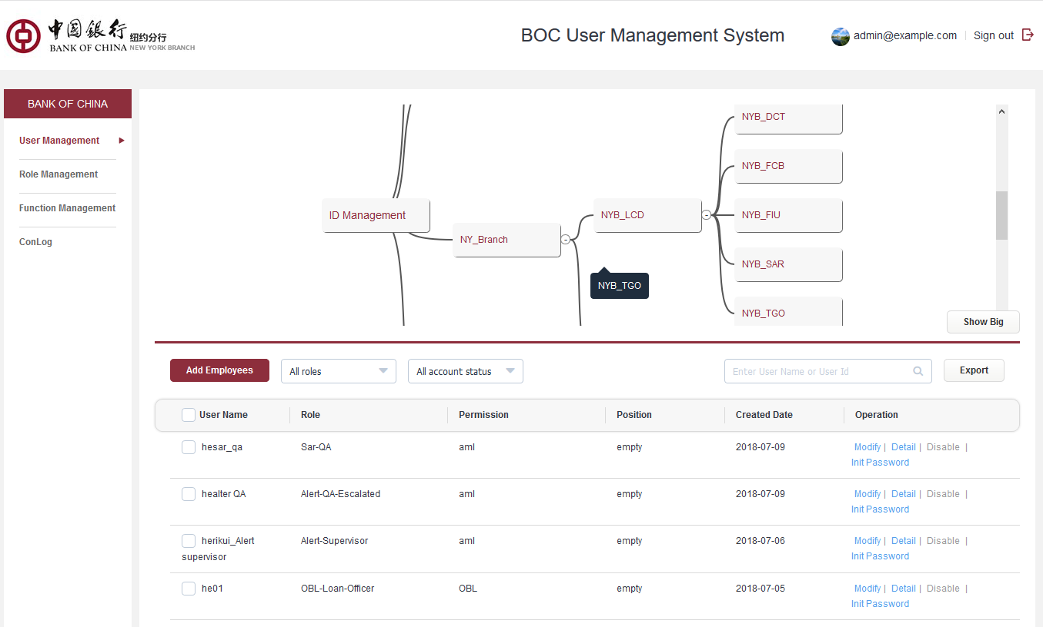

* **Login/Logout log**

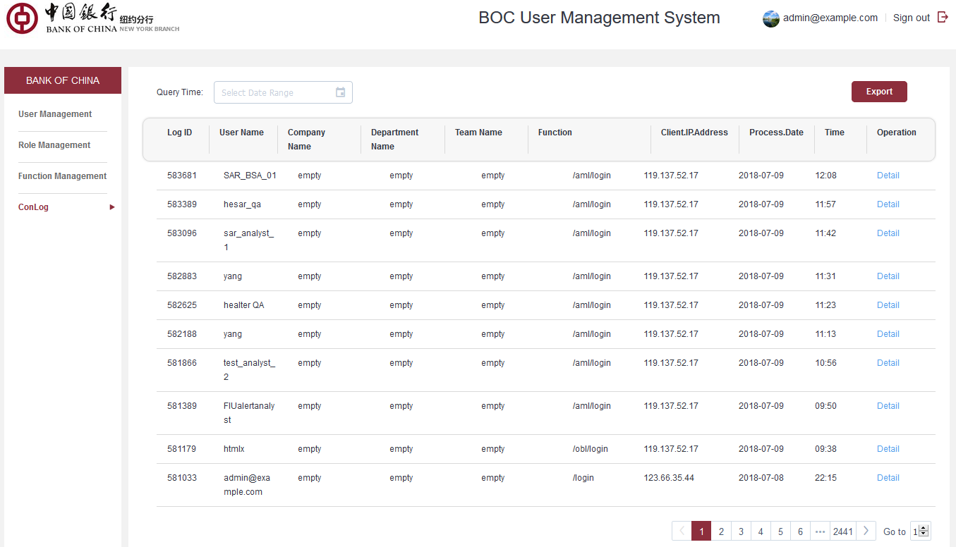

* **Account right configuration** (User Management System)

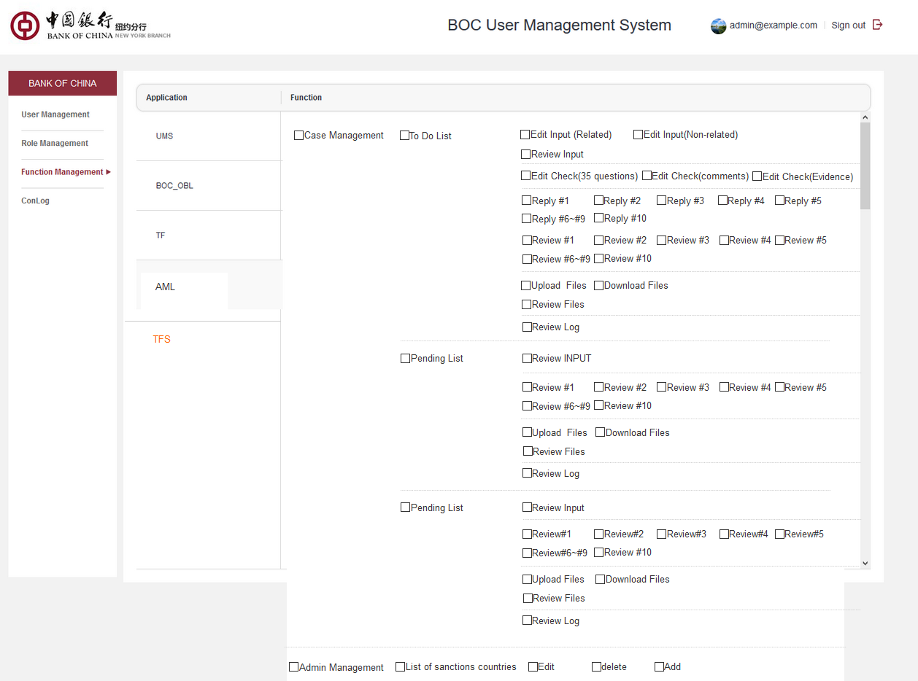

* **Login page**

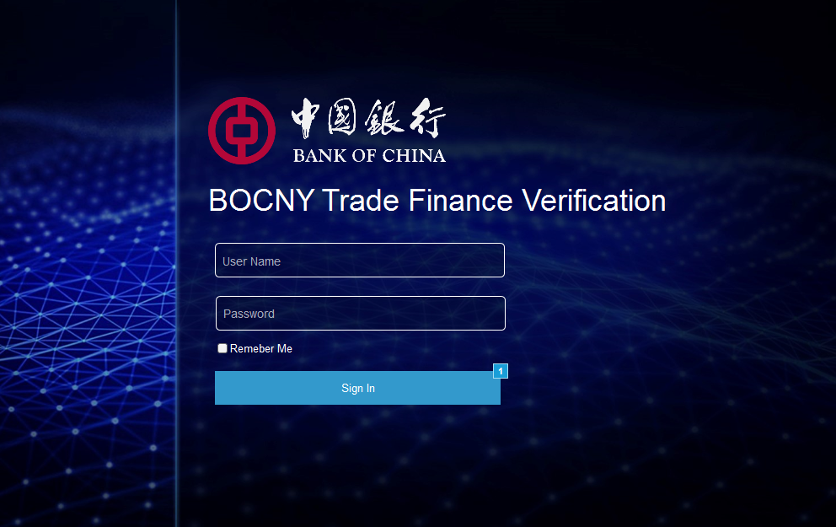

* **Change initial password**

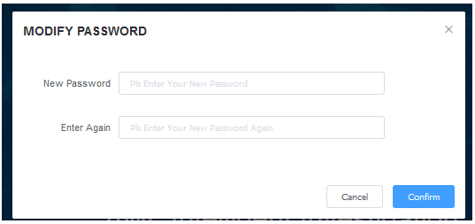



3.2.2 Home Page

### 1..1. AS-IS

The As-Is system only provides support for the operations function of Operations Analyst, and does not involve other roles. When Operations Analyst logs into this system, it will directly enter his/her own Case List working screen.

At the title area of the Case List working screen, some of the main function links are provided (as follows):



includes:

1. LOGO: Back to case list page when it is clicked.
2. ID Configuration：account and password configure for external web resources.
3. User ID: shown current login user’s email address.
4. Sign out：If user wants to sign out the system, he/she could click the “Sign out” button shown in upper right. Then he/she will sign out the system.

### 1..2. Enhancement

* Add a user main working screen (Home Page).
* The main working screen provides functional component management, while the user selects different functional components, and enters the operations interface of each component (displayed in Working Area)
* Add a “Change Branch” new function to Home Page, user can switch to other branches authorized to operate at any time. authorized branch at any time.

#### New Home Page

The new main working screen is provided as shown in the following figure:

*Page description:*

* This screen is divided into two areas: one is functional components area, and the other is working area.

The functional component area provides the user with access to the different operating function of the system, profile information of the currently login user, and related operations links. The work area is set to a blank page as default.

* When the user login successfully, it will go to this web page.
* Items Description of functional component area

| Item | Description |
| --- | --- |
| Case Process | Operations entry for handling case related operations. Includes case creation and case verify, case check, case review for operations unit, case review for compliance unit, and case feedback for LCD.  Click to enter the user’s Case list screen, and:   * Workflow management interface operations entry * Manual intervention of re-assign in case process flow |
| Configuration | An operations entry that includes the following function:   * Static data import from Excel file * Static data maintenance * Extranet ID & Password configuration |
| User Profile | * Display current logon user information, such as user id, user name, working role, current business branch * Link of Sign-out/Logout. |

* Note: each functional component is shown in a blue background, while the current selected functional component is indicated as a green background.  
  After the user selects a component in the functional component area, the system will display the entry page for the component in the work area.

#### Change Branch

* Each TSD role of New York branch can handle business cases in both New York branch and Chicago branch. The Los Angeles branch only needs to handle the business cases for their own.
* The user management and authorization management functions are implemented by "user management module UMS". When the user ID is created for the system under UMS, the user should be assigned at least one branch to handle the Trade Finance AML Intelligence Screening business.
* When the user login successfully, the user can click the Change Branch at any time on the Home Page of the system. After switching successfully, the data and functions matched by the newly selected branches can be seen.
* When the user wants to process cases for other branches, there are two switching modes. One is that the user exits the system first, then login again, and when he logs in, he chooses the other branch. The other is, after he has successfully logged in, switch to the designated branch in the Home Page of the system.
* The following screen will pop up when the user clicks the link of [Branch Name] in the title area of the Home Page screen.
* The content of the drop-down list is the list of branches that the user has authorized to handle in the UMS system. The user selects a branch to switch, the user does not need to logout from the system at the time of switching, the work UI returns to Home Page, and the user can access and operate the data of the newly-switched branch.

3.2.2.1. Brief introduction to function

Login into the default page: at the current stage each role shares the same case page

3.2.2.2. Detailed description

* **Navigation bar**

Home-page LOGO cannot be clicked; LOGOs on the other pages can be clicked to return to the home page

* **Account Information**

The display field and the default head image ICON are fixed and can not be changed. Nickname can be changed according to the design. User name is shown as default. If real name exists then it is shown under and the role name is shown

Click to enter into the basic information page to view

Password, NAME, Cell Phone、Telephone Number、Gender can be edited; others cannot be edited: the information is retrieved from the account system when the account is created

Click Update Setting to finish editting

* **Password modification rule**

1. Old password correctly entered; otherwise [old password is wrong] is shown
2. New password cannot be the same as the old one; hint message is shown
3. The two passwords entered are not the same: [two passwords must be the same]
4. No password is entered and the sumbit button cannot be clicked

* **Logout**

Click to logout and return back to the login page

3.2.2.3. Interface requirements

* **Modification rules for basic account information**

|  |  |  |  |
| --- | --- | --- | --- |
| *Name of element* | *Required/optional* | *Type* | *Remarks* |
| gender | *optional* | int |  |
| Name | *optional* | *60-digit characters* |  |
| Cell Number | *optional* | *20-digit number* |  |
| Telephone Number | *optional* | *20-digit number* |  |

* **Home page**

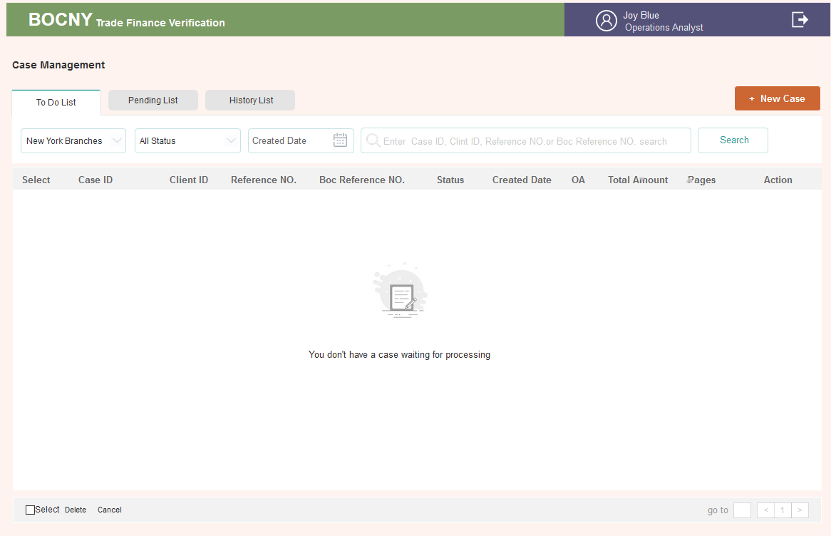

* **Account information**

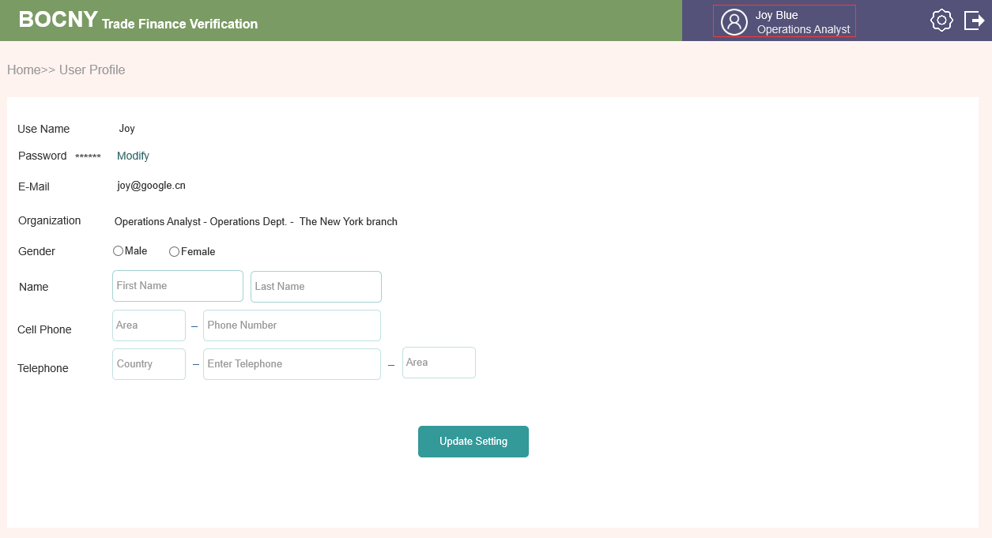

* **Password reset page**

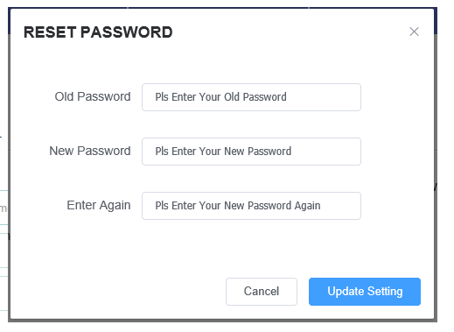

3.2.3 Operations Analyst: Case List Page

### 1..1. AS-IS

Currently，User work area Part for Operations Analyst only is shown as below：

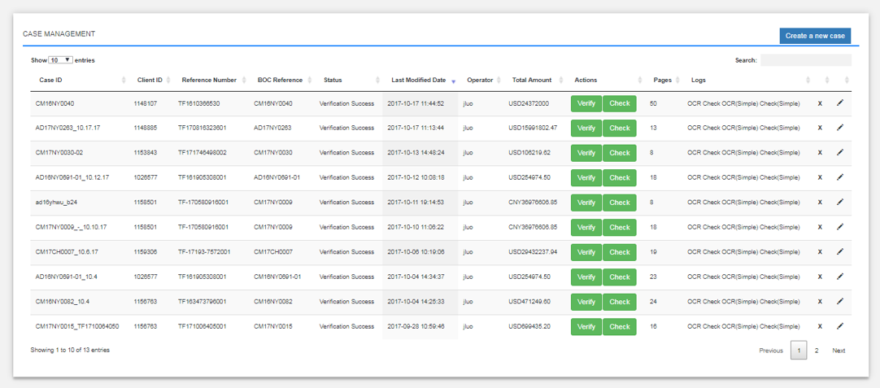

* 1. Show Entities: select how many entities you want to preview by each page. 4 options （10,25,50,100）for selection.
  2. Create a new case (Operations Analyst Only): case generation button.
  3. Title items for transaction: Cases can be ranked by the item in each column. The case management page will summarize the following items for each case. Components in tables is shown as below

|  |  |
| --- | --- |
| ITEM | DESCRIPTION |
| Case ID |  |
| Client ID |  |
| Reference No |  |
| BOC Reference No |  |
| Status | Verification Success and Verification Failed. |
| Last Modified Date |  |
| Operations Analyst | Operations Analyst who created the case |
| Total Amount | Total amount for this case |
| Action | Upload of documents |
| Pages: | page amount of the uploaded PDF |

### 1..2. Enhancement

* N/A

3.2.3.1. Brief introduction to function

* **OA workbench**



3.2.3.2. Detailed description

* **List status**

Divided into To Do List & Pending List & History list:

The CASE that requires the current role to process is placed in the To Do List list

The CASE that does not require the current role to process is placed in the Pending List . It is convenient for the current role tracking CASE to be dealt with.

Completed Cases is placed in History List. The search fields are same as that in Pending List.

* **To Do List**

**1.** Status

There are three status for a case 1) click on New case to create the case, button is Input 2)In the input click Submit, the list button turns to Check; Details page, send to manager, case is put into pending List 3) Rejected by OM, button is Modify. Refer to list status 1A~5B (Inclusive) for detail

**2.** Filter

* Filter Rule

All search conditions are associated search relationships

For example, if New York Branch is selected, then the state is under this branch.

* Filter Texts

|  |  |
| --- | --- |
| ITEM | DESCRIPTION |
| branches | The list seen by users in New York branch is only New York Branch, which can be switched to Chicago branch. Data to select Branch when users create CASE in New York branch |
| Action Status | Default is All Status , Dropdown is Under OA Review，Under OA Modify |
| Created Date | Search according to the creation date |
| CASE amount | Currency foramt |
| Search Window | Allow Case ID, Clint ID, Reference NO.or Boc Reference NO. for searching |

3. List

* Descriptions are as follows

|  |  |
| --- | --- |
| ITEM | DESCRIPTION |
| Select | Check box for batch operation |
| Case ID | When a case is created, this ID is generated |
| Client ID | Same as above |
| Reference NO. | Same as above |
| BOC Reference NO. | Same as above |
| Action Status | Under OA Review，Under OA Modify. Considering that the list display field is limited, the role is abbreviated when displaying the list. But the details page should be fully displayed |
| Created Date | The creation date, the list page is displayed to the date, the detail page needs to be displayed to the reverse sequence. |
| Opertor | Operations Analyst who created the case |
| Total Amount | Total amount for this case in order originated when the case is created |
| Pages | When uploading, the total number of PDF pages will change with the increase or decrease of INPUT pages in order |
| Action | Input, Check, Details, Modify |

If CASE changes, the CASE field will change accordingly

* Order Rule

The most recent case is in the front

Created Date & Total amount & Pages can be used for ordering

* Page Turn

The amount of data shown in one page is free to adjust and the default is 25.

One can turn the page and the total number of pages is shown in the bottom. The first page can not be clicked forward; the last page can not be clicked back

**4.** Delete&Cancel CASE

* Only the OA roles have this permission, and they can only delete the CASEs they create, which are only available in the OA editable state
* Select the box on the left of select, then check all CASEs on the page to do batch operations or single-select operations.
* To delete and cancel CASE, one needs to fill in the reason less than 1000 characters
* Delete

After deleting, the CASE will record the reason for deletion in the system database. The CASE is nowhere to be seen in the front end

* CASE Cancellation

After case is canceled, the CASE will be visible in History List. All records can be querying, but no longer enter the processing flow.

* **Pending List**

**1.** Status

The status list #6 and the state after deducting the History List will be placed in the Pending List.

**2.** Filter

Same as TO DO LIST

The state here is temporarily no need to be processed.

Time is the the latest update. The time changes to the time when the state is displayed

**3.** List

Descriptions are as follows

|  |  |
| --- | --- |
| ITEM | DESCRIPTION |
| Select | Check box for batch operation |
| Case ID | When a case is created, this ID is generated |
| Client ID | Same as above |
| Reference NO. | Same as above |
| BOC Reference NO. | Same as above |
| Status | The state of list 6 (inclusive) and the state of cancellation. |
| Modifled Date | The latest revision date, the list page displays to the day, the detail page needs to display to the time in order |
| Opertor | Operations Analyst who created the case |
| Total Amount | Total amount for this case in order when the case is created |
| Pages | When uploading, the total number of PDF pages will change with the increase or decrease of INPUT pages in order |
| Action | Details |

Note that the date is different from the TO DO LIST, which shows the most recent modification date.

Enter the details page to view

3.2.3.3. Interface requirements

* **To Do List**

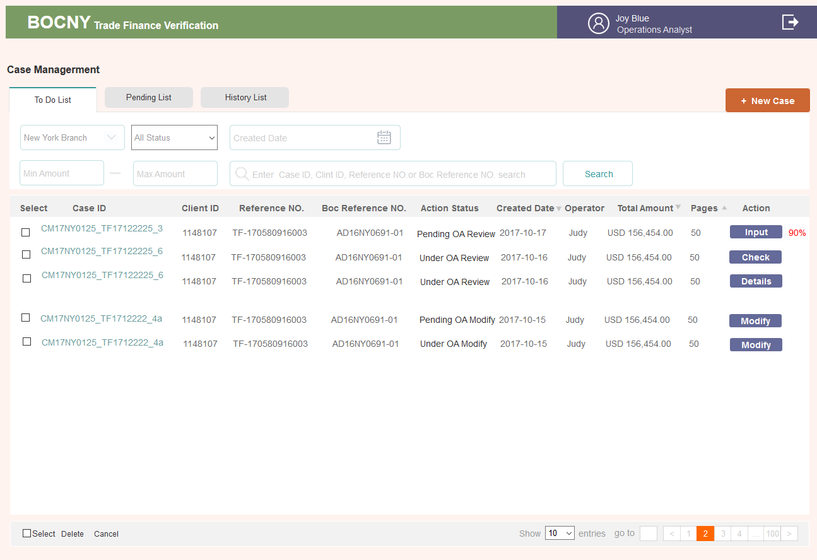

* **Pending List**

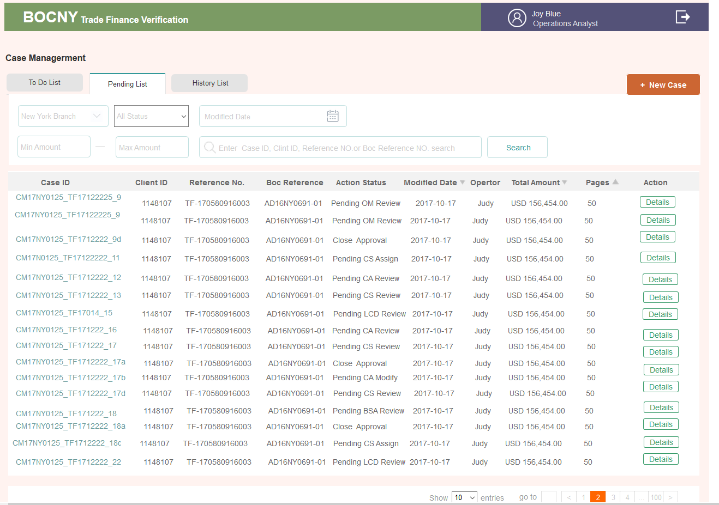

3.2.4 Operations Analyst: Create Case Page

### 1..1. AS-IS

Creation of a case is handled by Operations Analyst, which is based for trade finance transaction risk mitigation review and related documents categorize.

* A case is created by an Operations Analyst and each case can be identified by the analyst’s User ID.
* Only PDF documents can be uploaded.

After ID configuration, the Operations Analyst can click the “Create a new case” button to create the new case. The system will pop up a window.

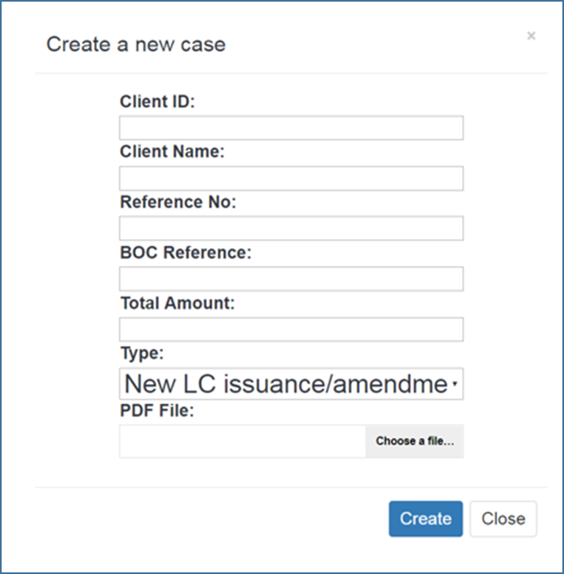

In the popup window, enter the following information:

Input component：

|  |  |  |
| --- | --- | --- |
| Field | Valid Data type |  |
| Case ID | Not need input | Need to show in page.  String, create automatically based on the name of upload PDF file ，input mandatory |
| Client ID | Arabic number  # auto-match hint with client name if the system has the client record | String，input manually, input mandatory ,appear selection which Operations Analyst could select one based on input characters |
| Client Name | Letter | String，selected automatically based on input client ID. Appear with client ID input in pairs |
| Reference No | Arabic number starting with TF | String，input manually, input mandatory, |
| BOC Reference | Letter/Arabic number | String，input manually, input mandatory, unique index code |
| Total Amount | Currency abbreviation in three letters and Arabic number | Input “USD” and case amount input mandatory, |
| Type | Select from the drop-down menu | 1. New LC Import issuance/amendment  2. New LC Import drawing  3. New LC Export documents/Transfer/AOP  4. New Inward Collections Documents  5. New Outward Collections Documents  6. Funded/Unfunded Risk Participation  7. Forfeiting  8. Factoring/Supply Chain Financing  9. Short Term Financing Transaction |

Subfolder Archiving:

The Operations Analyst may obtain documents from a client that may be an early draft of on invoice, B/L or another document. In these cases, the clients will present the final version of the document after discussion with the Bank. In this scenario, the bank will edit the electronic document to remove the early draft and replace it with the final document.

To accomplish the remove, edit and add functionality, the Operations Analyst, the system must be flexible and permit the creation of folders and sub-folders. Specifically, Operations Analyst must be able to:

* Insert one or more document pages to batch of documents
* Replace a document with another document
* Create a subfolder to hold the original page(s) that were removed
* Rename subfolder as required
* Advance or Reverse specific pages in a document so that the page location in a batch of document changes
* Move documents from the Sub-folder to the original documents.

For example:

1. Add invoice before B/L No. 5

2. replace B/L no. 1 by B/L no. 6 and move B/L no. 1 to subfolder (rename as bad B/L)

3. remove B/L No. 7 to subfolder (rename: pending )

4. drag B/L no. 7 from pending subfolder to original documents, position before B/L no. 4

5. direct upload customer instruction to subfolder (rename as customer instruction)

### 1..2. Enhancement

* Price input should include two sections:
  + Currency – Default value is USD. The currency list should start with: USD, CNY, EUR, JPY, GBP, KRW, CHF.
  + The ISO 4217 list of currency codes will be utilized in the system.
  + All amounts should be verified and include separators for “Thousands”. For example, if I manually input 250000, it should be adjusted as 250,000.00 automatically.
* For cases with the same reference number, Reference number will be unique code, system could block out and alert users once case create.

3.2.4.1. Brief introduction to function

Only OA has the right to create cases. OA examines the risks of trade financing transactions and put the case in the corresponding type of trade financing business.

3.2.4.2. Detailed description

The OA role clicks the upper right corner button on the home page list + New Case and the page that creates CASE will pop up.

* **Upload Documents**

1. Upload PDF documents; a progress bar is shown; when finished, check the box

2. At present, it is capable of supporting multiple uploads up to 100 copies of PDF within each PDF 30M.

In computer desktop or related folder, press CTRL to upload multiple documents.

3. PDF name: take the name of PDF when uploaded, if the name is repeated, a pop-up window is shown, "there is a PDF file with the same name, please confirm or modify the name and upload it. .

4. Allow for deletion

5. Drag to adjust the location. After submission, PDF will be sorted according to their position order

* **Submit**

1. Only the required form of the form is filled, and when the file is uploaded at least one copy, the button Submit and the Button submits and saves can be clickable. Otherwise, it is not clickable

2. Click submit and the system will generate an ID according to the rule: TF+year month day+6 digits

3. Submit to jump to the list page: a CASE is added to the list page

4. Submit&Continue is a NEW CASE page for cases to be imported conveniently

5. Modify the Case before send to OA(send to manager)，this page is editable. Click the Modify the Case in the upper right corner to enter the details page. Only the Submit button is shown. Click Submit and the modified prompt pops-up. Click confirmation to update the original content.

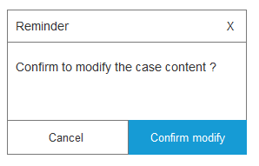

6. When a CASE is added, one can enter into the details page; refer to the descriptions for details

7. Based on the file type, the system will classify the file in its corresponding folder (requirement of database)

3.2.4.3. Interface requirements

* **Basic field descriptions**

Case and blank sensitive

|  |  |  |  |
| --- | --- | --- | --- |
| **Name of element** | **Required/optional** | **Type** | **Remarks** |
| Client ID | Required | 30-digit characters | Numbers,letters,underline  Manual input |
| Client Name | Required | 60-digit characters | Numbers, letters, bars  If there are customers in the system, ID will automatically match the name of the customer. |
| Reference No. | Required | 30-digit characters | The number is unique, and the system needs to identify. If the Reference No. has been found then the next window popped up, "Reference NO. has already existed, please check it again and re - enter it.” |
| BOC Relevance | Required | 30-digit characters | Numbers, letters, bars |
| 币种 | Required | Dropdown menu | Admin management, the default is the currency of highest weight |
| Total Amount | Required | 15-digit value | Two digits after the decimal point |
| Branch | Required | Dropdown menu | New York Branch, Chicago branch, and Los Angeles branch New York branch user can process business data of New York Branch and Chicago branch from the drop down selection. Los Angeles branch can only processes the business of Los Angeles branch and there is no dropdown list. |
| Type | Required | Dropdown menu | 1. New LC Import issuance/amendment  2. New LC Import drawing  3. New LC Export documents/Transfer/AOP  4. New Inward Collections Documents  5. New Outward Collections Documents  6. Funded/Unfunded Risk Participation  7. Forfeiting  8. Factoring/Supply Chain Financing  9. Short Term Financing Transaction |

* **Page to Create a Case**

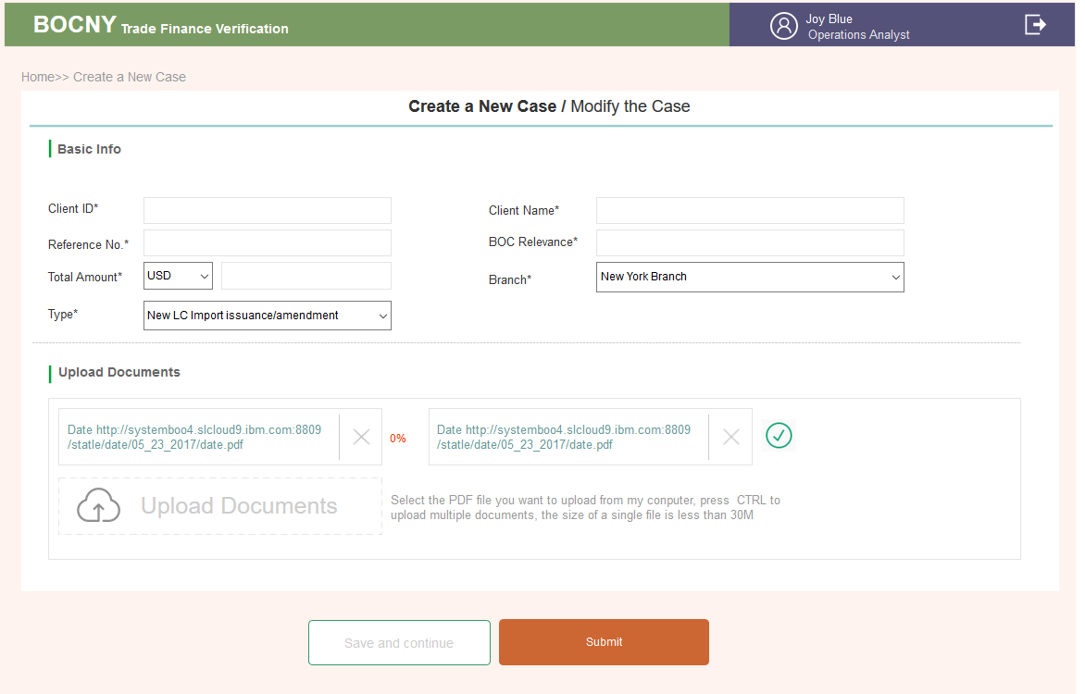

3.2.5 Operations Analyst: Case Verification Page

### 1..1. AS-IS

Case verification is where Operations Analyst input and verify the relevant information for each transaction case. After the Operations Analyst click the ~~“Verify”~~ button, the system will enter the case verification page.

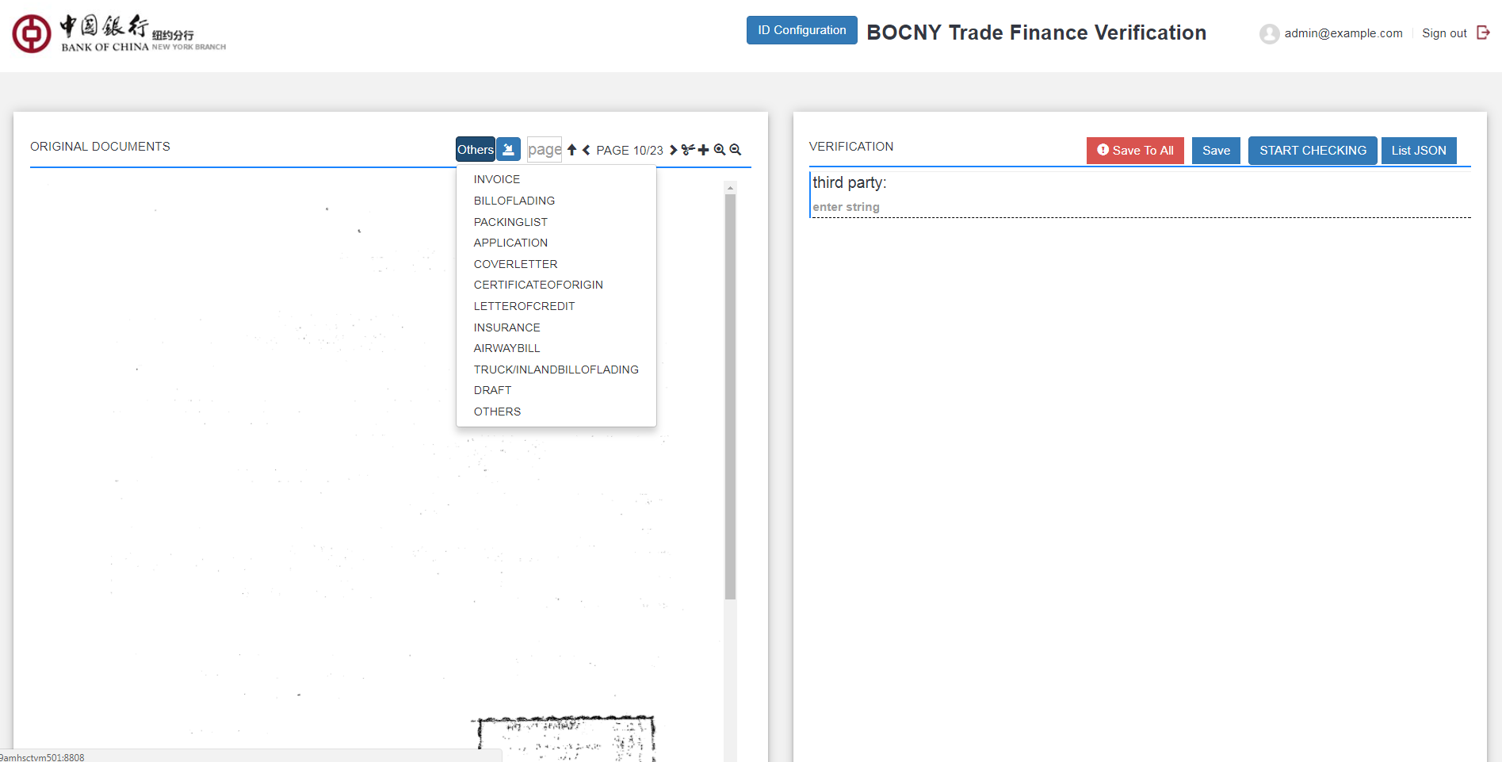

On the left-hand side of window, the system will show the original documents for preview. The system can automatically recognize two document types on each page. These two documents are the Invoice and Bill of Lading respectively. If the document type recognized by the system is incorrect, the Operations Analyst could also use the selection bar to change the document types.

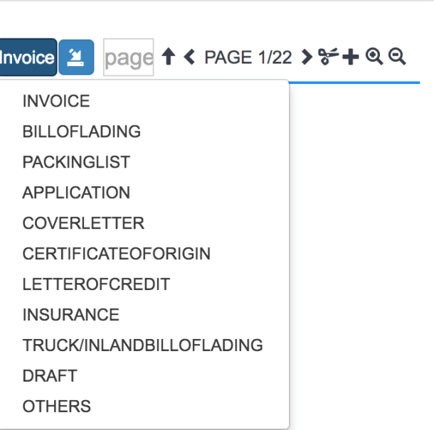

Other functions are listed in Quick reference

|  |  |  |
| --- | --- | --- |
| Button | Action | Reference |
| “<” and “>” buttons | “<” and “>” buttons will guide the Operations Analyst to switch to the previous and next page. |  |
| “ $↑$” | The Operations Analyst could also directly input the page number in “page” domain, then click “ $↑$”, the system will automatically jump to the according page. |  |
| ../Desktop/Screen%20Shot%202017-09-27%20at%206.45.50%20PM.p | The Operations Analyst could delete a page by clicking ../Desktop/Screen%20Shot%202017-09-27%20at%206.45.50%20PM.p button. System will prompt a window to ask whether the Operations Analyst confirms to delete the current page. If click “OK”, then the current page will be deleted. |  |
| ../Desktop/Screen%20Shot%202017-09-27%20at%206.50.37%20PM.p | If the current page is deleted by mistake, the Operations Analyst could click ../Desktop/Screen%20Shot%202017-09-27%20at%206.50.37%20PM.p to revoke the action or restore the detailed page. System will have two options. “PREVIOUS RECORD” allows Operations Analyst to recover to the latest record before deletion. “ORIGINAL RECORD” allows Operations Analyst to restore the document to its original state as initial upload. | ../Desktop/Screen%20Shot%202017-09-27%20at%206.14.11%20PM.p |
| “+” | To add extra PDF pages in the current case, the Operations Analyst could click “+” button on any page of document. Then a popup window will ask the Operations Analyst to upload the PDF file and the insert position before or after the current page. After click “Upload” button, the system return to case management page. The Operations Analyst could click “Verify” button to reenter the case with new added pages. |  |
| ../Desktop/Screen%20Shot%202017-09-27%20at%206.58.16%20PM.p | The ../Desktop/Screen%20Shot%202017-09-27%20at%206.58.16%20PM.pbuttons on the left-hand side of window allows Operations Analyst to zoom in/out the current page. On each document page, Operations Analyst can move the PDF by dragging the mouse. | ../Desktop/Screen%20Shot%202017-09-27%20at%206.58.16%20PM.p |
| Save | save all field value in current page  After the Operations Analyst finish entering and refining all the entity values, he/she could click “Save” button to save the entered value. A format reminder will be prompted if there is incorrect format. Without correcting the incorrect entity value format then clicking the “Save” button will trigger the following popup window The Operations Analyst must correct the incorrect format to save the current page. | ../Desktop/Screen%20Shot%202017-09-27%20at%206.12.39%20PM.p |
| Save to all | save all field value across same type of document  If “Save To All” button is clicked, then the entity values across all the same document type will be saved as the current page value. A format reminder will be prompted if there is incorrect format. Without correcting the incorrect entity value format then clicking the “Save To All” buttons will trigger the following popup window. The Operations Analyst must correct the incorrect format on the current page. | ../Desktop/Screen%20Shot%202017-09-27%20at%206.12.39%20PM.p |
|  | Rotate button, current page will be rotated 90 degrees once click, it could be saved after adjustment. |  |
| START CHECKING | It should trigger the API process, and it will provide answers/evidence for auto/semi-automatically questions |  |
| ../Desktop/Screen%20Shot%202017-10-23%20at%204.16.51%20PM.p | Add/delete same set |  |

The transaction documents fields please ref to Appendix 7.2

### 1..2. Enhancement

* When 'shipment date' is blank an alert should be generated. The shipment date is necessary for a Lloyds search.
* Operations Analyst should be able to select the document type from the document type drop-down list.
* When a new page is added, the system will default the newly added page into the “Others” category.
* New API to the new Lloyds website.
* Adjust Verify Page: split PDF edit function (add page, delete page, change page sequence, rotate page, Operations Analyst can zoom-in or zoom-out or rotate for view) from original page and add new page for these edit functions; keep PDF view function (Operations Analyst can zoom-in, zoom-out, page up, page down, page restore) in original page.

As is:

1. Operations Analyst click “verify” button on case list page, switch to case verification screen(A)
2. On screen (A) left side, Operations Analyst can edit PDF pages and identify documents page type.  
   On screen (A) Right side, Operations Analyst can input data refer to left side PDF page.
3. After data input finished, click “Start Checking” button on the top of right site, and return to case list screen.

To be：

Split screen (A) to two screens. (Left side separate to screen B). Screen (B) focuses on PDF modifications. Screen (A) focuses on Data input and left side keeping PDF view function. Switch to screen-B from screen-A if needs

1. Operations Analyst click “verify” button on case list page, switch to case verification screen(A)
2. Add a “Edit” button on screen(A) left side, then skip to new screen(B)
3. On screen (B), Operations Analyst can edit and click “Save” return to screen (A). The updated PDF file should be shown on the left side of screen(A).
4. Input data on the right side of screen (A).

*Page description:*

* In AS-IS Case Verify screen, an “Edit PDF” button is added to the left PDF file display area. When Operations Analyst wants to modify the content of PDF file, click this button to jump to Document Edit Page.
* This page is divided into two areas: 1. Function control area, 2. PDF page display area.
* The function control area includes basic operations buttons: enlarge, reduce, rotate, add pages, delete pages, browse pages and move pages.

The PDF page operations area will display multiple pages one by one in thumbnail mode.

* When Operations Analyst finishes editing the PDF file, clicking the "Save" button will return to the Verify page and the contents of the updated PDF file will be displayed on the left side of the Case Verify page.
* The left side of the Verify page only retains the functions of browsing page, enlarge page and reduce page, and the operations of the page classification and identification.

3.2.5.1. Brief introduction to function

Case input is where OA structures the forms of cases for the system to classify



3.2.5.2. Detailed description

The OA role clicks the upper right corner button on the home page list + New Case and the page that creates CASE will pop up.

* **PDF on the left**

**1.** Data resources

A ) The PDF uploaded when a New Case is created is shown here. The PDFs will be divided page and page for display.

B)After upload is done, an initial number is recorded at the lower level of the program, which will not be changed if the position of the page is changed. For example, if No.98 page is deleted, numbers of other pages are the same; only the page numbering is changed

**2.** Function menu

|  |  |
| --- | --- |
| **Button** | **Action** |
|  | Page number: the total number of pages will be displayed; one can turn pages on the upper left corner or turn pages in scroll bars. The first page cannot be turned backwards and the last page cannot be turned afterwards  Double click the page numbers to edit; page number must be within the limit; click enter to jump to the page |
|  | Click to insert a new PDF page after the current page  A window will pop up，”successfully inserted 10 PDFs” disappears after 1000ms  The page stays on the first page of the newly inserted PDF  The inserted PDF needs to be recorded in the attached package. See below. |
|  | Click to delete the current page  A window will pop up  Hint :” Permanent delete or move and save into subfolder？”  Confirm to delete completely or keep it in the temporary reclaim station |
|  | Click on this ICON and two operations are available:go back to the previous step, or go back to the first step. Click on the top right corner SAVE or Submit  PDF is automatically saved on every operation on the left side.  This ooperation applies only on the PDF to the left; it does not apply to the operation on forms to the right |
|  | 1) This is a subfolder, click the add buton to add subfiles  2) The added subfiles will be placed inside the subfolder  3) One can enter into the folder to add/delet subfiles  4) One can turn the page |
|  | 1) The page deleted by  will appear in the older folder; users can enter in to retrieve the lost files  2) Click  to put the deleted file to its original place Hint: the file is moved to PDF, which disappears after 1000ms. It will be inserted before the current page. Return to view the last inserted page  3) Click to insert those pages to be saved temparily，but not added to the main PDF folder in here. Click  to insert the page into PDF folder to the previous page of the current page. Return to see the last inserted page |
|  | 1）The mouse moves into the PDF box and the ICON layer appears.  2） Clicking arrow refers to moving forward or moving back to a position.  (that is, click the down arrow, the tenth page changes to eleventh pages, and the eleventh page changes to tenth pages).  Note that the first page cannot be turned backwards and the last page afterwards  3）If one clicks on the small triangle button, a pop-up window is shown to switch pages: for example, if at the fifteenth page, one click the upper right small triangle, fill in the number less than 15, jump to the page, and insert the current page into the desired number of page. |
|  | 1）Moves the cursor into the PDF window, the level of the ICON will be shown  2）From right to left:  Zoom out, zoo in, retrieve(to the original size),  Rotate(rotate the PDF) |
| Scroll bar | Move the cursor to this area to scroll down the page |

* **Dropdown menu on the right**

**1. Abstract**

These are two ways to input the form: relational input, non-relational input

1）The related entry method will bind all kinds of documents with invoices and some will not bind the invoice.

When the user sees the PDF uploaded as the CASE is created on the left, it will identify which kind of document (bill of lading, invoice and so on) that this PDF belongs to, and which kind of invoice. (It can be understood as when Taobao bought an order and got an invoice to indicate the order, the invoice will be attached to the express form, bill of lading and other documents.)

2）Non-relational input: select the template directly and no matching operation is done

The comparison scheme is form by form. For example, if there are 3 invoices, 5 For example, there are 3 invoices, 5 transport bills (maybe land, sea and air), and 4 packing lists. Then the products, quantity and unit fields of all invoices are compared with the total sum of all transport documents.

**2. Field**

|  |  |  |
| --- | --- | --- |
| First-class category | Second-class category | Third-class sample plate |
| NO INVOICE | BILLOFLADING | BILLOFLADING 1  BILLOFLADING 3  BILLOFLADING 7 |
| PACKINGLIST |  |
| APPLICATION |  |
| COVERLETTER |  |
| CERTIFICATEOFORIGIN |  |
| L/C ISSUANCE |  |
| INSURANCE |  |
| AIRWAYBILL |  |
| TRUCKIN LAND BILL |  |
| OF LADING |  |
| DRAFT |  |
| OTHERS |  |
| INVOICE 1 | Same as above | Same as above |

* **Relationship between classes**

There are three levels. Generally speaking, an invoice will be associated with a series of bills of lading, packing list and so on. Of course, some notes are not related to invoices.

**1）the first level** is the confirmation of the relationship (not related to invoices, associated invoices, EDD classes).

**2）** the second level is the corresponding form under the relationship of confirmation: All ticket types except invoices (later invoice calls may be made based on the TYPE type selected when CASE is created). Click the corresponding type, and then the corresponding empty form (such as Bill of lading) is transferred out.

3）The third level is the completed form. Click SAVE or SUBMIT to enter the third level. The same type of form may have multiple sheets, so there will be a label for record.

4) When one selects PDF on the left, the system identifies the left PDF over a few pages. When one clicks the empty form, the number of pages identified is displayed at the top right corner.

If a page skip occurs, such as to page 10, insert it into page 5, and the original association, pages 1 to 5 are invoices, and pages 6 to 8 are bills of lading. The tenth page is automatically returned to the invoice, 1 to 6 is the invoice, and 7 to 9 is the bill of lading.

You can manually enter the range of PDF page Numbers associated with the document

Click save&submit to submit, and click this form again, the PDF on the left will return to the first page

* **No relate invoice**

1. Represents the PDF document type on the left side, and does not relate to any invoice.

2. Move in, dial out second levels - corresponding document type, not clickable. If we can recognize a PDF, we can map the fields of the PDF to the empty form, and if not, refer to the following rules

3. At the second level, there are some mapping relationships

1) Click on the mapping settings in the upper right corner to bring up the Map Fields check box. After saving, when you encounter the same credentials such as bill of lading 2, the fields will be automatically mapped according to the fields had set on the page (for example, bill of lading 1) that no need enter again.

2) If a new bill of lading (for example, bill of lading 3) is reset, the setting of bill of lading 1 will be cleared. When input bill of lading 4, it will be entered according to the setting of bill of lading 3

If all mapping fields are cleared on the bill of lading 3 and click "Save", the bill of lading 4 will no longer continue to map. (When the bill of lading 3 clicks on the mapping setting, the default is to map the mapping field set by the bill of lading 1)

4.Third level: When the second level fills in the form in the form, click SAVE (save) or SUBMIT (submission); the third level will generate the corresponding content, and click to switch

5. At the third level, click on this icon to drag the document. For example, if this document is under INVOICE1, it can be dragged to INVOICE2 or NO INVOICE

* **INVOICE**

**1. First Level**

1) To relate to the invoice, one needs to add the invoice first.

Click +ADD INVOICE, in the first level directory, there will be one more INVOICE.

The mouse moves in to display second levels of directory, allowing users to choose other documents related to the invoice. Click to retrieve the invoice.

2) Delete

If deleted then the invoices will be reordered

Deletion will only delete the invoice. Other forms associated with it will be automatically placed in NO INVOICE

A window will pop up when deleting

Note that irreversible deletion in the system requires a prompting pop-up for the users to confirm

3) Invoices’ Notes

When the invoice has been recorded in the content (such as INVOICE1): drag the mouse into the left side, the left side will appear some notes, so that the user knows the basic content of the invoice and it is easy to select the invoice associated with the document

Fields are

Invoice Number, Invoice Buyer / Applicant / Drawee, Invoice Seller / Beneficiary / Drawer、Total amount (The sum of the unit price * of all commodities), title of the first three products

**2. The rules for the second and third level** are the same as No relate invoice

* **SAVE&SUBMIT**

1. Quit in the middle of an action

When the user performs any operation on the page, including the addition and deletion of PDF on the left and the page is withdrawn without saving, there will be a hint of a pop-up window

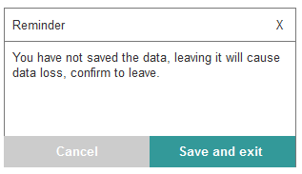

2.SAVE

1) It is for users to avoid data loss during operations, such as power outage, and so on. There is no page-jump

2) After saving, the add-on to the left of the left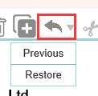is gray in theory

3）The third level of the drop-down box will contain the form

4）Documents Verification in the details page will put the form with added content in it.

5）if no operation, SAVE&Submit to gray

3.Submit

1）Click submit to jump to the deteails page

2）the Submit button initiaties the next step: the button on the list page turns into Check

3) The button Evidence Management&Check in the details page, originally gray, can be clicked

4）After the Check, the result is confirmed. So before Check is clicked, the status of unchecked documents is pending

The results are divided into 2 categories, one is consistent with the verification results. One is the result that is verified with the third party. Except for other items, the verification of all items is in 35 questions.

The program transfers the contents of CASE information and INPUT to the third party. The third party accounts have been verified when the user is created by Admin.

**Program API Input**

Information sent back from T24&graphen

A.The 35 questions have answers YES&NO&N/A; if there is a comment, then comment is returned to display.

B.Each problem has evidence, corresponding evidence fields (forming EXCEL) or links or other forms of documentation or NOFOUND; fields such as ALERTC.

* **After sent to OM**

The page cannot be edited

1. The page after entered in is no longer allowed to be edited.

2. The scroll bar remains on the left side: zoom in and zoom out and restore function；

Reclaim station & add-page function (not editable). Other roles do not have these two pages.

3.Edition and deletions are no longer allowed in the form to the right. The plug-in for addition and deletion disappears

4.The drop-down box is used only for retrieving the corresponding page: click to create empty pages; addition of invoices and classification functions disappear.

5.Save&Submit button disappears

* **Form**

1. The ability to add fields indicate that the fields can be multiple, so 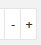 is used for addition and deletion

2. The merging of cells in multiple fields indicates that strings are added or reduced, such as commodity descriptions.

3.  relates to the 35 questions refer to 3.2.16 for explanation

3.2.5.3. Interface requirements

* **Rules for Fields in the Forms**

1.INVOICE

|  |  |  |  |  |
| --- | --- | --- | --- | --- |
| Name of element | Required/optional | Type | Can Add | Remarks |
| Invoice Number | Required | 50-digit  number/letter/-// | N | Any arabic number and String combination, including -, /, ., i.e. 16TAC-123AA |
| Goods Description | Required | Max255Text | Y |  |
| Unit Price | Required | 15-digit value | 2 decimal points in price format. If not fill in the 2 digit number, the next form will automatically complete the digits. |
| Currency | Required | Dropdown menu | Admin backend management, the unit with the highest weight will be the dafault |
| Quantity / Weight | Required | 15-digit number | Digit, allows for two decimal digits, select one from the two titles in the dropdown list |
| Type of Unit | Required | Dropdown menu | Admin backend management, the unit with the highest weight will be the dafault |
| Gross Weight | optional | 15-digit number | Digit, allows for two decimal digits, select one from the two titles in the dropdown list |
| Type of Unit | optional | Dropdown menu | Admin backend management, the unit with the highest weight will be the dafault |
| Country of Origin | optional | Dropdown menu | Country plug-in (including full names and abbreviation), search in a dropdown list which will be automatically filled based on the previous names |
| Invoice Buyer /  Applicant /  Drawee | Required | 60-digit characters | N | Invoice Buyer 3 fields of titles, dropdown list to select one |
| Invoice Seller /  Beneficiary /  Drawer | Required | 60-digit characters | N | Invoice Buyer 3 fields of titles, dropdown list to select one |
| Assignee Name | optional | 60-digit characters | Y |  |
| Transferee Name | optional | 60-digit characters | Y |  |
| Manufacturer / Supplier(drop down) | optional | Max255Text | Y |  |
| Invoice Third Party | optional | Max255Text | Y |  |

2.BILLOFLADING

|  |  |  |  |  |
| --- | --- | --- | --- | --- |
| Name of element | Required/optional | Type | Can Add | Remarks |
| B/L NO. | Required | 50-digit  number/letter/-// | N | Any arabic number and String combination, including -, /, ., i.e. 16TAC-123AA |
| Port of Loading | optional | Max255Text | Y |  |
| BL P/L Ccountry | optional | Dropdown menu | Country plug-in |
| Port of Discharge | optional | Max255Text | Y |  |
| BL P/D Country | optional | Dropdown menu | Country plug-in, search in dropdown menu |
| Transshipment Country | optional | Dropdown menu | Y | Country plug-in, search in dropdown menu |
| Goods Description | Required | Max255Text | Y |  |
| Gross Weight | Required | 15-digit value | Digits allow for 2 decimal points |
| Type of Unit | Required | Dropdown menu | Admin backend management |
| Quantity / Weight  (下拉选某一个名称) | optional | 15-digit value | Digits allow for 2 decimal points |
| Type of Unit | optional | Dropdown menu | Admin backend management |
| BL Shipper | Required | 60-digit characters | Y |  |
| BL Consignee | optional | 60-digit characters | Y |  |
| Notify Party | optional | 100-digit characters | Y |  |
| Vessel Name / IMO NO. | Required | 100-digit characters/50-digit  number | Y | Arabic number /String |
| Shipment Date | Required | Datetime | Display in the format of yyyy-mm-dd; |
| Transshipment Vessel | optional | 100-digit characters | Y |  |
| Transshipment Date | optional | Datetime | Display in the format of yyyy-mm-dd; |
| Forwarding Agent | Required | 100-digit characters | Y |  |
| Destination Agent | Required | 100-digit characters | Y |  |
| Carrier/Master | Required | 100-digit characters | Y | Carrier select 1 from the 2 fields in the dropdown menu |
| Shipping Agent | optional | 100-digit characters | Y |  |
| BL Third Party | optional | 100-digit characters | Y |  |

3.PACKINGLIST

|  |  |  |  |  |
| --- | --- | --- | --- | --- |
| Name of element | Required/optional | Type | Can Add | Remarks |
| Goods Description | optional | Max255Text | Y |  |
| Gross Weight | optional | 15-digit value | Digits allow for 2 decimal points |
| Type of Unit | optional | Dropdown menu | Admin backend management, the unit with the highest weight will be the dafault |
| Net Weight | optional | 15-digit value | Digits allow for 2 decimal points |
| Type of Unit | optional | Dropdown menu | Admin backend management, the unit with the highest weight will be the dafault |
| PL Third Party | optional | 100-digit characters | Y |  |

4.APPLICATION

|  |  |  |  |  |
| --- | --- | --- | --- | --- |
| Name of element | Required/optional | Type | Can Add | Remarks |
| Application Buyer/Applicant/Drawee | Required | 100-digit characters | N | Application Buyer select 1 title from the 3 fields in the dropdown menu |
| Application Seller/Beneficiary/Drawer | Required | 100-digit characters | N | Application Seller select 1 title from the 3 fields in the dropdown menu |
| Transferee Bank | optional | 100-digit characters | Y |  |
| High Risk Country | optional | Dropdown menu | Admin backend management |
| Bank of China | optional | 100-digit characters |  |
| Second Beneficiary | optional | 100-digit characters |  |
| Assignee | optional | 100-digit characters | Y |  |
| Assignee Bank | optional | 100-digit characters |  |
| High Risk Country | optional | Dropdown menu | Admin backend management |
| Bank of China | optional | 100-digit characters | None, blank and case sensitive |
| Shipment Date in Application | optional | Datetime | Y | mm-dd-yyyy |
| Application Date | Required | Datetime | N | mm-dd-yyyy |
| Application Third party | optional | 100-digit characters | Y | None, blank and case sensitive |

5.COVERLETTER

|  |  |  |  |  |
| --- | --- | --- | --- | --- |
| Name of element | Required/optional | Type | Can Add | Remarks |
| Correspondent Bank | optional | 100-digit characters | Y |  |
| High Risk Country | optional | Dropdown menu | Admin backend management |
| Bank of China | optional | 100-digit characters |  |
| CL Third Party | optional | 100-digit characters | Y |  |

6.CERTIFICATE OF ORIGIN

|  |  |  |  |  |
| --- | --- | --- | --- | --- |
| Name of element | Required/optional | Type | Can Add | Remarks |
| Origin | Required | Dropdown menu | Y | Country full name or Abbreviation |
| Certificate Third  Party | optional | 100-digit characters | Y |  |

7.L/C ISSUANCE

|  |  |  |  |  |
| --- | --- | --- | --- | --- |
| Name of element | Required/optional | Type | Can Add | Remarks |
| Advising Bank | optional | 100-digit characters | Y | BANK OF CHINA |
| High Risk Country | optional | Dropdown menu | Admin management |
| Bank of China | optional | 100-digit characters |  |
| LC Transshipment Country | optional | Dropdown menu | Y | Country plugin |
| Port  Of Loading/Departure Place/From | optional | 100-digit characters | Y | select 1 title from the 3 fields in the dropdown menu |
| LC P/L country | optional | Dropdown menu | Country plugin |
| Port of Discharge/Arrvial Place/To | optional | 100-digit characters r | Y | select 1 title from the 3 fields in the dropdown menu |
| LC P/D Country | optional | Dropdown menu | Country plugin |
| Goods Description | optional | Max255Text | Y |  |
| Unit Price | optional | 15-digit value | 2 decimal points in price format. If not fill in the 2 digit number, the next form will automatically complete the digits. |
| Currency | optional | Dropdown menu | Admin backend management, the unit with the highest weight will be the dafault |
| Type of Unit | optional | Dropdown menu | Admin backend management |
| Applicant | optional | 100-digit characters | N |  |
| Beneficiary | optional | 100-digit characters | N |  |
| End User | optional | 100-digit characters | Y |  |
| LC Third Party | optional | 100-digit characters | Y |  |

8.INSURANCE

|  |  |  |  |  |
| --- | --- | --- | --- | --- |
| Name of element | Required/optional | Type | Can Add | Remarks |
| Insurance Company | Required | Max255Text | Y |  |
| Insurance Issuing Agent | Required | 100-digit characters | Y |  |
| Insurance Third Party | optional | 100-digit characters | Y |  |

9.AIRWAYBILL

|  |  |  |  |  |
| --- | --- | --- | --- | --- |
| Name of element | Required/optional | Type | Can Add | Remarks |
| AWB NO. | Required | 50-digit  number/letter/-// | N | Any arabic number and String combination, including -, /, ., i.e. 16TAC-123AA |
| Shipment Date | Required | Datetime | N | Display in the format of yyyy-mm-dd; |
| Departure Airport | optional | Max255Text | Y |  |
| Departure Airport Country | optional | Dropdown menu | Country plugin |
| Arrival Airport | optional | Max255Text | Y |  |
| Arrival Airport Country | optional | Dropdown menu | Country plugin, documents searching in the dropdown menu |
| Transshipment Country | optional | Dropdown menu | Y | Country plugin, documents searching in the dropdown menu |
| Goods Description | Required | Max255Text | Y |  |
| Gross Weight | Required | 15-digit value | Digits allow for 2 decimal points |
| Type of Unit | Required | Dropdown menu | Admin backend management |
| Quantity / Weight | optional | 15-digit value | Digits allow for 2 decimal points(select one from the dropdown menu) |
| Type of Unit | optional | Dropdown menu | Admin backend management |
| Airwaybill Shipper | Required | 60-digit characters | Y |  |
| Airwaybill Consignee/Receiver | Required | 60-digit characters | Y | select one field from the dropdown menu |
| Airwaybill Notify Party | optional | 100-digit characters | Y |  |
| Transshipment Airport | optional | Max255Text | Y |  |
| Transshipment Date | optional | Datetime | Display in the format of yyyy-mm-dd; |
| Forwarding Agent | Required | 100-digit characters | Y |  |
| Destination Agent | Required | 100-digit characters | Y |  |
| Carrier | Required | 100-digit characters | Y |  |
| Carrier Agent | optional | 100-digit characters | Y |  |
| AIRWAY Third party | optional | 100-digit characters | Y |  |

10.TRUCKIN LAND BILL OF LADING

|  |  |  |  |  |
| --- | --- | --- | --- | --- |
| Name of element | Required/optional | Type | Can Add | Remarks |
| TRUCK BL  NUMBER | Required | 50-digit  number/letter/-// | N | Any arabic number and String combination, including -, /, ., i.e. 16TAC-123AA |
| Shipment Date | Required | Datetime | N | Display in the format of yyyy-mm-dd; |
| Departure Place | optional | Max255Text | Y |  |
| Departure Country | optional | Dropdown menu | Country Plugin |
| Arrival Place | optional | Max255Text | Y |  |
| Arrival Country | optional | Dropdown menu | Country plug-in, search in dropdown menu |
| Transshipment Country | optional | Dropdown menu | Y | Country plug-in, search in dropdown menu |
| Goods Description | Required | Max255Text | Y |  |
| Gross Weight | Required | 15-digit value | Digits allow for 2 decimal points |
| Type of Unit | Required | Dropdown menu | Admin backend management |
| Quantity/Weight | optional | 15-digit value | Digits allow for 2 decimal points(select one from the dropdown menu) |
| Type of Unit | optional | Dropdown menu | Admin backend management |
| TRUCK/BL Shipper | Required | 60-digit characters | Y |  |
| TRUCK/BL Receiver/Consignee | Required | 60-digit characters | Y | select one field from the dropdown menu |
| Truck Notify Party | optional | 100-digit characters | Y |  |
| Transshipment Place | optional | Max255Text | Y |  |
| Transshipment Date | optional | Datetime | Display in the format of yyyy-mm-dd; |
| Forwarding Agent | Required | 100-digit characters | Y |  |
| Destination Agent | Required | 100-digit characters | Y |  |
| Truck Company Name | Required | 100-digit characters | Y |  |
| Truck Third Party | optional | 100-digit characters | Y |  |

11.DRAFT

|  |  |  |  |  |
| --- | --- | --- | --- | --- |
| Name of element | Required/optional | Type | Can Add | Remarks |
| Issuing Bank / Confirming Bank | optional | 100-digit characters | Y |  |
| High Risk Country | optional | Dropdown menu | Admin Management |
| Bank of China | optional | 100-digit characters |  |
| Draft Third Party | optional | 100-digit characters | Y |  |

12.OTHERS

|  |  |  |  |  |
| --- | --- | --- | --- | --- |
| Name of element | Required/optional | Type | Can Add | Remarks |
| Third party | optional | 100-digit characters | Y |  |
| End User | optional | 100-digit characters | Y |  |

* **Note**

1. The capability to add columns and merged cells indicate that those fields are associated with the occurrence of each other: if one wants to increase one field then the relevant fields are also

2. One can move the cursor to the corresponding form

3. Good Description has a "LME" Check, which is related to the 35 questions

Input page can be editted

* **Input**

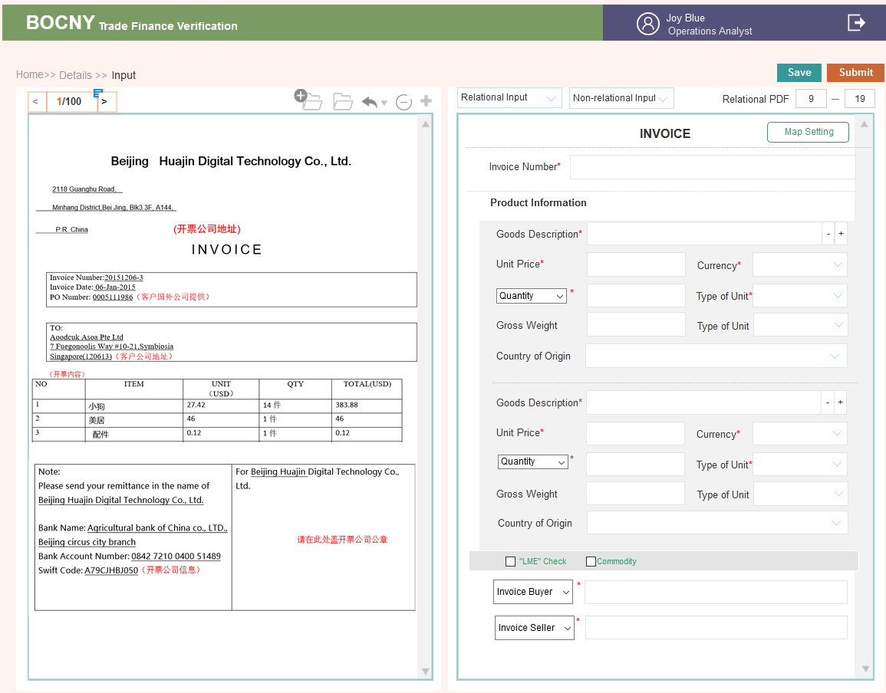

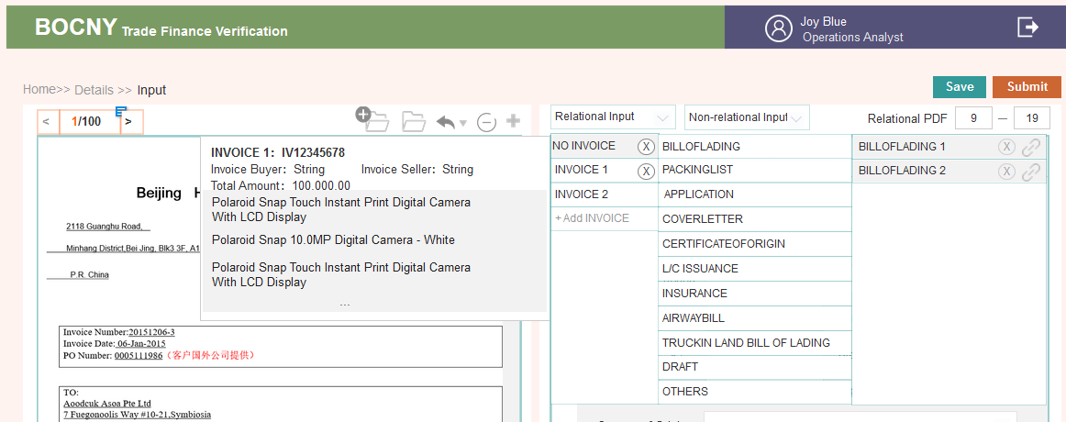

* Input page cannot be editted

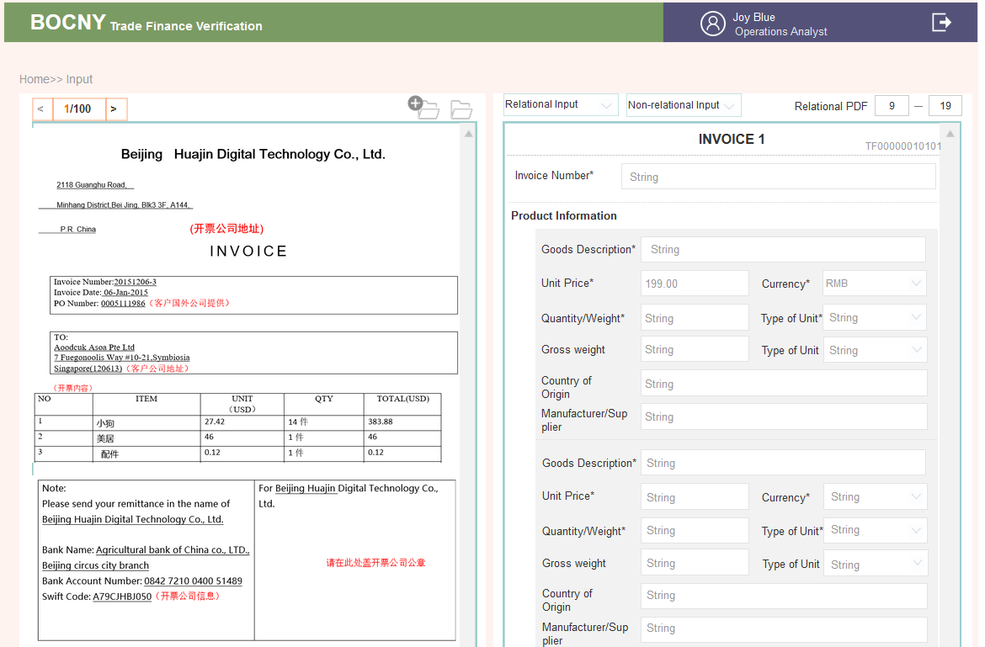

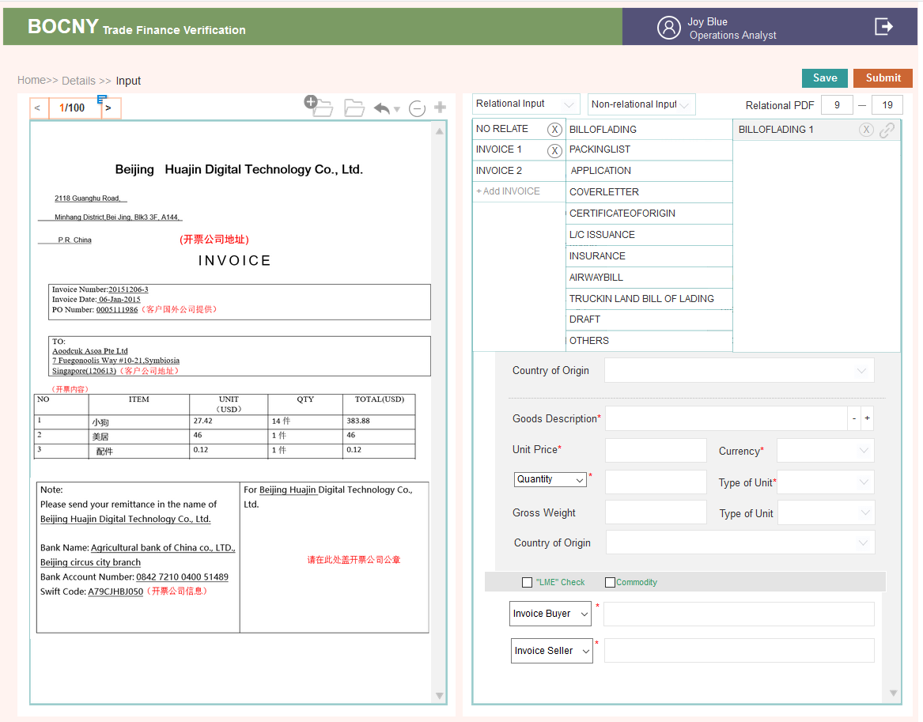

older folder;

Can be editted

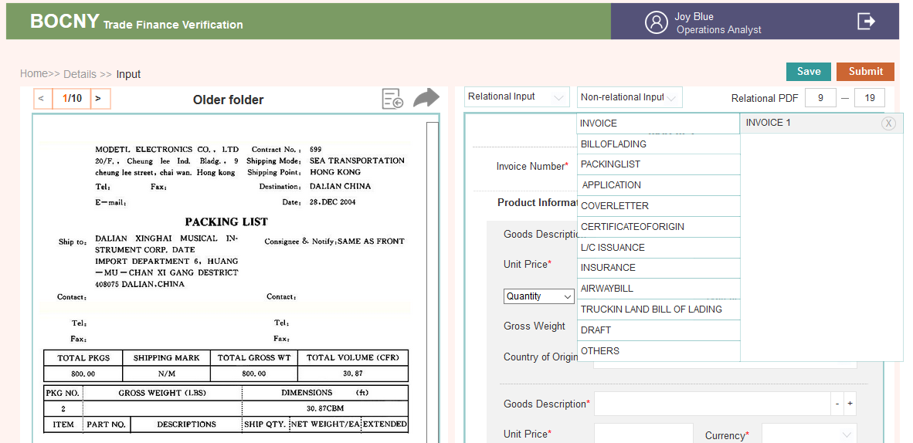

Cannot be editted

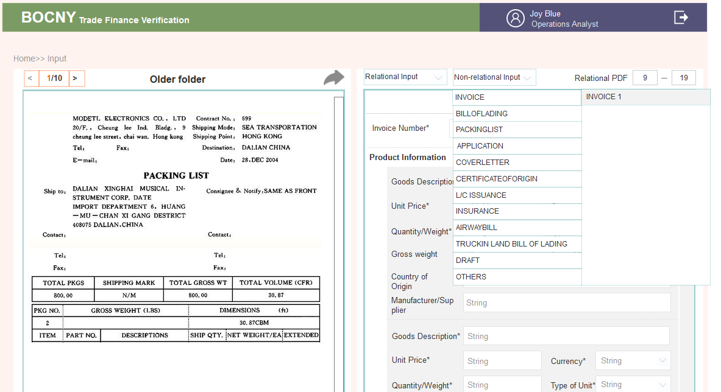

* **Form Style**

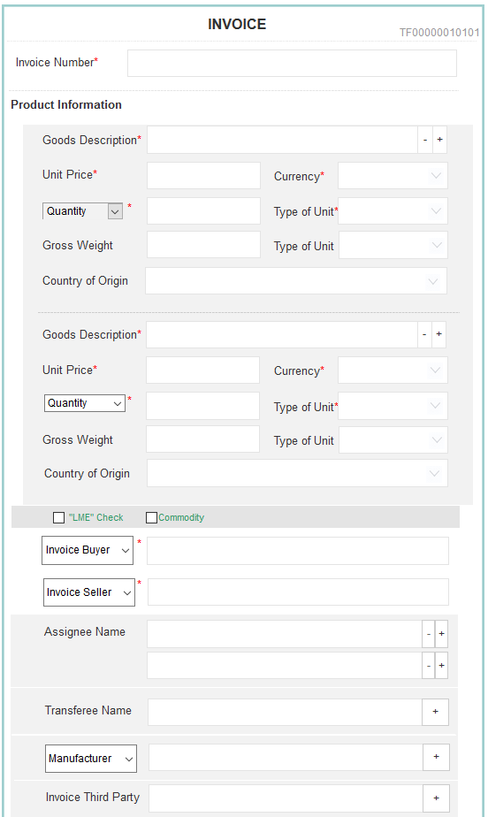

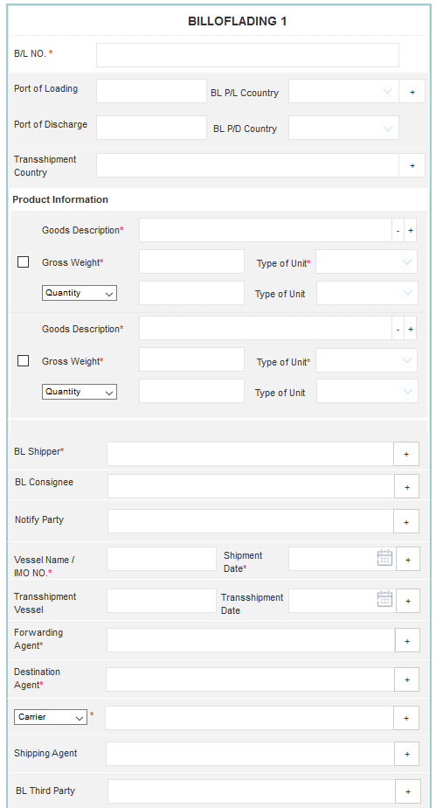

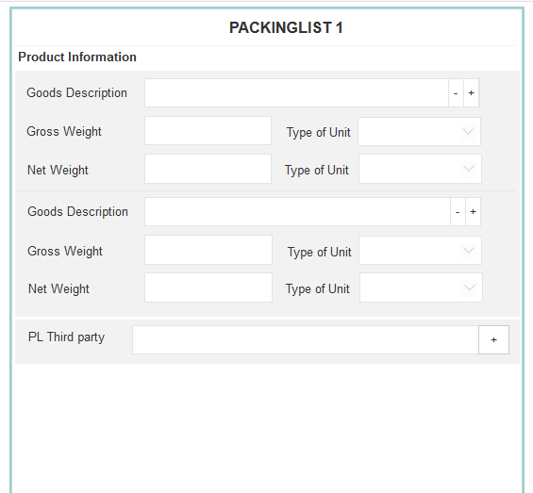

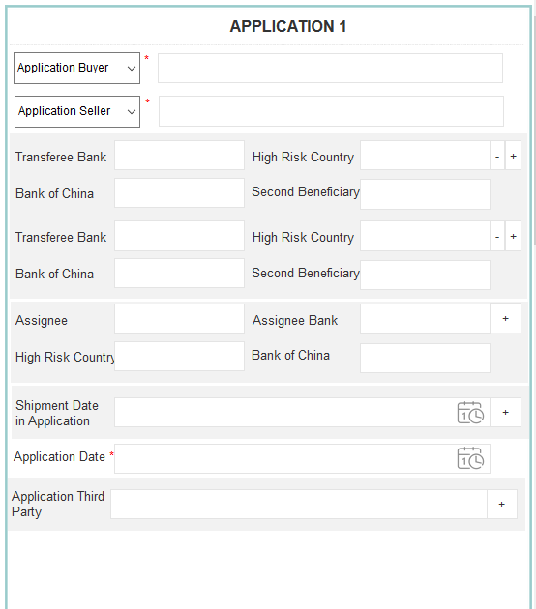

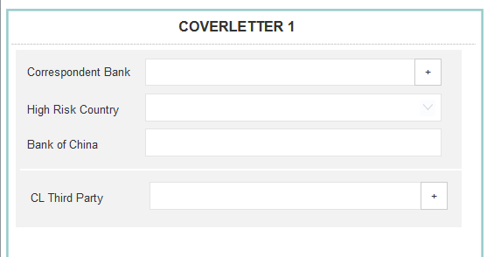

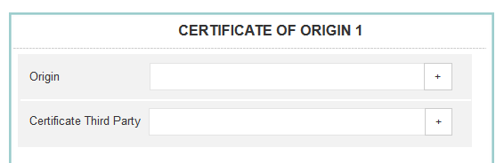

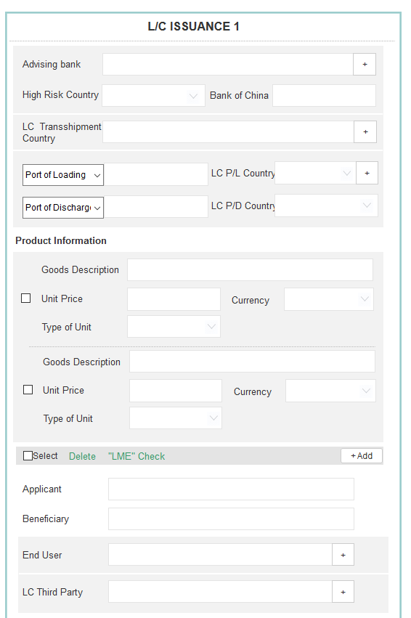

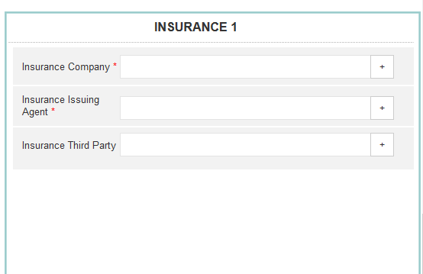

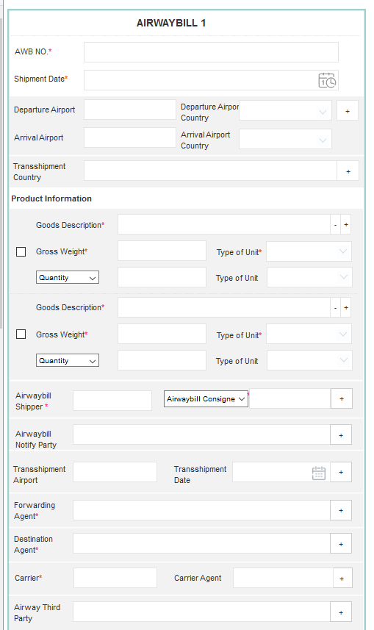

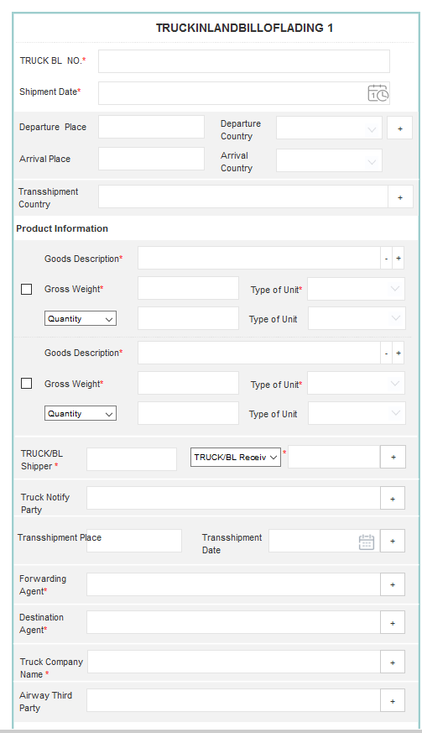

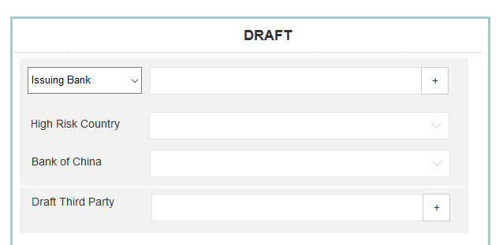

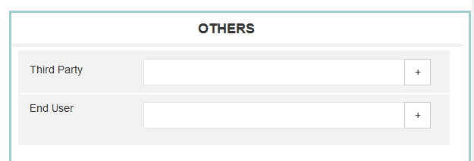

3.2.6 Operations Analyst: Case Questions Check Page

### 1..1. AS-IS

Case verification is to generate the answers to the 35 questions.

On the left-hand side of the interface, it will still show the preview of the case. On the right-hand side of the interface, system will display all 35 questions page by page. For questions that have the automatic logic check, system will answer the question automatically and display relevant evidence if the question has designed to display evidence. For semi-automatic questions, system will only display evidence for operations to answer the question accordingly.

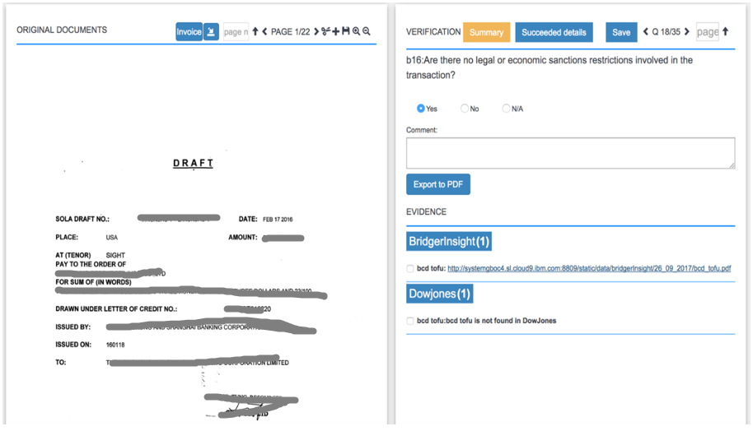

As shown in picture question “a1” is listed on the upper right-hand side, this question will be answered by the system automatically. There are 23 questions which could be answered by the system automatically/semi-automatically. For any incorrect answers, the Operations Analyst could also modify the answer manually. For the other 12 manually answered questions, the system will be answered manually by Operations Analysts. (Note that the logic of all 35 questions is as reference in the appendix.)

After all the entity fields in all pages have been filled in, the Operations Analyst can click “START CHECKING” button to start the checking process. Then the system will automatically return to the [ page and the case status under “Status” column will change to “Verification Running”. Once verification running completed, the case status will change to “Verification Success”, then “Check” button will be shown under “Actions” column, the Operations Analyst can click on the “Actions” button to check the results of the case.

3.2.6.1. Brief introduction to function



3.2.6.2. Detailed description

* **Click Check on the detailed page and list page**

1. If data is not changed, then the submitted result is displayed directly

2. If data is changed, when clicking Submit or Input, one needs to re-request the change through the API (INPUT’s SUBMIT button will lead to re-requesting as well)

* **PDF on the left**

1. Match

Through the INPUT page, it is the final PDF after INPUT is adjusted to click save&submit. Notice that after the INPUT page is modified, it should be adjusted in time to ensure the matching of data on both sides.

2. Function Plugin

The PDF of this page can no longer be modified. Only the left upper corner switch is reserved, and the scroll bar on the right is rolled back:

Amplification, reduction and reduction of PDF function

* **35 questions on the right side**

**1. Page turn**

The system will display all 35 problems page by page, and the problem can be turned over in the upper left corner. After clicking the document, there are 35 questions drop-down box, which allow for quickly switching to the corresponding problem.

**2. Questions title**

Refer to the Appendix

**3. Answers to the questions**

Answers returned from graphen

8 answers are automatically generated; 15.5 answers are semi-automatically generaated; there may be some results returned;12 answers are answered by person. The answers are divided into three kinds: Yes, no, no know. (YES\NO\N/A)

**4. Comment,** 1000 characters at most，Each question is accompanied by a comment for notes.

The answer is N/A, and the system will extract some COMMENT copies, and automatically display them in the comment form. See the attached table in detail. The 5. answer to the system is whether yer or no and can be manually modified.

|  |  |  |
| --- | --- | --- |
| Answer method | Number | Question Seq No |
| Automatic | 8 | a1, b3, b5, b6, b8, b9, b17, b20 |
| Semi-Automatic | 15 | a2, b1, b2, b4, b7, b11, b15, b16, b18, b21, b22, b23, b24, b25, b29 |
| Manually answered by Operations | 12 | b10, b12, b13, b14, b19, b26, b27, b28, b30, c1, c2, d1 |

* **Evidence on the right**

1.when switching 35 problems, the corresponding evidence will follow. This page question is one-to-one correspondence with evidence. Some problems are accompanied by evidence, while others do not contain evidence.

2.users can add or delete evidence on their own

3. pay attention to the distinction between automatically obtained evidence from the system and the evidence added by users.

The details are shown in the following evidence module

* **Save& Submit**

1. Save is to preserve the current change

2. Submit will generate a result: 35 questions, questions answered by no will be colored in red; questions with evidence not found will be colored in red as well

3. If the 35 questions are not answered completely, the Submit button can not be clicked.

* **The INPUT page has been modified to re click the Submit page**

1. if the INPUT page is modified, then SUBMIT requests the third party API again, which will cause the content to change.

2. 35 questions YES&NO, is the direct coverage of automatic acquisition.

3. Comment: the manual input will be be overwritten

4. Evidence: Manual uploading is not overwritten. If system uploaded, all replaced to new

* **After sending to OM, the page cannot be edited**

1. After clicking into the check page, the page cannot be edited

2. The right COMMENT fill box is turned into a pure display box. It shows the final answer

3. +New Evidence button, trash cans, check boxes, Edit disappear

4. Save& Submit button disappears

5. Output PDF is operable

3.2.6.3. Interface requirements

* **Check page can be edited**



* **Check page cannot be edited**

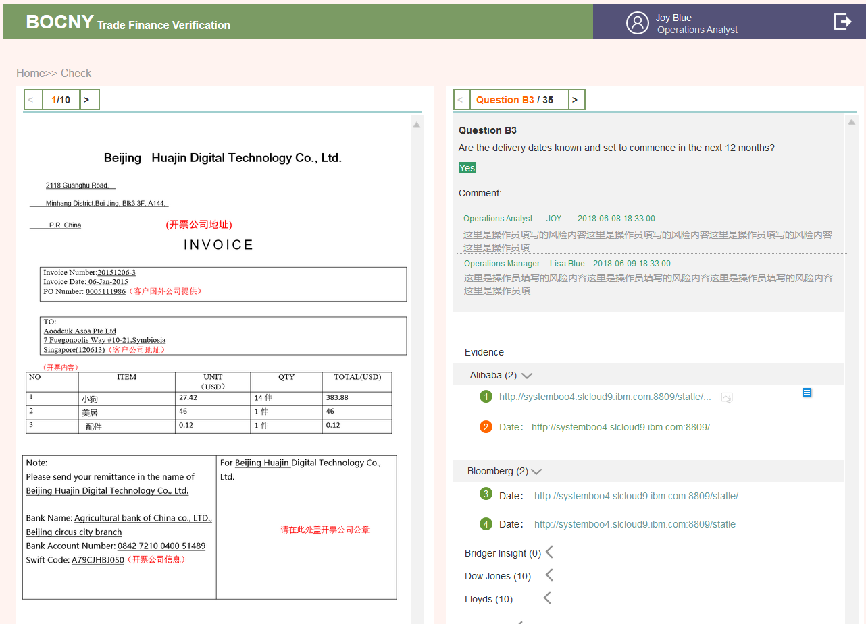

3.2.7 Operations Analyst: Evidence Management Page

### 1..1. AS-IS

In the “EVIDENCE” field, if there is any evidence available, the evidence will be shown and divided into different vendor categories including “Bridger Insight”, “Dow Jones”, “Alibaba”, “Bloomberg”, “Lloyds” and Logic result from T24 DB based on each question’s logic and requirement. The evidence will be shown as the query name followed by the PDF link. The evidence and evidence PDF for each domain is listed as follows:

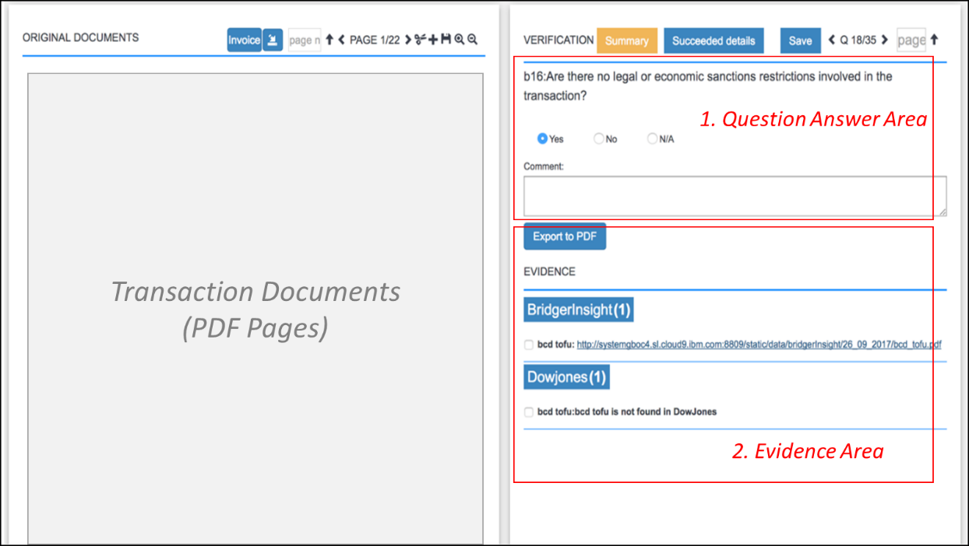

When the user clicks the “Evidence management” button, a popup window for evidence management will appear. All original evidence can be downloaded and exported when the user clicks the “Download” button.

If the user wants to upload subfolder evidence, Operations Analyst could use “upload folder” shown to upload the zip folder.

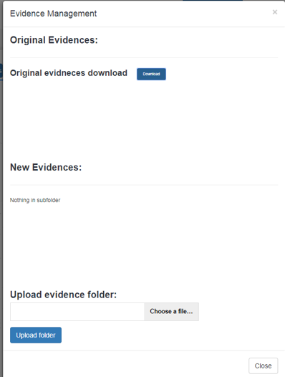 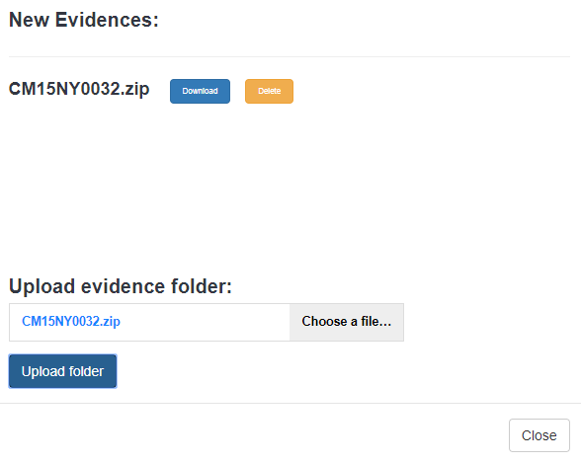

If the query is not found in certain domain, then the system will list the query name, followed by “XXX is not found in XXX”. (e.g., XYZ is not found in Bloomberg.) When the evidence is incorrect, the Operations Analyst could delete the PDF evidence by clicking “X”. If “ $↑$” button is clicked, the Operations Analyst could upload the answer evidence to the system using “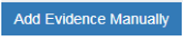” shown in the “Upload New Evidence” popup window, enter the following information to upload additional evidence:

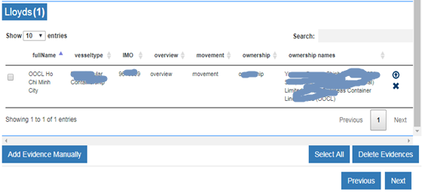

1. Choose an evidence file from the computer to upload.
2. Input Evidence Name
3. Type: select from the drop-down bar including “Alibaba”, “Bridger Insight”, “Dow Jones”, “Lloyds”, “Bloomberg”.
4. Any comments added (imposed onto the artifact) to an uploaded document must be displayed on the document.

After click “Upload” button, the manual evidence will upload to the current question.

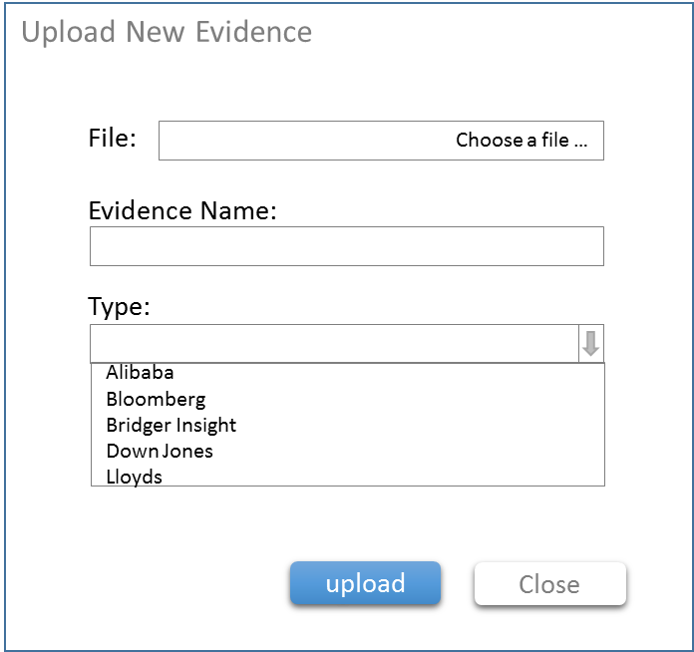

Operations Analyst could click “” to select/unselect all evidence， and batch delete the evidence with“”.

For Bridge Insight evidence，the system obtains the result from Bridge Insight via API. The Operations Analyst is required to input comments if the Bridge Insight RATIONALE OVER 80%. The Operations Analyst could select theevidence, and it will trigger and pop out a window to add comments.

Once the Operations Analyst complete comments input and save, the highlighted comments will appear in left PDF，and a PDF could be created which is including original Bridge insight result and inserted comments. The PDF name should be original name+ identified stamp. The system must allow a PDF file to be upload as evidence manually.

Lloyd’s evidence must be displayed as a table , and the Operations Analyst could click for details with PDF in pop-up window:

Store digital sample for transaction

|  |  |
| --- | --- |
| A2-Anticipated Activity.xlsx |  |
| A2-T24 results |  |
| B1-Invoice&Industry Description |  |
| B2-T24 results |  |
| B2-Transaction amount |  |
| B4-Goods information |  |
| B4-T24 result: Country Name |  |
| B5-Product tolerance max and min |  |
| B6-T24 results |  |
| B6 Invoice Number |  |
| B7 Invoice & Lading Quantity check |  |
| B9 Transaction Amount |  |
| B11 Invoice & Lading Quantity check |  |
| B16 Country List |  |
| B16 Sanction Countries | Two fields:  1. Country Name  2. Abbreviation (two characters) |
| B20 Country List |  |
| B21 Tax Heavens | 1. field：Country Name/Region Name |

### 1..2. Enhancement

1. Evidence management-not organize and categorize

1) Name standard of file which download is Reference No. (e.g. TFxxxxxxxxxx.zip)

2) There are 6 sub-folders under this zip file. (5 API evidence + 1 logic)

1. Evidence file should have naming standard which can contain ownership, movement and vessel information.
2. All evidence should be internally linked: once an evidence is deleted under certain question, the same evidence will automatically disappear under other questions at the same time.
3. If BI rationale is over 80%, Operations Analyst should input comments, otherwise system should alert.
4. Establish database for commodity and unit price，establish database for invoice no.
5. If Dow Jones RATIONALE OVER 80% (manually judge). Operations Analyst could select an evidence, and it will trigger and pop out a window for comment input. Once Operations Analyst complete comments input and save, the highlighted comments will appear in left PDF. The input comment will be added at the end of the PDF. And a PDF could be created which is including original DJ result and input comments. The PDF name should be original name+ identified stamp. The PDF file could upload as evidence via manually.
6. Operations Analyst could select an evidence in Bloomberg/Google, and it will trigger and pop out a window for comment input. Once Operations Analyst complete comments input and save, the highlighted comments will appear in left PDF. The input comment will be added at the end of the PDF. And a PDF could be created which is including original result and input comments. The PDF name should be original name+ identified stamp. The PDF file could upload as evidence via manually.

3.2.7.1. Brief introduction to function

Click the case to view more evidence regarding the case

The evidence obtained from the API and from manual uploading will be shown here



3.2.7.2. Detailed description

**API Method to acquire evidence**

* **source**

1. API interface acquisition: request from T24 or Graphen according to 35 question rules

* **Form of content display**

1.Title

EXCEL title refers to the sample, with .xlsx suffix;

Links are shown

2.There are five channels plus one other. The evidence obtained from which channel is placed under which channel, and those without corresponding channels are placed under other categories. “Alibaba”, “Bridger Insight”, “Dow Jones”, “Lloyds”, “Bloomberg”,“others”

3.the evidence management page shows all the evidence lists of a CASE.

4. all types of display can be carried out

* **related evidence not found or evidence abnormality**

1.If a particular field is not found, the system lists (e.g. XYZ is not found in Bloomberg.) The evidence preceding number is marked in red.

2.Users can manually delete the red evidence. If there is no evidence of standard red, the red logo of the details page will disappear.

3. If Bloomberg has more than 80% of the evidence in one question, there will be an ALERT under the COMMENT box for 35 questions, Hint：”Alert: The BI rationale is over 80%, Please input comments.”

* **Search**

1.provide a search by the name of the evidence

2.search results show source and related evidence Title &comment and so on

3.if there is no result, it shows: "no relevant evidence has been searched, please replace the search condition search".

* **Select all& delete**

1.Before sending to manager, OA can delete the evidence

2.Click the bottom selection box to expand all the evidenc

Click delete to select

3.One can the box on each category’s left to select the evidence in the category; click the trash bin or delete to delete

4.If none is selected, the delete button cannot be clicked

5.If evidence is slected and delete is clicked, a window is popped: “confirm to delete the evidence”. Click confirm to delete the evidence

6.Pay attention to the mapping relationship: the delete operation at one place will affect others’ positions. The pages of other roles who have the permission to view the evidence will be affected as well

* **Download**

1.Click download to download all the evidence

2.The name of the zip file is the Reference No. when case is uploaded plus.zip

(e.g. TFxxxxxxxxxx.zip)

3.The zip file has 6 folders（5 methods +1 others）

* **Permission**

Refer to 3.2.1.2 permission configuration table

**Upload evidence manually**

1.Click + New Evidence to select evidence on the desktop; after selection, jump to the evidence uploading page

The progress bar is shown; check to complete the process

2.The default title is the name of the file on the desktop and can be edited

A title can have 300 characters at most

3.There is a COMMETNS section, which is not required, 1000 characters at most; if filled, the texts are displayed under the evidence

4.If the evidence is added to the check page and under which question, the sequence number of the problem is transferred by default. If it is on the evidence management page, the number of the evidence is empty

5.Before submit, the page can be added or deleted

6.There is no text in the document if uploading is not completed; if fields are empty then submit button is not clickable

After sending to OM, the evidence cannot be edited

Except the download function, all other functions no longer can be used

7.Store digital sample for transaction, refer to the sample evidence for explanation on the 35 questions

3.2.7.3. Interface requirements

* **Evidence page that can be edited**

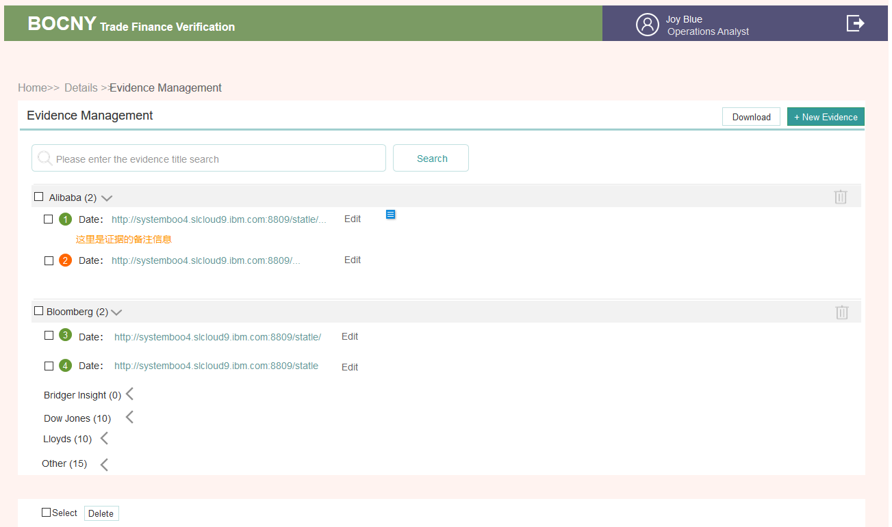

* **Evidence page cannot be edited**

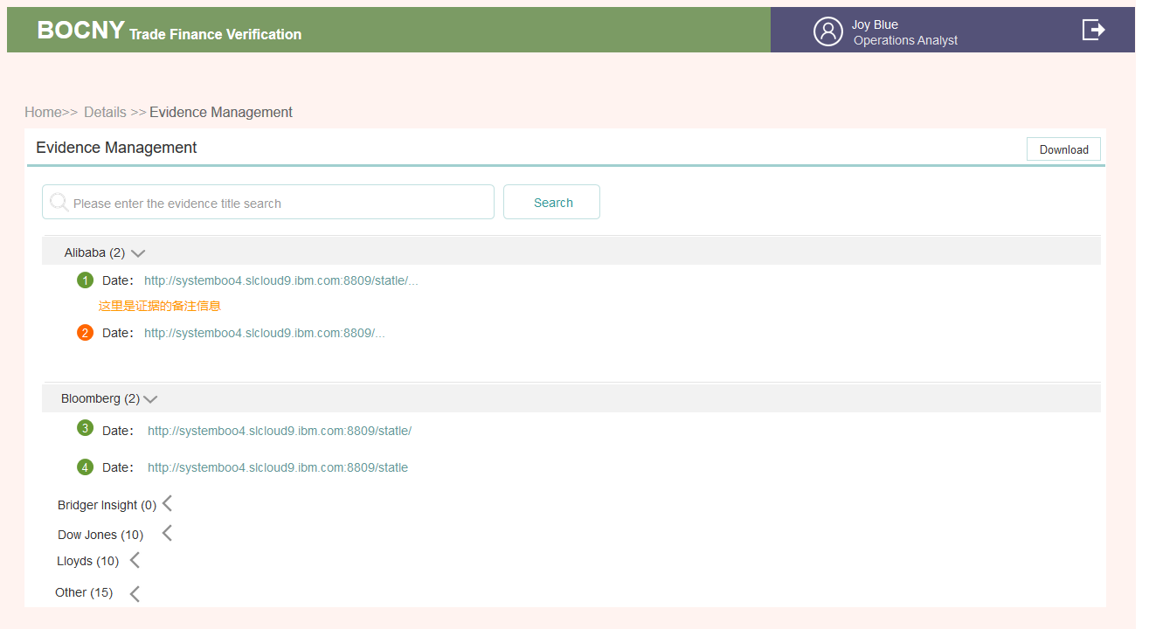

* **Upload page**

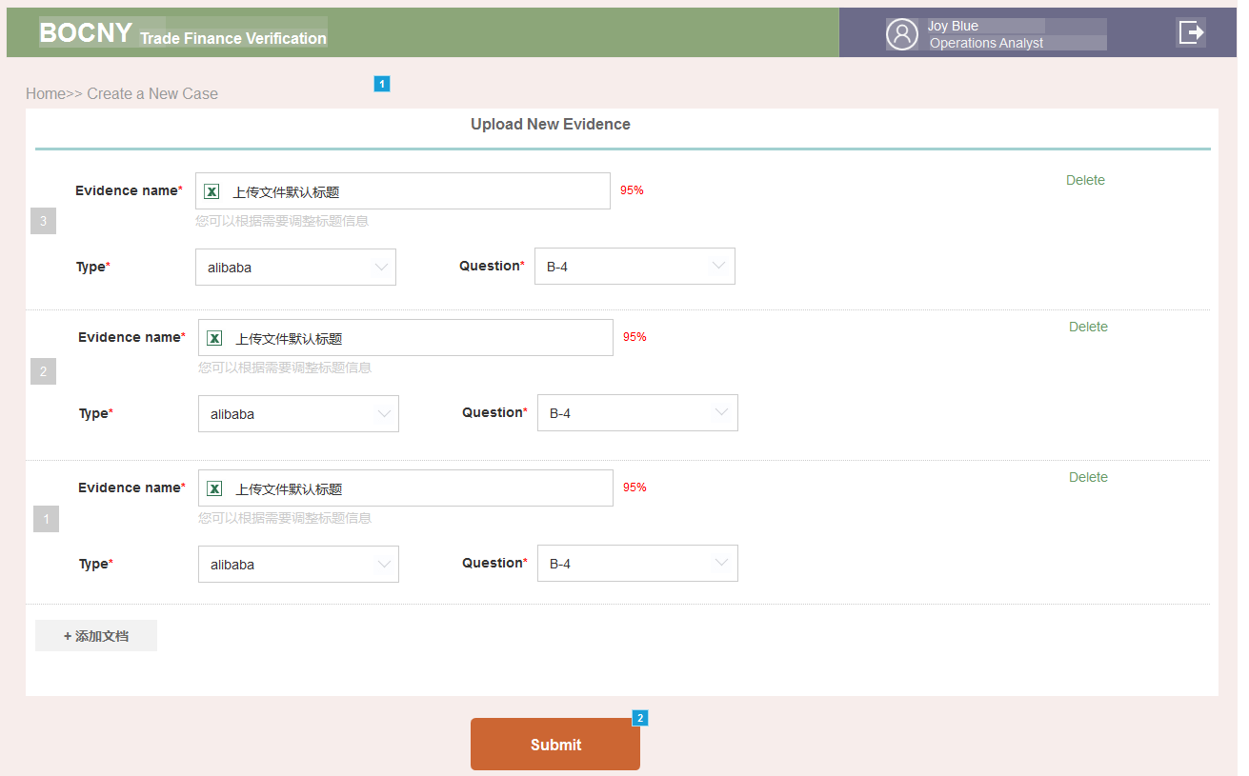

3.2.8 Operations Analyst: Details

3.2.8.1. Brief introduction to function

There are three parts: User basic information; INPUT entry forms; 35 questions and evidence, and the corresponding operation button. In different states, the content button varies



3.2.8.2. Detailed description

* **Fields**

|  |  |  |  |
| --- | --- | --- | --- |
| # | ITEM | Source | Content |
| 1 | Status | Depends on the status list | * Pending Operations Analyst Review * Under Operations Analyst modify |
| 2 | Account basic information | Sourced from the fields when a case is created | * Case ID * Total Amount * Pages * Clint Name * Reference No. * Boc Reference * Clint ID * Created Date * Modifled Date * Operator |
| 3 | Button the top right | Varies according to the users’ operation progress | * Send to Manager * 1#TRM * 2# SAF * 6# EDD Form * 10# Case by Case * FILE Management * Modify the case |
| 4 | Documens Verification | On the input page, after the form is imported and Save&Submut is clicked, this section appears | * Form type * Category * API confirmation success& failure * Summary of the core fields of the form |
| 5 | Documens Verification operation plugin | Edit is shown only when there is some content  Unfold is shown only when there are more than 2 lines | * Input * Edit * Unfold |
|  | Checking&Evidence  >>Commetns | Comments are shown here | * Writer * Role * Time * Question number * Commets content |
|  | Evidence and results to the 35 questions | Answering NO's Question and finding the Evidence of the corresponding field will be marked by the exclamation mark. | * Question number * Questions or evidence is marked by “dangerous” |
|  | Checking & Evidence operation plug in on the top right | Depends on the status | * Evidence Management * Check |

* **Basic information**

1. After the CASE is created and part of the content is wrong, one can click Modify to edit the case. All fields can be adjusted.

2. Before sending to Manager, the form can be edited; after edition, the details page of client account will be changed accordingly

3. If rejected, the form can be edited; after edition the details page of client account will be changed accordingly

If rejected and reasons are given, the reasons are shown below the account information; the latest comment will be shown; click see more to view the history

To ensure consistency, all actions altering into another role will have a COMMENT field, not required. The account of the role will be selected at the same time.

Every submission will be recorded by the log

* **Documens Verification**

1. Situation： after the form is completed and filled after clicking SAVE or Submit, it is shown under the Documens Verification. If not completed or not submitted, the status is Verification Pending. After submit is clicked, the system will verify the forms one by one. Priority: first the system compares invoices, second compares bill of lading, and then compares packing list.

2. Order: the lastest will be shown in the front; if more than 2 lines, there is a button to unfold

3. Field: show the type of the certificate: serial number; the classification of documents; the verification of documents; the core field of a document; select several displays.

4. There are 2 ways to display

1）Batch display

A. display according to the relationship between documents and invoices; titles on the top right

All the forms have the format：caseID+Doc Type+ID。DOC TYPE starts from 01, which is the same as numbering

B. Displays the total number of files in the package, number of success and number of failure

C. If there is no correlation with the invoice then it is placed in the NO INVOICE package, NO INVOICE will not be verified.

D. Click on the file to see all the files under the package. Under the invoice package, one can see which fields have been verified and which have been abnormal.

2）tile display

Move the cursor, then a dropdown button will appear, click to delete&move, delete the pop-up pop-up window, allowing users to confirm whether to delete the mobile, one can move from invoice 1 to the invoice 2 package.

6. search: clicking search will automatically switch to the tile display, screening a certain type of documents, such as Bill of lading.

* **Checking & Evidence**

After click SUBMIT on the Check page, the result is shown

* Comments in red is shown here
* Only NO is colored in red
* Click Check to jump to the Check page, click Evidence Management to jump to the evidence management page
* **Prepare the form**

Prepare the corresponding form according to the situation, the form is explained, and the following is in another description.

* **After preparation**
* Click Send to Manager to send to OM
* A window is popped showing the roles in the branch of the OM to select
* After the first-time selection, the default person is changed to this person; if rejected, the default is to display the OAon.of lading.ether
* COMMENTS can be filled, at most 1000 characters, not required
* When the process goes to the next person, it will send an email to the next person.
* **File management**

1. After check, a file entry is shown

2. The corresponding documents can be classified and packed according to the documents

|  |  |  |
| --- | --- | --- |
| Files 1-level package  Name | Files 2-level package | Source |
| Evidence | Company Info | Bloomberg API |
| OFAC | T24 |
| Dow Jones | 35 questions with data from Dow Jones |
| Google Strings | 35 questions with data from Google |
| Price | Alibaba |
| Lloyds | 35 questions with data from Lloyds |
| Logic | 35 questions with evidence in EXCEL |
| Form |  | 1#, 2#, 10#, EDD Forms |
| Transaction documents | invoice&no invoice 2-level package, 3-level under the invoice | The PDF file uploaded on the left side of INPUT page can be downloaded from PDF. Notice that it is the result of final adjustment. |
| SubFolders | Export L/C (for export only) | PDF subfolder on the input page |
| Due Diligence checklist | Manual uploading |
| Old Documents | Deleted PDF |
| Customer Correspondence/Info | Manual uploading |
| Issuing bank correspondnece | Manual uploading |
| Payment | Manual uploading |
| Others | Manual uploading |
| Compliance |  | #3, #4, #5 in all the form |

1. SubFolders: there is an upload button on the right to upload files to the corresponding package.

2. Download: click download to download the selected file according to the above package, the whole package name is

FILE Management_ Case ID

* **修改**

详情页点击日志，可以查看日志的变化。分为5种日志类型

1. Forms,如果那10张表格在点击SUBMIT后发生了变化，就会产生一条日志，显示之前表单中的内容和之后表单中的内容。详情页显示文案【修改了Forms】

2. Input规则通Forms。详情页显示文案【修改了Input】

3. 35个问题，如果改变了答案 ，点击SUBMIT后，就会产生一条日志记录，显示之前的答案以及新改的答。详情页显示文案【调整了35个问题答案】

4. 证据，如果上传或删除了证据，则产生一条日志记录。文案【删除了证据”这里显示标题“】【增加了证据”这里显示标题“】详情页显示文案【调整了证据】

5. 流程日志

比如Send to Manager这样的流程日志会直接在日志列表中显示，不需要再点进详情页查看。详情页显示文案就直接是【Send to Manager】这种

|  |  |  |  |  |  |
| --- | --- | --- | --- | --- | --- |
| 时间 | 状态 | 操作角色 | 操作人 | 日志类型 | 日志 |
| 2017/10/03 9:00:00 | Under Operations Analyst Review | Operations Manager | Lisa Blue | Forms | details |
| 2017/10/03 9:00:00 | Under Operations Analyst Review | Operations Manager | Lisa Blue | Input | details |
| 2017/10/02 9:00:00 | Under Operations Analyst Review | Operations Analyst | Joy Blue | 35Q | details |
| 2017/10/02 9:00:00 | Under Operations Analyst Review | Operations Analyst | Joy Blue | Evidence | details |
| 2017/10/03 9:00:00 | Under Operations Analyst Review | Operations Manager | Lisa Blue | Action | Send to manager |

|  |  |  |
| --- | --- | --- |
| 字段 | 修改前 | 修改后 |
| Description |  |  |

|  |  |  |
| --- | --- | --- |
| 问题序号 | 修改前 | 修改后 |
| A1 |  |  |

|  |  |
| --- | --- |
| Type | Evidence |
| Google/Bloomberg | 删除了证据 “我是证据名称” |
| Alibaba | 增加了证据 “我是证据名称” |

* **Appendix: the status after each operation**

| Step | Operation | Location | Type | Content |
| --- | --- | --- | --- | --- |
| 1A | Click submit to create a case | To Do List | Button | Input |
| Details>>Account information | Status | Under Operations Analyst Review |
| Content | Basic information of clients |
| Button | * Modify the case * Send to Manager |
| Details>> Documens Verification | Content | Blank |
| Button | Input |
| Details>> Checking & Evidence>> Comments | Button | Blank |
| Details>> Checking & Evidence>>Alert notation | Content | Blank |
| Button | * Evidence Management(grey) * Check(grey) |
| 1B | Edit Case | Same as above | Same as above | Same as above  (if customer information changes, then it changes, other information unchanged) |
| 2 | Input PDF: click Submit | To Do List | Button | Check |
| Details>>Client information | Status | Same as above |
| Content | Same as above |
| Button | Same as above |
| Details>> Documens Verification | Content | 【修改】在INPUT页点击SAVE时就会出现在这里了，点击SUBMINT，能验证的会出验证结果。显示有几条验证通过，有几条验证没通过。没结果就横杆显示 |
| Button | * Delete (delete the input document) * move a document to be associated with an invoice * Input (the default is to jump to the first PDF on the INPUT page) |
| Details>> Checking & Evidence>> Comments | Content | Same as above |
| Details>> Checking & Evidence>> Alert notation | Content | Same as above |
| Button | Evidence Management  Check |
| 3 | Check (ask API& to answer 35 questions & collate evidence) and click Submit | To Do List | Button | Details |
| Details>>Client information | Status | Same as above |
| Content | Same as above |
| Button | * Send to Manager（select a specific person and a note） * 1#TRM * 2#SAF * # EDD Form (this needs to be filled out before there will be a number; if not filled the source of # 6 ~ 9 is not known) * Case by case form * File management * Modify the case |
| Details>> Documens Verification | Content | 【修改】The result of verification. shows：there are several successes, and several failures |
| Button | * Edit * Input（This page will mark the abnormal color mark when check is clicked） |
| Details>> Checking & Evidence>> Comments | Content | * Comments in red is shown here * Those with NO is colored in red(if evidence is added by a person, then the red NO label disappears) |
| Details>> Checking & Evidence>>Alert notation | Content | Included |
| Button | Evidence Management  Check |
| 4A | directly send INPUT to OM review. | Details>> Checking & Evidence>> Comments | Same as 4D | Same as 4D |
| 4B | Create 1#Summary | Details | Same as 3 | Same as 3 |
| 4C | Create 2#SAF (determine if needed) | Details | Same as 3 | Same as 3 |
| 4D | Send a case to OM | Pending List | Button | Details |
| Details>>Account information | Status | Pending Operations Manager review |
| Content | Included |
| Button | All Forms  FILE Management |
| Details>> Documens Verification | Content | Included |
| Button | Details【prototype：after input is sent to OM】  1. input pages no longer allowed to edit  2. left page scroll bar to zoom in and restore function.  3. no more edit additions and deletions are allowed in the right form.  4. the drop-down box just clicks out the corresponding page, clicks out empty pages, adds invoices, and moves the classification function away.  5. Save&Submit button disappears |
| Details>> Checking & Evidence>> Comments | Content | If it has content then shown |
| Details>> Checking & Evidence>>Alert Notation | Content | Same as before |
| Button | * Check [prototype: Check (after OM)]   1. Check pages no longer allowed to edit  2. the right COMMENT fill box is turned into a pure display box. The answer to the answer shows the final answer  3. the +New Evidence button, trash can, check box, Edit disappear.  4. Save& Submit butto   * Evidence Management   In addition to the PDF package download function, other new, deleted, and check controls disappear. |
| 5A\7A | Process the case rejected by OM | Status | Status | Under Operations Analyst Modify |
| Same as 3 | Same as 3 | Change to the state before sending OM   * OM may be processed (add evidence). It should be displayed synchronously. * OM generally will fill in the reply opinions at ALL Forms, and will synchronize. ALL Forms there can be answered * All controls have a ALL Forms control |
| 5B | Send the case after Recheck to OM | Status | Status | Pending Operations Manager review |
| Same as 4D | Same as 4D | Pay attention to the change synchronization after the content adjustment |



3.2.8.3. Interface requirements

* **Form style with no content**

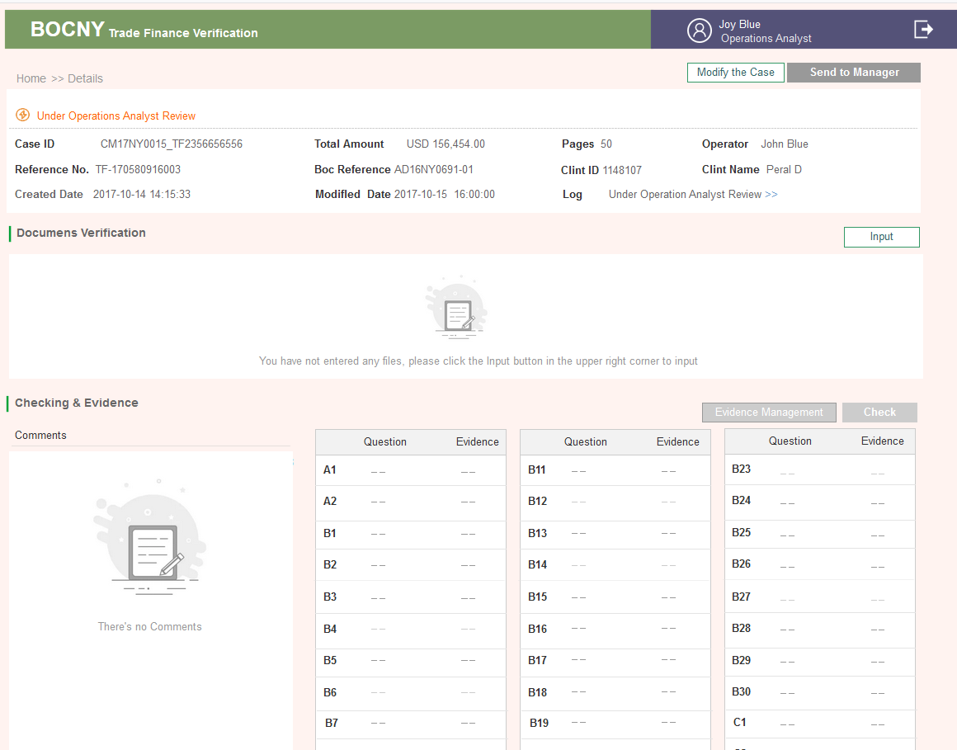

* **Form style with content**

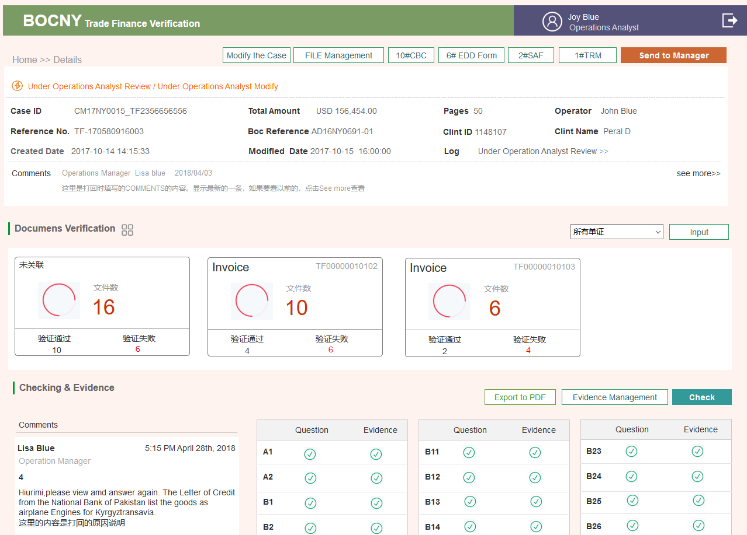

3.2.9 All Forms

### 1..1. AS-IS

After clicking the “Summary” button, the popup window “Case Summary” will summary the overview answer of the entire 35 questions.

Basically, the window will summarize the following editable information

1. Client ID
2. Client Name
3. Reference No
4. BOC Reference
5. Type
6. Total Amount
7. Remark which is editable

Summarization of answer and comments in each question where the comments are editable and will show in the final report

Each question’s comments will keep 85 bytes length for user key in.

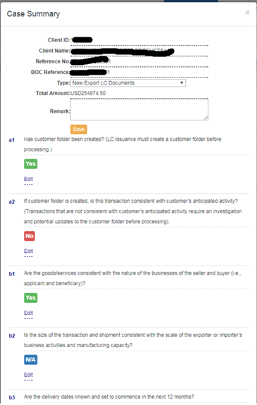

After the Operations Analyst reviews all the questions, he\she could click the “Export to PDF” button to export the final report. Without go to the summary page, the Operations Analyst could also click “Export to PDF” button in any question answer page to generate the report any time.” Export to PDF” is available after ALL questions are answered. An alert will note Operations Analyst which questions have not been answered yet in a pop up window.

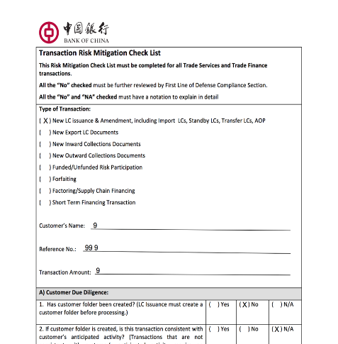

### 1..2. Enhancement

* Alert before quit summary page without saving content.
* In the interface of Case Summary, information of the case (such as client ID, client name, reference no. and so on) can be modified and the system doesn't start or ask the Operations Analyst to recheck the case using new information.
* For stringency of the whole due diligence process, such information should ONLY be allowed to modify before checking begins, and once such information modified, re-checking of the whole case should automatically start.
* Show user name (*name*) and action date for Operations Analyst & Operations Manager. Operations Analyst *name* once form #1 is submitted, operations manager *name*  click “**approve”** for no red flag section，click “**refer to”** for red flag section）

3.2.9.1. Brief introduction to function

There are currently 6 tables + 1 EDD table; there are 2 styles;

One is create & modified style (single form);

One is to review and reply to the style of the opinion (After send to manager, the All Forms button will appear, one can click the view & download, add tags, switch to view as the number of forms increases.)

Only the new form creater can modify the form

Different roles can create, reply, or browse based on their permissions

3.2.9.2. Detailed description

* **Permission to process the forms**

|  |  |  |  |  |  |  |  |
| --- | --- | --- | --- | --- | --- | --- | --- |
|  | EDD | #1 | #2 | #3 | #4 | #5 | #10 |
| OA | Create &  Revise and reply after rejected back | Create &  Revise and reply after rejected back | Create(Label by red)&  reply after rejected back | Cannot browse | Cannot browse | Cannot browse | create |
| OM | reply; reply after rejected back | reply; reply after rejected back | Reply(label as red); reply after rejected back | Cannot browse | Cannot browse | Cannot browse | reply |
| CA | reply | browse | reply | create& Revise and reply after rejected back | create& Revise and reply after rejected back | Cannot browse | reply |
| CS | reply | browse | reply | reply; reply after rejected back | reply | Cannot browse | reply +add content |
| BSA | browse | browse | browse | browse | reply | reply | reply |
| LCD | browse | browse | reply | browse | browse | browse | browse |

These are the default permissions; one can adjust the browse & reply permissions in role management

* **Create fields**

See the description of the form field below

* **Export PDF**

1.Afer clicking submit, all forms button appears; the page can be used to export PDF

2.Refer to 3.6 for PDF form

3.The signer takes the name of the corresponding handler according to the corresponding role. Time records the time after the role clicks Submit

4.In the middle of the signature column, the name is derived from comment if any

* **Reply fields**

1. Progress bar

* One can see it in the reply box at the bottom of the page one browses
* Status: there are 3 colors for small squares to be processed: pending, completed, rejected
* The corresponding state is displayed under the small square - the handler. The copywriting can correspond to the state table
* Time records the time after the role clicks Submit
* Switch, one can see each rolehe role clicks Submitll square - the handler. The copy

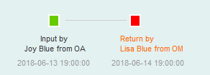

1. Processing opinion

* This line shows the current processor
* If there is a processing conclusion field, the processing conclusion is displayed

1. Comments

If none, then no text is displayed

Workflow Detail

List presentation, theoretically corresponding to that little square

* **#6~#9 Enhanced Due Diligence（EDD form）**

In the details page of the OA role, click EDD Form to call up the relevant page.

1. Upload the EDD client table; 2. Select the EDD type; 3. The program calls out the corresponding EDD template according to the selected EDD type.TSD REFERENCE 100 characters at most

Other forms are self-adaptive, within 1000 characters

A questionnaire containing four industries

* + Shipping
  + Service & Insurance
  + Metals
  + Oil & Gas
* **#1 Transaction Risk Mitigation Check List**

All CASEs have the form

1.The basic information field comes from the creation of CASE

Client ID

Client Name

Reference NO.

BOC Relevance

Total Amount

Type

No modification is allowed on this page. If one wants to modify it, one can only modify CASE. After the modification, the data will change accordingly.

2.35 questions

1) Here's the serial number of 35 questions -- Title & answer -- Coments generated by the system -- manually filled out Commets

2) Editors are allowed to edit, but the editors are skipping to the Check page for editing, and after editing, notice that the information on the bottom of the red label at the bottom of the information &Details page here will change accordingly. Clicking on SAVE or Submit to change

3. Comments

Each problem's COMMENTS will be attached to the problem, and it will be displayed

4. OA

fill in a summary note that summarizes the risk assessment for the entire CASE

Max length is 1000 characters

1) OA Role

A. Create (logo & Comment must be filled) or Submit is not clickable

B. After the return (all editable fields) (logo & Comment must be filled in) or Submit is not clickable

2) OM Role

A. Make comments, edit each question, and commets under each question

B. fill in the general reply (not required)

After the return, continue to comment on the comments

Fill in a reply (not required)

3) Other roles

Permissions are configurable

* **#2 Special Approval Form**

**1. form fields**

|  |  |  |  |
| --- | --- | --- | --- |
| Name of element | Required/optional | Type | Remarks |
| Approval of | Required | Dropdown menu | * Single choice； * If chosen, one needs to specify less than 100 characters |
| Party to be approved | optional | 80 characters at most |  |
| Our Ref. No | Required | 30 characters at most | Default is to get the BOC REFERENCE field filled when the CASE is created |
| Amount | Required | 20 characters at most | Default is to get the Total amount field filled when the CASE is created (monetary unit + amount. 2 bits after a small sum of money) |
| Import/Export | Required | Dropdown menu | Single choice from the dropdown menu |
| From to | Required |  | Address |
| Description of Goods | Required | One is displayed per line, one line is not more than 255 characters. At most no more than 200 lines | Unduplicated item headings from INPUT invoices |
| BOC branch | optional | 80 characters at most | When the CASE is created, the default is made, and the modification is allowed. |
| Red&no red | Required | Single choice | System can judge default selection |
| Comments | optional | 1000 characters at most |  |

Our Ref. No；Amount；Description of Goods；BOC branch these four field systems are taken and allowed to modify

**2. Submit**

Click to create and jump back to details page

**3. Role permission**

OA role

Create&Modify

when the creation is successful, one can export it to PDF

* **#3 Supplementary Notes Page**

1. only CA has the right to create #3

For Non-Productive Case, Productive Case, CS also has the right to judge (retaining the CA's judgment), so this form CA&CS handles the conclusion field

CS makes a Non-Productive Case, Productive Case judgment in the commets reply box

2. a time point, when LCD is hit back

See the CA role description

3. form fields

|  |  |  |  |
| --- | --- | --- | --- |
| *Name of element* | *Required/optional* | *Type* | *Remarks* |
| Clint Name | *Required* | *Retrieve where the case is created* |  |
| Reference No. | *Required* | *Retrieve where the case is created* |  |
| Transaction Risk Mitigation Check List | *Required* | Program classifies | If 35 questions are answered, then click them. Generally speaking, one cannot do this without answering them. |
| Types of Red Flags Identified* | *Required* | *Multiple Checkbox* | * Bridger Insight * High Risk Country * Miscellaneous * Negative News * Price Check |
| Red Flag Analysis | *Required* | Adaptive text box |  |
| Transaction Disposition | *Required* | Checkbox | Non-Productive Case  Productive Case |
| Comments | *optional* | *1000 characters at most* |  |

* **# 4 TSD Case Review Check List**

1. Only CA has the right to create # 4, as shown in the table above

2. a time point, when CS is hit back

See the CA role description

3. form fields

* **CA role**

|  |  |  |  |
| --- | --- | --- | --- |
| Name of element | Required/optional | Type | Remarks |
| TSD Transaction Number | Required | Retrieve | BOC reference & Reference No when the case is created |
| Client Name | Required | Retrieve | When case is created |
| Address | optional | 100 characters at most |  |
| Source of Referral | optional | Multiple Checkbox | * Operations Section identified Red Flag * Discrepancy Compliance Section identified Red Flag * Discrepancy Legal Compliance Department * Other (e.g., 314(b) referral, internal audit referral) Describe   Other items can be manually completed within 100 characters |
| Describe Red Flag/Discrepancy | optional | 1000 characters at most |  |
| Comments | optional | 1000 characters at most |  |

* **CS role**

|  |  |  |  |
| --- | --- | --- | --- |
| Name of element | Required/optional | Type | Remarks |
| Further Action(s) Required | Required | Multiple choice | * Potential OFAC Match-Escalate to LCD * Dow Jones Negative News Match – Escalate to LCD * Follow up vessel movement or transshipment * Additional due diligence on price verification * Seek additional information from account officer * Additional due diligence on transaction details * Resolution of Red Flags (Describe): Other |
| Assigned to |  |  | It is not displayed in the interface. When one exports PDF, one needs to fill in the program by oneself. According to which CA the CS assigns and the allocation time, one can decide which CA to fill in. |
| Referral Conclusion | Required | Single choice | * Transaction Activity Deemed Reasonable (No Further Action At This Time) * No Unusual Activity During the Period the Investigation Covered * Transaction Activity Deemed Inexplicable and Possibly Suspicious |
| Comments | optional | 1000 characters at most |  |

To ensure consistency, both options are placed in the COMMETS column

The form of CS&BSA role has the Processing result field

* **BSA role**

|  |  |  |  |
| --- | --- | --- | --- |
| Name of element | Required/optional | Type | Remarks |
| Approval of Case Disposition | Required | Single choice | * Waive Case – Continue Process Transaction * Further Investigate – Special Due Diligence Report * Reject Transaction |
| Comments | optional | 1000 charaters at most |  |

It should be noted here that the selection of Reject by BSA will cause the state of this CASE to change. See the status table for details.

24B Close Reject

* **#5 Referral Form of Unusual /Suspicious Activities (offline)**

1. When the Reject item is selected in Table 4, #5 will appear (if the modification is made, the #5 entry disappears)
2. BSA has right to create #5
3. Form Field

|  |  |  |  |
| --- | --- | --- | --- |
| Name of element | Required/optional | Type | Remarks |
| Clint Name | Required | System obtain | * Come from CASE |
| Account NO. (if any) | optional | Within 30 characters |  |
| Related Accounts (if any) | optional | Within 30 characters |  |
| Has This Activity Been Reported Before | Required | Within 255 characters |  |
| Dollar Amount of Activity | Required | Currency | 2 bits after a decimal point |
| Date(s) of the Activity | Required | Time plug-in |  |
| Unusual Brief | Required | Multiple choices | Other fileds comment box within 100 characters |
| Comments | optional |  | Filed: PLEASE PROVIDE A BRIEF DESCRIPTION  OF UNUSUAL ACTIVITIES: |

When table 5 completes, the BSA role has an Export button that exports all of these forms to print, and they have an offline process, as shown in 3.2.14 BSA

* **#10 Referral Form of Unusual /Suspicious Activities (offline)**

1. This table appears when you create a CASE and discover that a new customer has been added

2. Form fields

|  |  |  |  |
| --- | --- | --- | --- |
| Name of element | Required/optional | Type | Remarks |
| Date | Required | Time Plugin | Defaults on the day of filling the form |
| Our Ref. No | Required | Within 30 characters | By default to get the BOC REFERENCE field when the CASE is created |
| Type of Transaction | optional | Single choice |  |
| Correspondent Bank ID | Required | Numbers, letters, slopes, crossbars, underscores within 30 characters |  |
| Name | Required |  |  |
| Counterparty's I.D | Required | within 30 characters | Numeric, alphabet recognition space |
| Account with our bank | Required | Single choice | Yes/No |
| Counterparty's Name | Required | within 100 characters |  |
| Contact person | Required | within 60 characters |  |
| Contact phone | Required | within 30 characters |  |
| Amount | Required | Currency |  |
| Customer's Tax I.D. | Required | within 30 characters | Number, letter |
| Customer's US Bank | Required | within 60 characters |  |
| A/C No. | Required | within 30 characters | Number, letter |
| Comments | optional | within 1000 characters |  |

3.2.9.3. Interface requirements

* **#1 Transaction Risk Mitigation Check List**

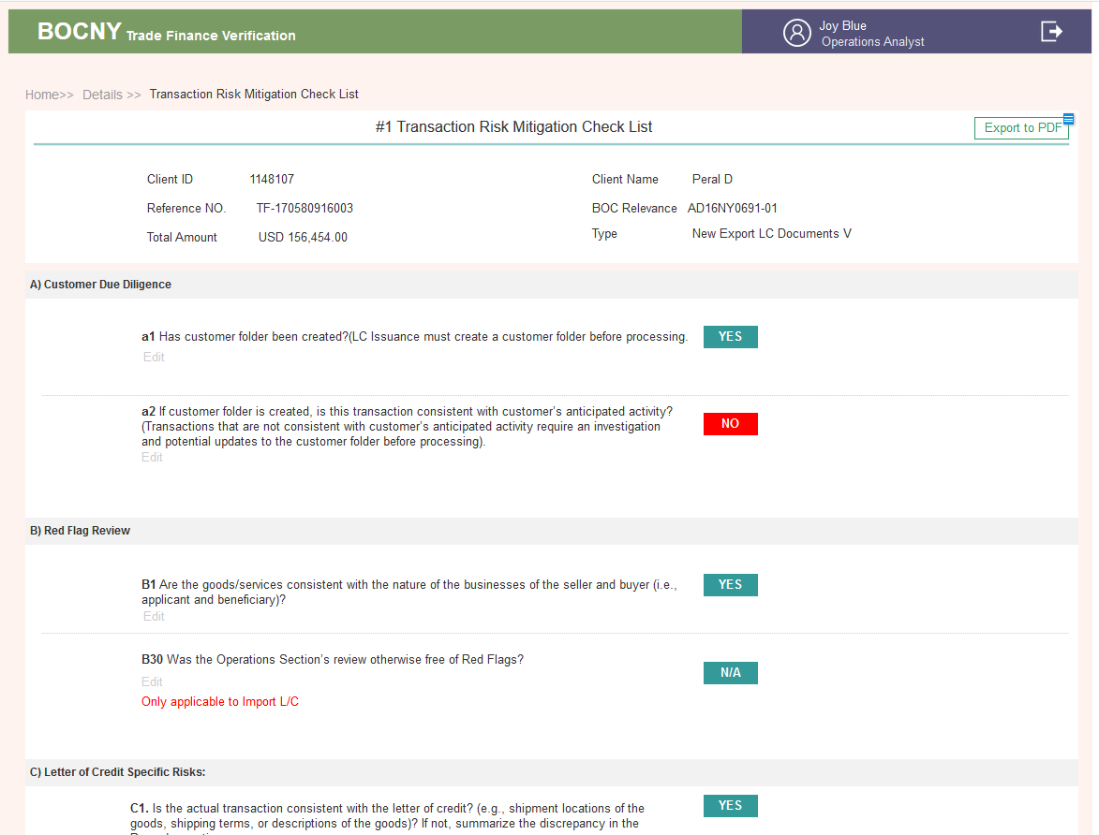

* **#2 Special Approval Form**

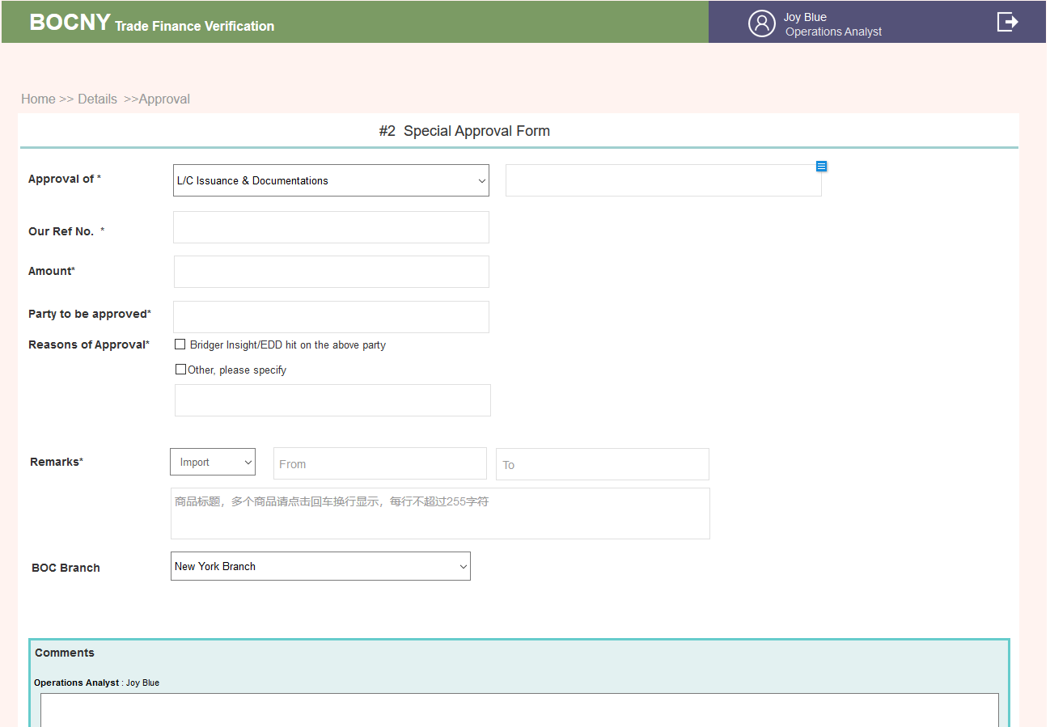

* **#3 Compliance Section Supplementary Notes**

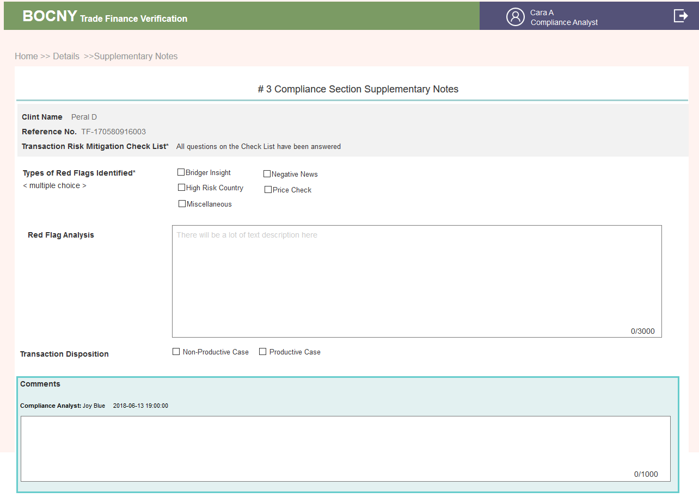

* **#4 TSD Case Review Check List**

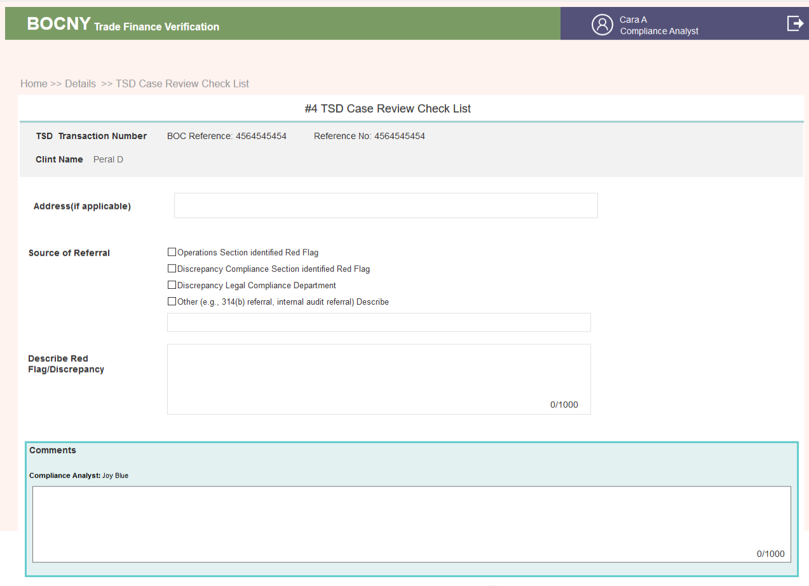

* **#5  Referral Form of Unusual**

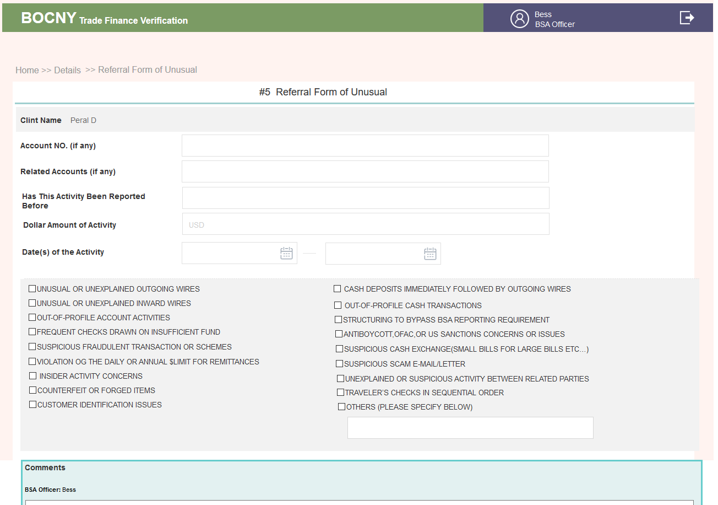

* **#10 Case by Case**

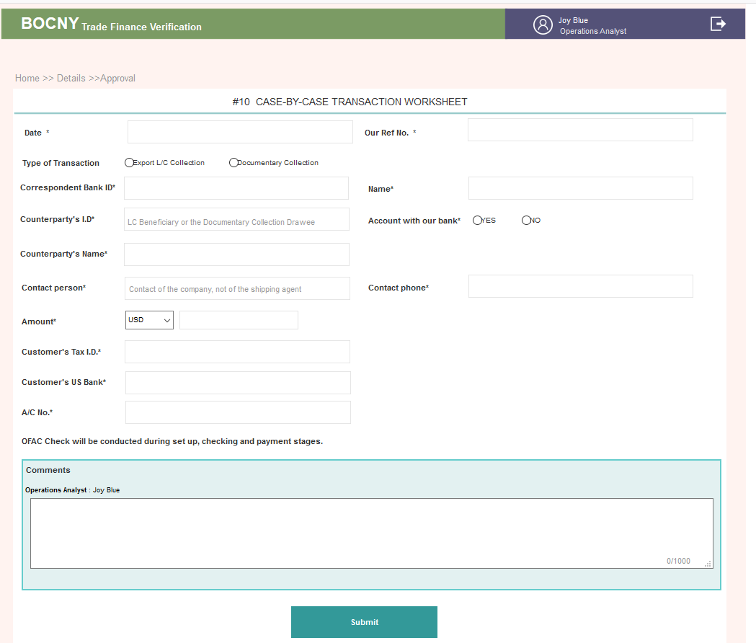

* All Forms

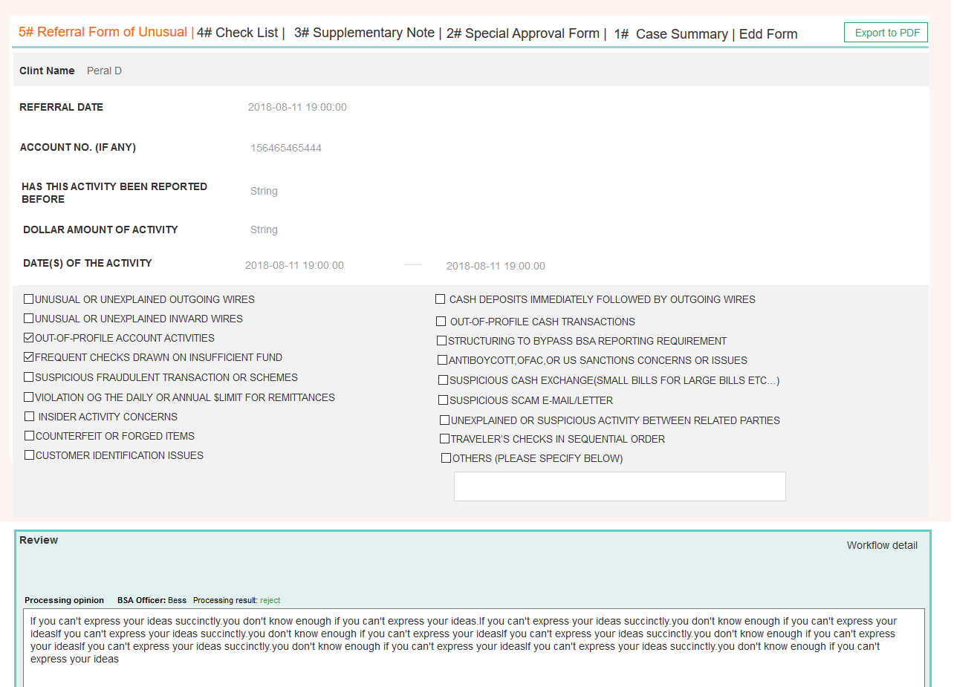

3.2.10 Admin

### 1..1. AS-IS

ID configuration is login integration with Lloyd’s and Dow Jones. BOC Trade Finance system utilizes a cognitive solution and provides a semi-auto platform for case review and verification. The system will automatically use Operations Analyst’s user account to log into several external resources to gather relevant meta-data, and answer the logic questions in the verification procedure. Before cases are created, Operations Analyst needs to finish the ID Configuration step. In the ID configuration login page, the Operations Analyst needs to enter his/her user account information on “Lloyd’s” and “Dow Jones” as well as his/her Bank of China ID (Email).

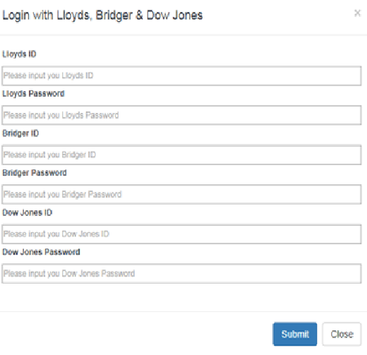

Component in this page：

|  |  |  |  |
| --- | --- | --- | --- |
| # | ITEM | NAME | COMMENTS |
| 1 | Login ID (Dow Jones) | User ID | Mandatory input |
| 2 | Password (Dow Jones) | User PWD | Mandatory input，Context with secret cover “****” |
| 3 | Login ID (Lloyd’s) | User ID | Mandatory input， |
| 4 | Password (Lloyd’s) | User PWD | Mandatory input，Context with secret cover “****” |

Input authorized ID & password of Lloyd’s & Dow Jones， Click “Submit”, you will get the related authorized access synchronously.

After the Operations Analyst clicks the “Submit” button, the system will automatically verify whether the account information is valid in each external resource. The system will display a popup window to notify if the system successfully login to each external resource. If information in a domain is invalid, the popup window will show “Failed” after the related domain’s name. Then the Operations Analyst could click “ID Configuration” again to reenter the account information. If the ID configuration cannot login to any of the external resource, relevant meta-data won’t be able to extract from the resource in the checking stage.

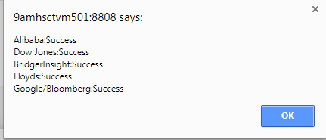

### 1..2. Enhancement

* IF ANY ID CONFIGURATION FAILED, IT SHOULD BE BIG ALERT TO DRAW OUR ATTENTION.

3.2.10.1. Brief introduction to function  
Mainly the management of some common data used by the platform.

3.2.10.2. Detailed description

* **List of sanctions countries**

**1. Search** by country full name or shortening

Search by risk level

Place an overview in the right side of search bar to indicate the number of countries at each risk level.

**2. New method of adding**

choose import or single add

Before the addition is placed, a maximum of 25 pages can be displayed (adjustable, all lists use the adjustable universal page-turning plug-in).

**3. New field rules**

A. search if there are countries maximum of 25 pages can be displayed (adjustable, all

B. if the country exists, system returns the corresponding fileds of the country and alert user that this country already exists. If the user resubmits, it’s like editing function and will cover the previous content.

|  |  |  |  |
| --- | --- | --- | --- |
| Name of element | Required/optional | Type | Remarks |
| Country | Required | Dropdown menu | plugin |
| ISO Alpha-2 | optional | 2-digit value | 2-letter abbreviation |
| ISO Alpha-3 | optional | 3-digit value | 3-letter abbreviation |
| ISO Numeric | optional | 6-digit value | numeric |
| Risk Score | Required | 6-digit value | Allow 2 digits after the decimal point |
| Risk Rank | Required | 6-digit value | numeric |
| Risk Rating | Required | Dropdown menu | 1. High  2. Medium  3. Low  4.HIGH(based on BOC-USA's past experience)  5. MEDIUM(based on BOC-USA's past experience) |

4. For dropdown list in the document that related to sanction country, from here to manage High Risk Country fileds and 35 Questions.

5. Select all, delete: Delete as physical delete

Edit: Single edit, all fields are editable

6. Import

1）If you import the same country name again, it will overwrite the previous country name.

Modify Date in the list is the most up dated time. Iterwrite the previous co

2）If the required fields of the import are not completed, the display exception is displayed. E.g:  
Successfully imported 100 data, 4 (15,19,20,25) failed entries are shown by the serial number on the left side of EXCEL.

* **Common Tax Havens**

1. For B21

2. Can be imported or added individually, can be deleted all

New field rule

|  |  |  |  |
| --- | --- | --- | --- |
| Name of element | Required/optional | Type | Remarks |
| Country /Region Name | Required | Dropdown menu | plugin |
| Source | optional | within 300 characters | It’s mainly the source of the data. The list is not displayed. You can see it when you click edit. |

3. search  
Search by country name or abbreviation

* **Company name suffix list**

1. Apply: Remove the suffix when search by company name B16 & B21

2. Search: Can be found by various variants

3. The abbrevation is without a dot. If the suffix has a dot, then the name is the full name.

4. Add at least one form to add click to confirm adding

* **Top 10 Exports**

1. Apply:　B4

2. Search: Allow entry of country name or abbreviation search

3. New Field Rule

|  |  |  |  |
| --- | --- | --- | --- |
| Name of element | Required/optional | Type | Remarks |
| Country Name | Required | Dropdown menu | Plugin |
| Abbreviation | optional |  |  |
| Link | optional | within 300 characters |  |

* **Customer list of branches**

1. Apply: A1, A2, B1

2. Field

|  |  |  |  |
| --- | --- | --- | --- |
| Name of element | Required/optional | Type | Remarks |
| Customer Name | Required | 80-digit value |  |
| Customer ID | Required | 30-digit value |  |
| Industry/Sector | Required | 80-digit value |  |
| Expected Annual Transaction Volumn | Required | 225-digit text |  |

* **List of third-party websites**

Third-party website account & password settings: When requesting a third-party API to obtain evidence, you need to pass the data of this piece. If the password is wrong, it will return, and then you can change the account password here.

If success, then it shows hange the account password here

|  |  |  |  |
| --- | --- | --- | --- |
| Name of element | Required/optional | Type | Remarks |
| Source | Required | 80-digit value |  |
| API address | optional | 300-digit value |  |
| Website URL | optional | 300-digit value |  |
| Account | Required | 30-digit text |  |
| Password | Required | 30-digit text | Code |

* **Unit setting**

On the Input page, ADMIN has the right to change unit setting and see the change in the drop down list. Refer to Unit Field Explanation.

There are currently 3 fields: Quantity ，Weight ，Currency

* **All CASE**

Able to see all CASE here. All of the CASE-related DETAILS can be seen here, except that there is no permission to operate on the business flow

* **CASE BY CASE**

If any CASE has filled out the CASE BY CASE form, it will appear hereThe top right corner shows how many CASE BY CASE forms have been filled in, and the numbers change over time. Click Details to view the contents of the CASE BY CASE form

3.2.10.3. Interface requirements

* **List of sanctions countries**

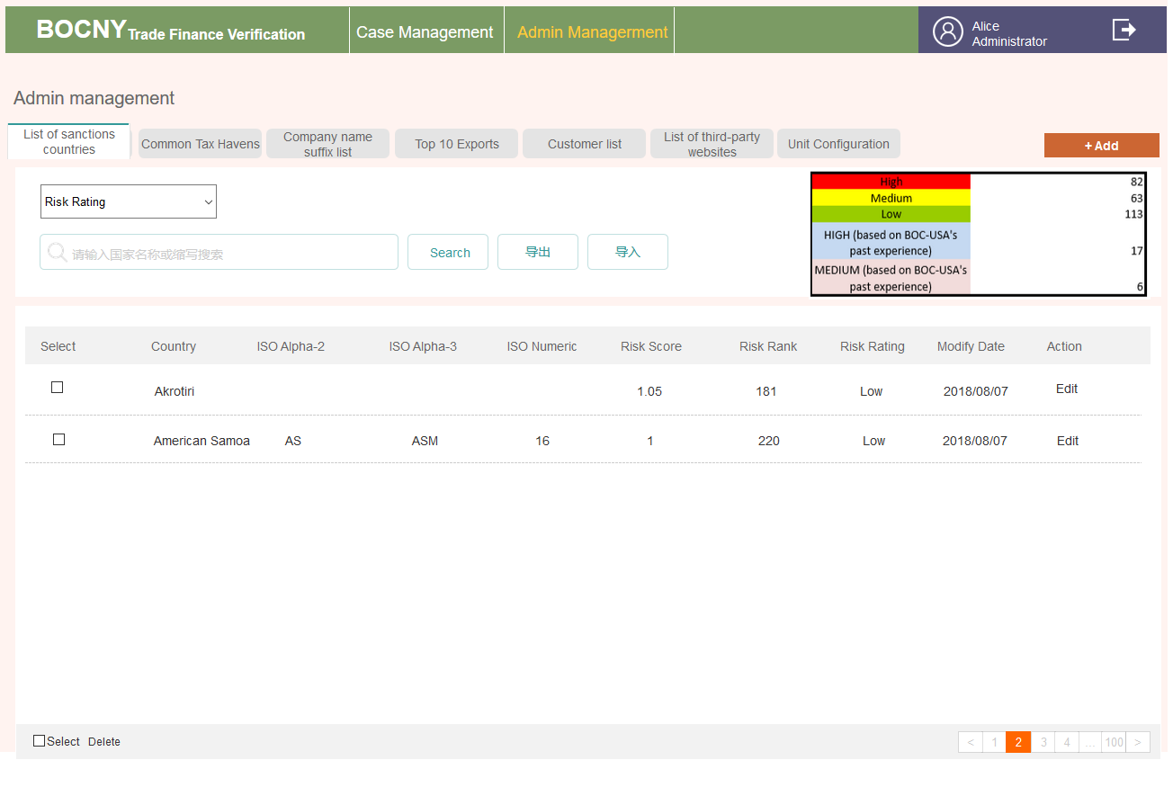

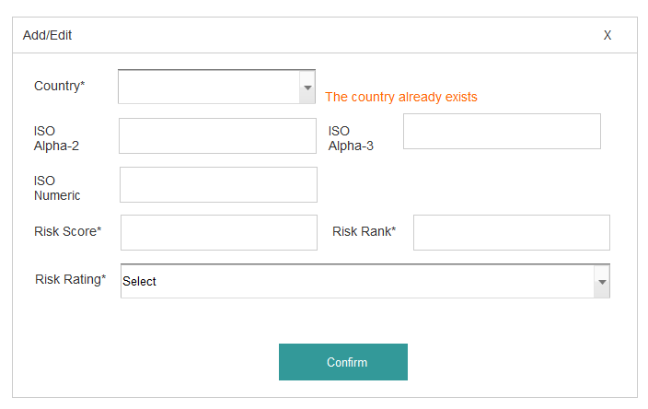

* **Common Tax Havens**

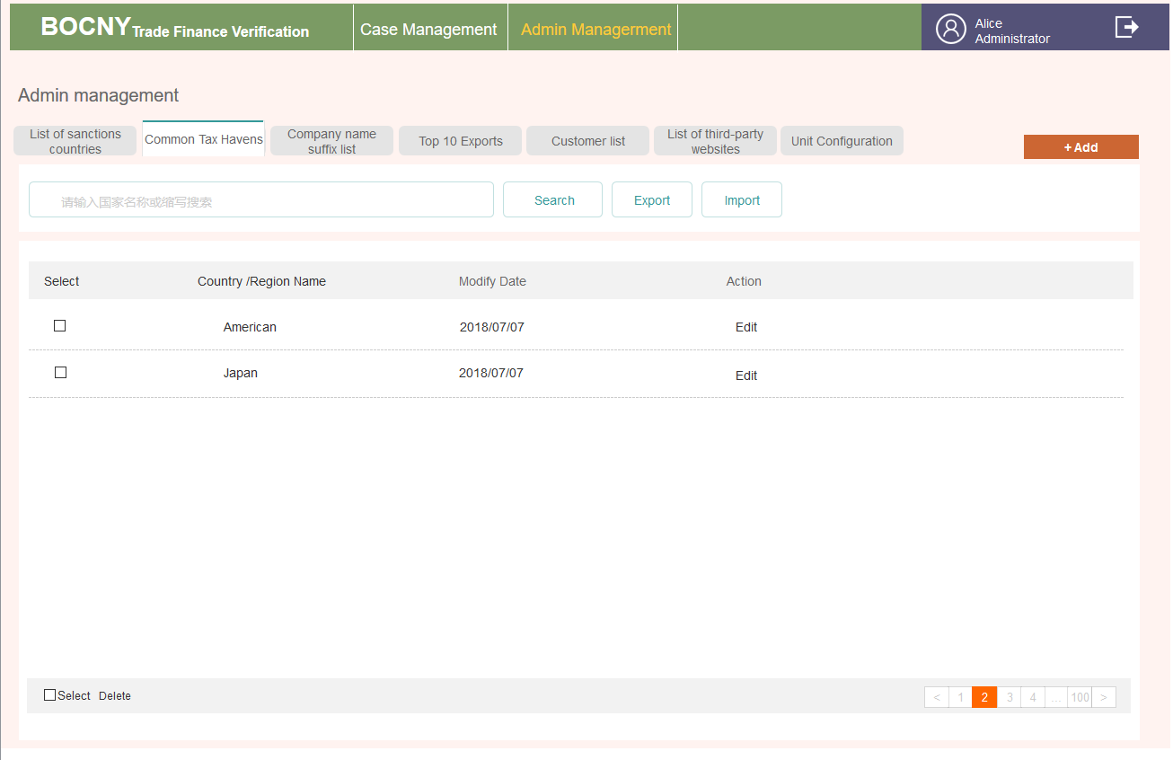

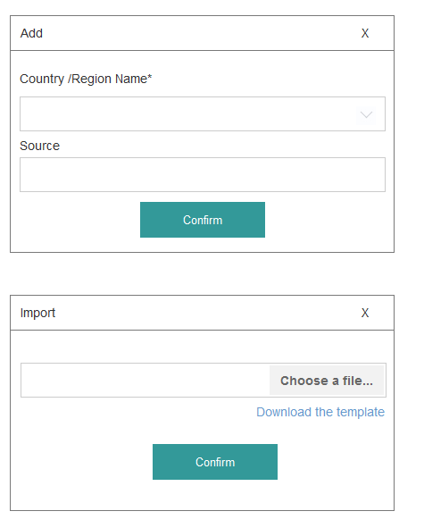

* **Company name suffix list**

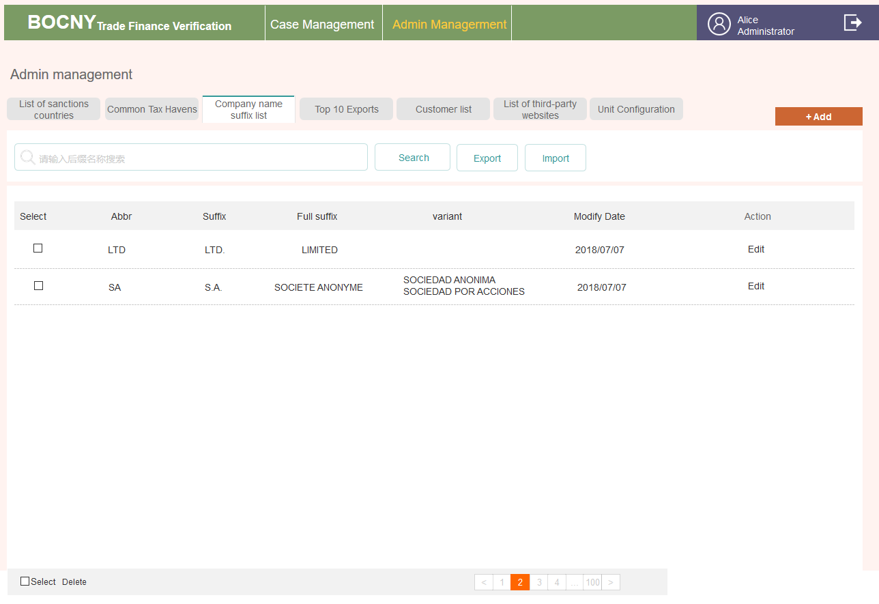

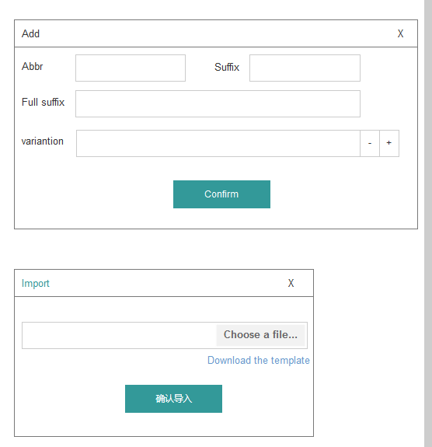

* **Top 10 Exports**

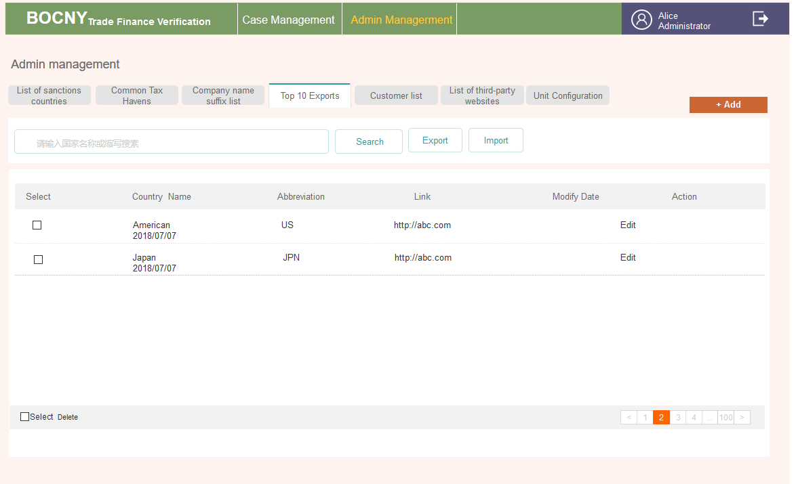

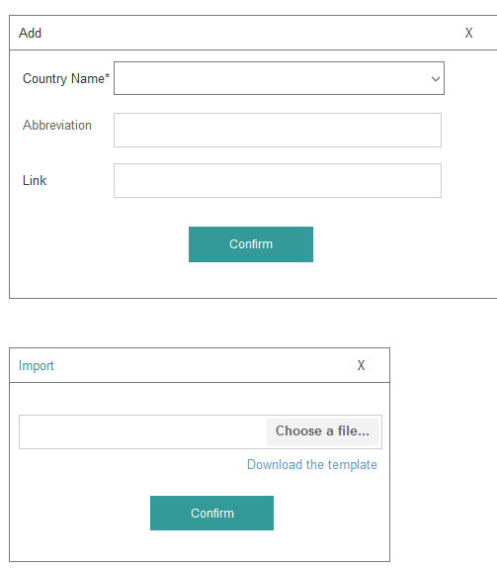

* **Customer list of branches**

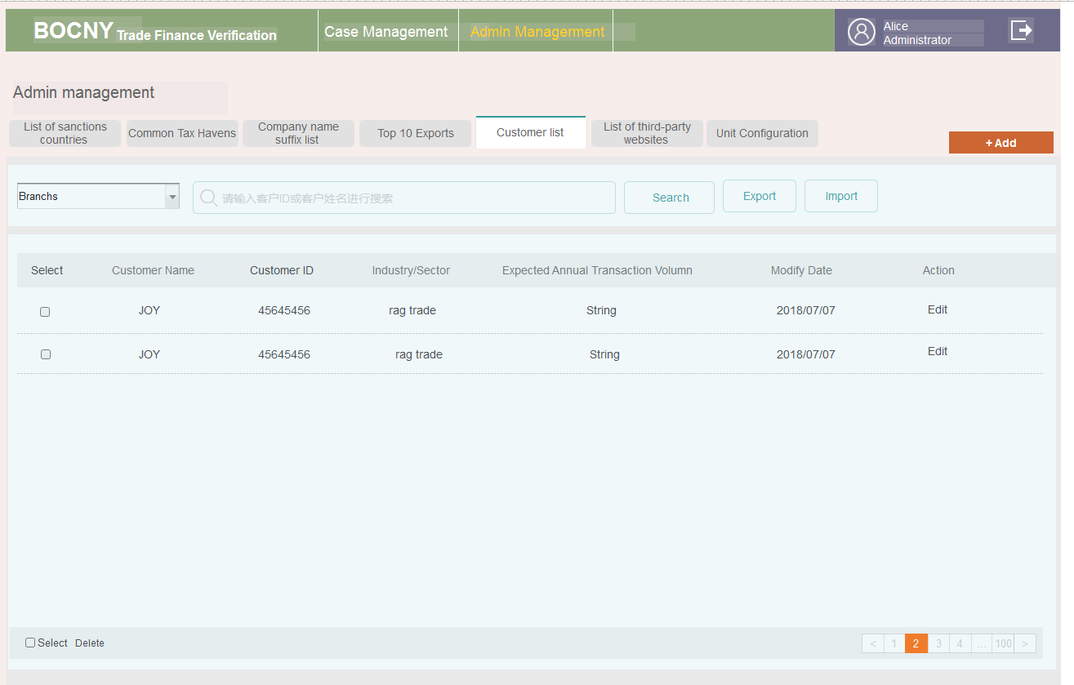

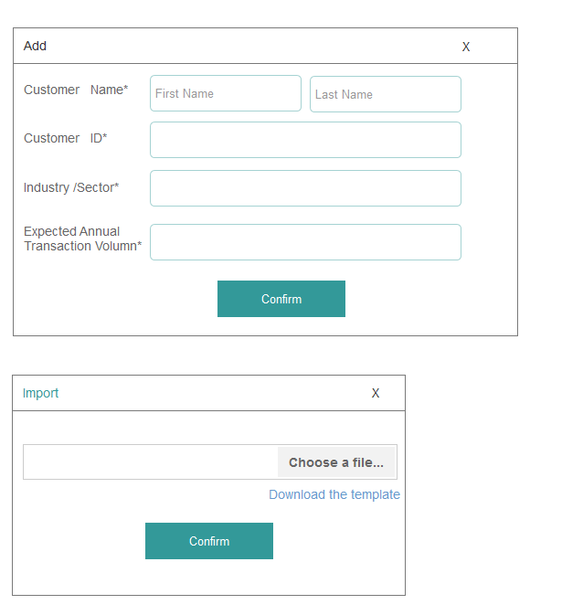

* **List of third-party websites**

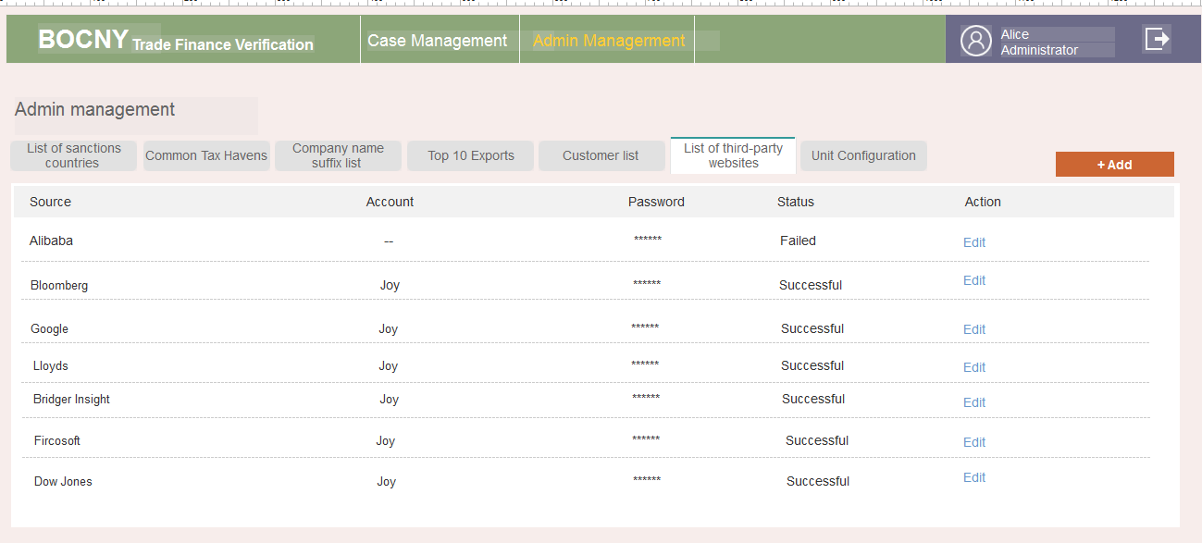

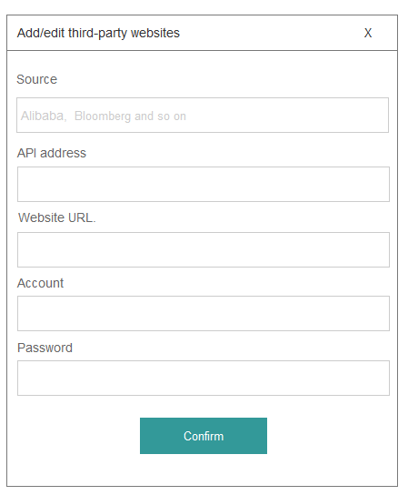

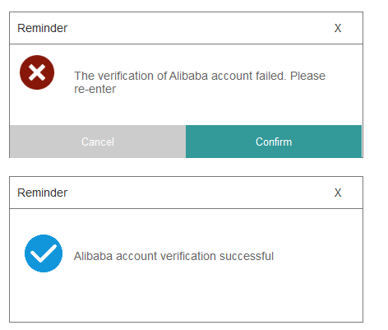

* Unit Configuration

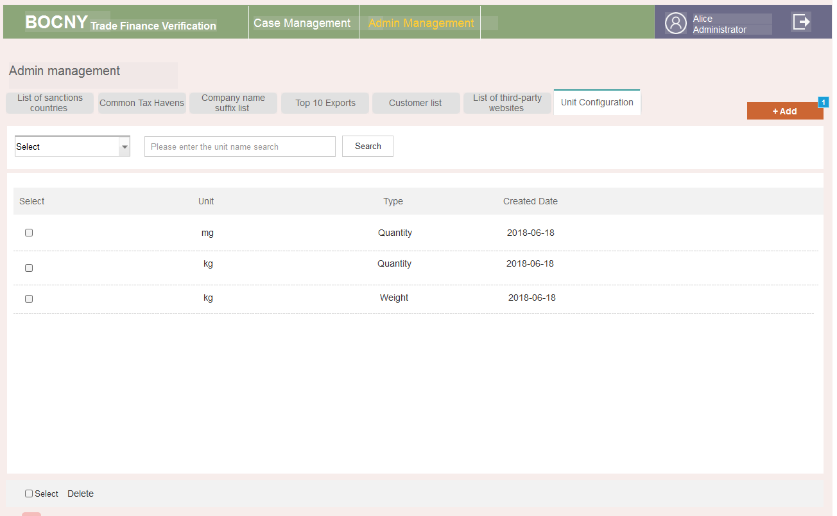

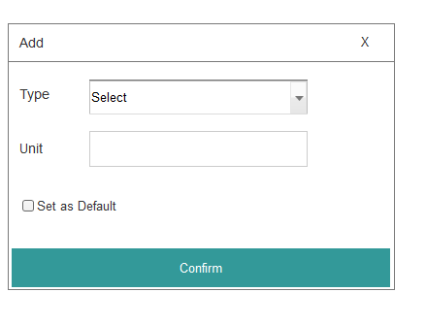

* **Case list**

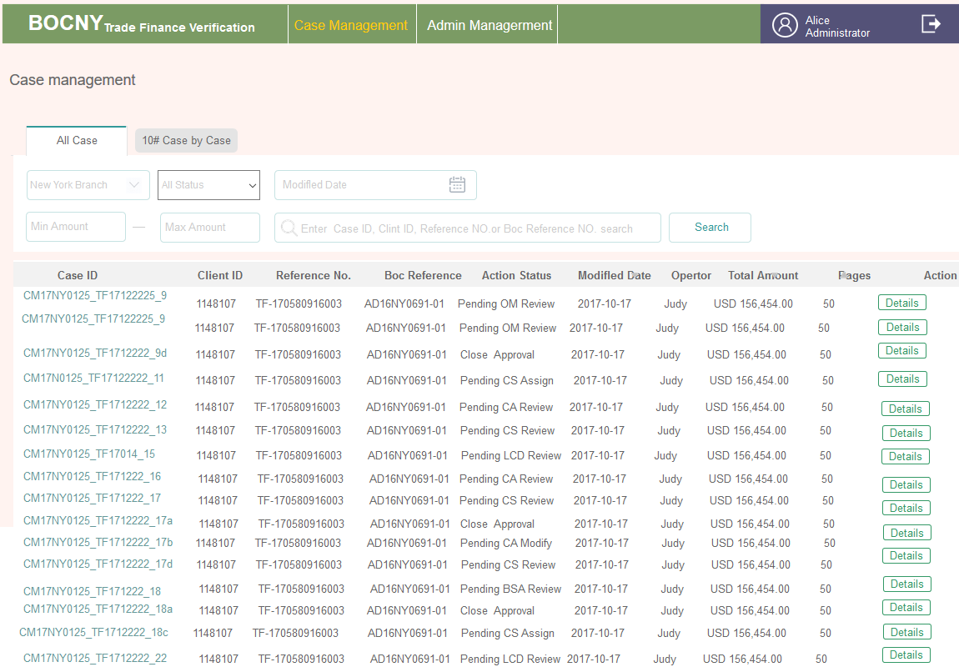

* **Case by case**

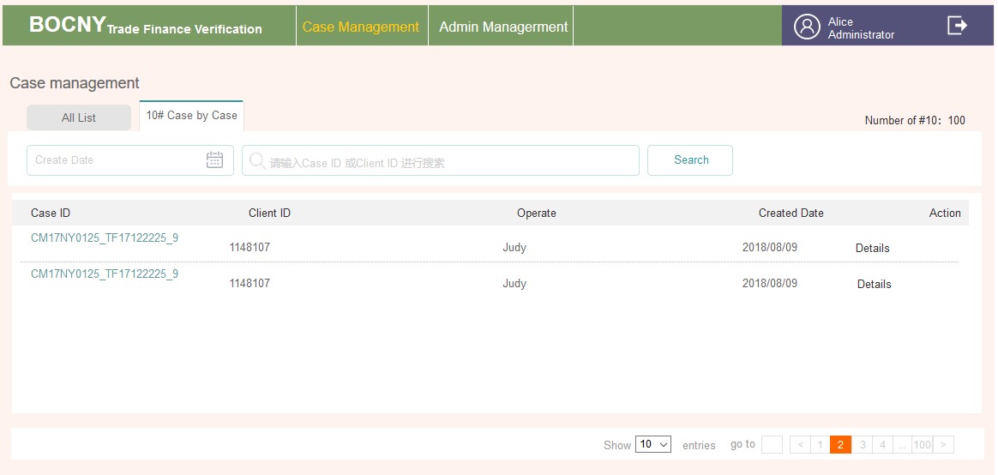

3.2.11 Operations Manager

3.2.11.1. Brief introduction to function



3.2.11.2. Detailed description

* **List**

|  |  |  |
| --- | --- | --- |
| List Label | Corresponding Status | Remarks |
| TO DO LIST | 6A~ 6B | * There are two situations that will appear in the pending items of the OM role. * One is the CASE sent by OA for the first time (note that OM first saw this CASE) * The other is to return back to OA, and the OA modified and submit it again. * Click Check button to go to the details page |
| Pending List | After status 8（included）&5A&5B, except Completed Status | The action button is Details and clicks to enter the details page. |
| History List |  |  |

* **Status Control**

| Step | Action | Location | Type | Content |
| --- | --- | --- | --- | --- |
| 6A | OA sent over CASE for the first time | To Do List | Button | Check |
| Details>>Customer Information | Status | Under Operations Manager Review |
| Content | Customer Basic Information |
| Button | File Management |
| Details>>Confirms Case | Content | * If OA filled EDD or #1 or #2 and sent them over, they would be displayed here(The form has not been fully reviewed, except for ALL FORMS, other buttons are visible but not clickable) * After that, it will be increased with the filling of the following roles. |
| Button | * All Forms * Return to OA * Refer to CS * Approve |
| Details>> Documens Verification | Content | Yes(the same as OA) |
| Button | Details (As same as OA. Buttons with edit permissions are Input and buttons without edit permissions are Details) |
| Details>> Checking & Evidence>> Comments | Content | If it exists in OA, then it will be displayed here |
| Details>> Checking & Evidence>>Alert Sign | Content | Yes |
| Button | * Evidence Management (Editable) * Check (Editable) |
| 7A | Click Return to OA and send it successfully. | Pending List | Button | Details |
| Details>>Customer Information | Status | * Pending Operations Analyst Modify * Under Operations Analyst Modify |
| Content | Yes |
| Button | File Management |
| Details>>Confirms Case | Content | As same as above |
| Button | All Forms(only export, not editable) |
| Details>> Documens Verification | Content | As same as above |
| Button | Details |
| Details>> Checking & Evidence>> Comments | Content | As same as above |
| Details>> Checking & Evidence>>Alert Sign | Content | Yes |
| Button | * Evidence Management(Not Editable) * Check(Not Editable) |
| 7B | After  Click on Approve button on the details page | Pending List | Button | Details |
| Details>>Customer Information | Status | Close Approval |
| Content | Yes |
| Button | File Management |
| Details>>Confirms Case | Content | If any |
| Button | All Forms |
| Details>> Documens Verification | Content | Yes |
| Button | Details |
| Details>> Checking & Evidence>> Comments | Content | If any |
| Details>> Checking & Evidence>>Alert Sign | Content | Yes |
| Button | * Evidence Management(Not Editable) * Check(Not Editable) |
| 7C | After refer to CS | Pending List | Button | Details |
| Details>>Customer Information | Status | * Pending Operations Analyst modify * Under Operations Manager review |
| Content | Yes |
| Button | File Management |
| Details>>Confirms Case | Content | As same as above |
| Button | All Forms(only export, not editable), increase with newly added forms |
| Details>> Documens Verification | Content | as same as above |
| Button | Details |
| Details>> Checking & Evidence>> Comments | Content | as same as above |
| Details>> Checking & Evidence>>Alert Sign | Content | Yes |
| Button | * Evidence Management(Not Editable) * Check(Not Editable) |
| 6B\5B | OA modified and sent it over | Refer to 6A | Refer to 6A | Refer to 6A. Return button in the form |

3.2.11.3. Interface requirements

* **Home**

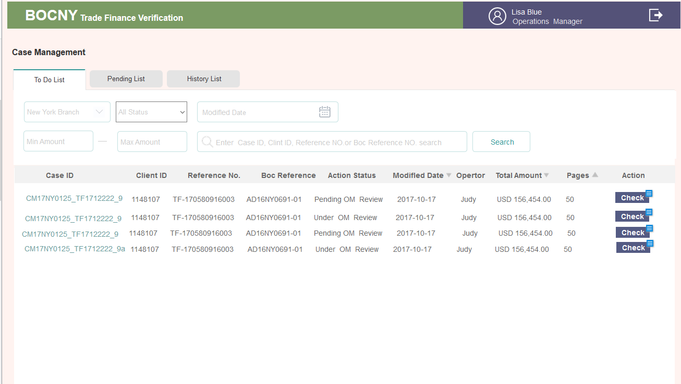

1. Details

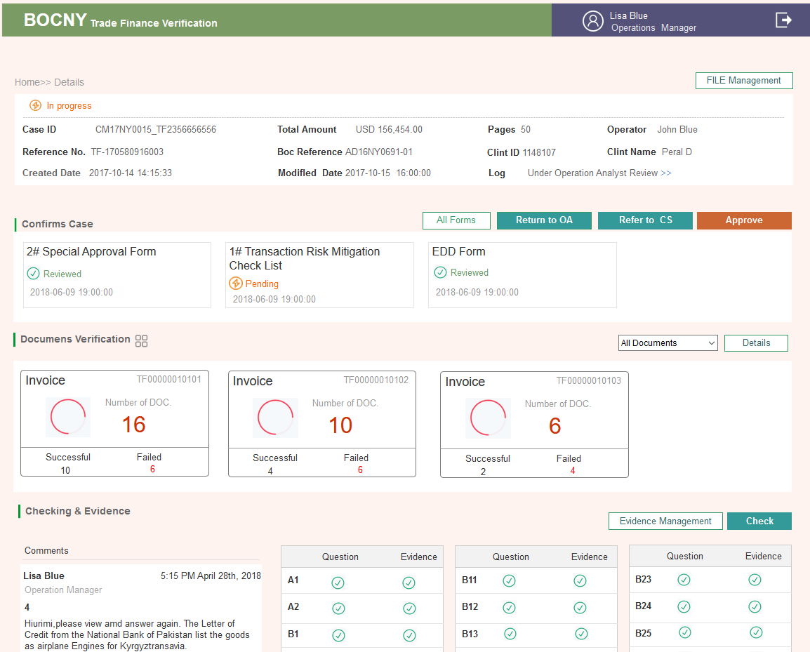

1. ALL FORMS page with comments

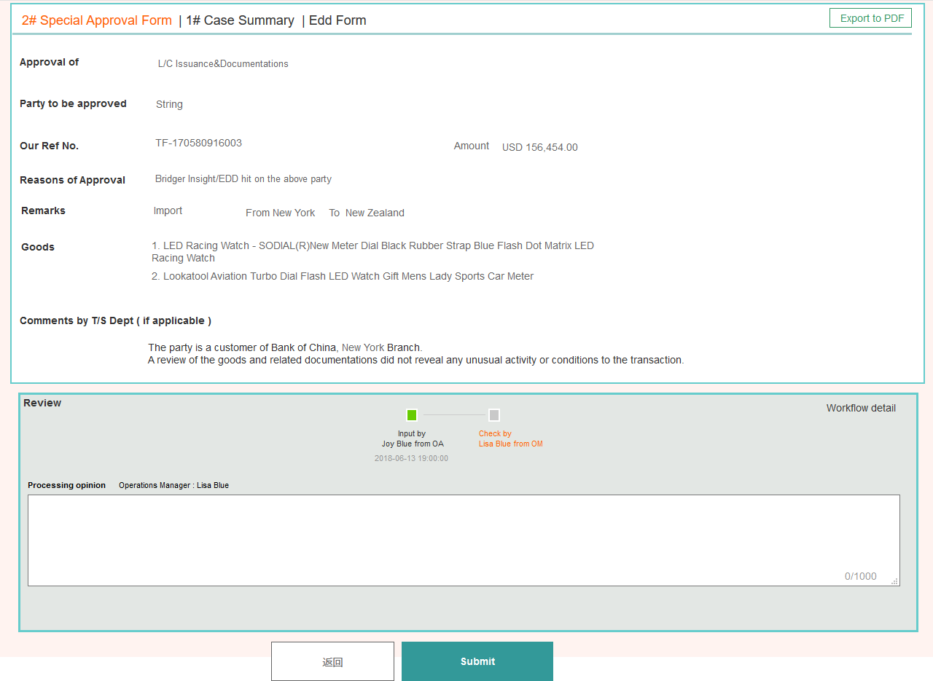

3.2.12 Compliance Supervisor

3.2.12.1. Brief introduction to function



3.2.12.2. Detailed description

* **List**

|  |  |  |
| --- | --- | --- |
| List Lable | Corresponding Status | Remarks |
| TO DO LIST | 8A, 8B  11,12  15,16A,16B  19,20  30A,30B | * OM sent to CS for the first time * CA finish #2 and sent to CS * CA added #3 and sent to CS * CA added #4 and sent to CS * BSA ask for more information and return back to CS |
| Pending List | After 9(included) | Refer to Status List |
| History List |  |  |

* **Status Control**

| Step | Action | Location | Type | Content |
| --- | --- | --- | --- | --- |
| 8A | OM sent case to CS for the first time | To Do List | Button | Assign |
| Details>> Customer Information | Status | * Under Compliance Supervisor Assign |
| Content | Customer Basic Information |
| Button | File Management |
| Details>>Confirms Case | Content | * If OA filled EDD or #1 or #2, these forms will be displayed here. The content can be added by the following roles. |
| Button | * All Forms (if any form was sent forward, this ALL Forms button would be shown. At this point, there are at most 4 tables, #1,#2, EDD,#10) * Assign |
| Details>> Checking & Evidence>> Comments | Content | If it exists in OA, then it would be displayed here |
| Details>> Checking & Evidence>>Alert Sign | Content | YES |
| Button | * Evidence Management (Editable) * Check (Editable) |
| After 8B | After the case is sent to CA | Pending List | Button | Details |
| Detail Page>>Status | Content | * Pending Compliance Analyst Review * Under Compliance Analyst Review |
| Detail Page >>Confirms Case | Button | Assign button disapper  All Forms is no longer allow edited |
| Checking & Evidence | Button | * Evidence Management (Editable) * Check (NOT Editable) |
| 11 | After CA processed and sent it over | To Do List | Button | Check |
| Detail Page>> Status |  | * Under Compliance Supervisor Review |
| Confirms Case | Content | 修改：按设置确定哪些表有权回复，设置了有权回复的表，没回复时状态为待处理，回复后状态变为已处理。 The form has not been fully reviewed, except for ALL FORMS, other buttons are visible but not clickable |
| Button | * All Forms * Refer to LCD |
| Alert Sign | Button | * Evidence Management (Editable) * Check (Editable) |
| 12 | After refer to LCD | Pending List | Button | Details |
| Detail Page>>Status | Content | * Pending LCD Feedback * Under LCD Feedback |
| Detail Page >>Confirms Case | Button | * Refer to LCD button disppear * All Forms are no longer allow editing |
| Checking & Evidence | Button | * Evidence Management (Not Editable) * Check (Not Editable) |
| 15 | CA add #3 and sent it over | To Do List | Button | Check |
| Detail Page>>Status | Content | Under Compliance Supervisor Review |
| Detail Page >>Confirms Case | Content | One more form #3 is created，replyable  #3 is pending review, Others have been reviewed |
| Button | * All Forms(plus #3) * Return to CA * Approve |
| Alert Sign | Button | * Evidence Management (Editable) * Check (Editable) |
| 16A | Click on Approve button on Detail Page | Pending List | Button | Details |
| Detail Page>>Status | Content | Close Approval |
| Detail Page>>Confirms Case | Button | The other two buttons disappear. All Forms are no longer editable (Plus #3) |
| Checking & Evidence | Button | * Evidence Management(Not Editable) * Check(Not Editable) |
| 16B | Click on Return to CA button on Detail Page | Detail Page>>Status | Content | * Pending Compliance Analyst Review * Under Compliance Analyst Review |
| Other fields | Refer to 16A | Refer to 16A |
| 19 | CA added form #4 and sent it over | To Do List | Button | Check |
| Detail Page>>Status | Content | Under Compliance Supervisor Review |
| Detail Page>>Confirms Case | Content | One more form #4, replyable  #4 is pending review, others are reviewed. |
| Button | * All Forms(Plus #4) * Refer to BSA |
| Alert Sign | Button | * Evidence Management(Editable) * Check(Editable) |
| 20 | After sent to BSA | Pending List | Button | Details |
| Detail Page>>Status | Content | Pending BSA Officer Review  Under BSA Officer Review |
| Detail Page>>Confirms Case | Button | The other two buttons are disappear, All Forms are no longer editable(plus #4) |
| Checking & Evidence | Button | * Evidence Management(Not Editable) * Check(Not Editable) |
| 30A | Return from BSA | To Do List | Button | Assign |
| Detail Page>>Status | Content | Under Compliance Supervisor Assign |
| Details>>Confirms Case | Content | Cases with COMMENTS of BSA, status change to pending review |
| Button | * All Forms * Assign |
| Details>> Checking & Evidence>> Comments | Content | If it exists in OA, then it will be displayed here |
| Details>> Checking & Evidence>>Alert Sign | Content | Yes |
| Pending Compliance Supervisor Assign | Button | * Evidence Management(Editable) * Check(Editable) |
| 30B | After assign to CA | Pending List | Button | Details |
| Details |  | Assign button disappear, not editable anymore |

3.2.12.3. Interface requirements

* **List Page**

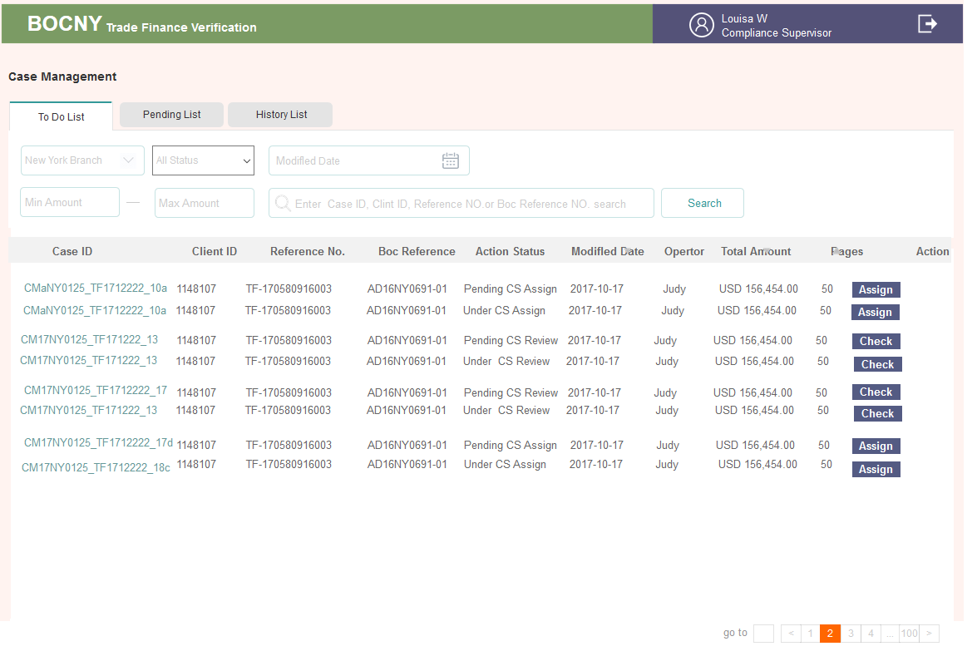

* **Processing Detail Page**

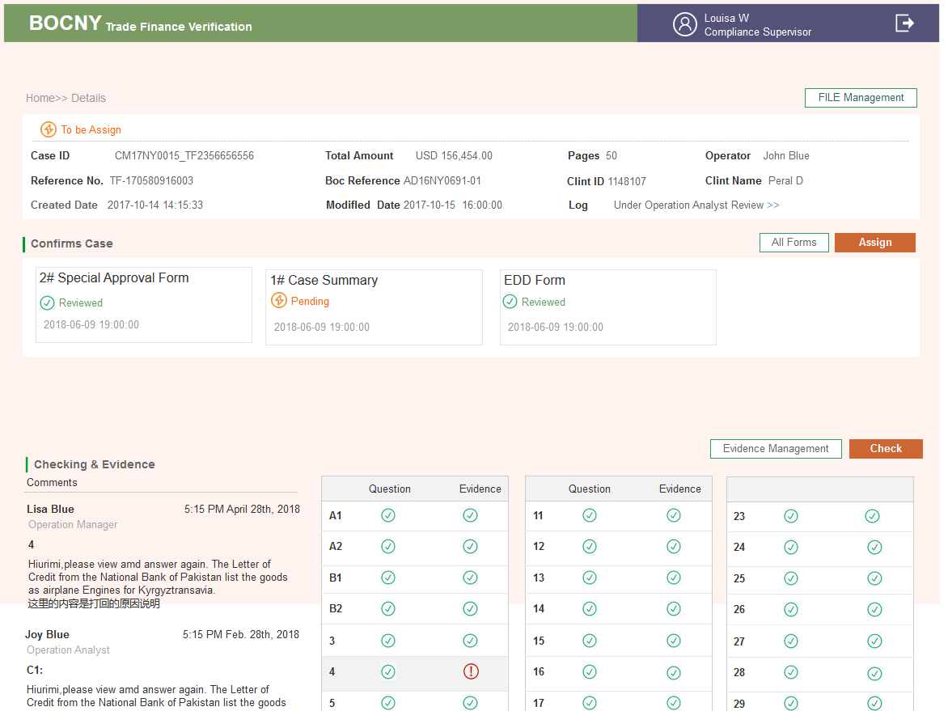

* **#4 ALL Forms**

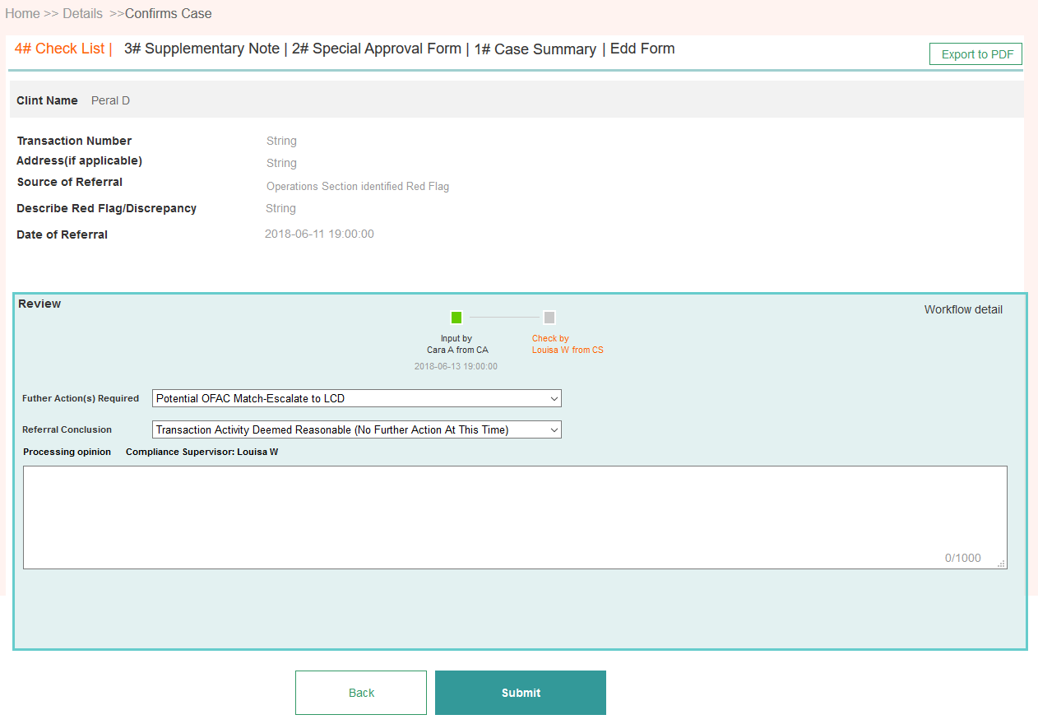

3.2.13 Compliance Analyst

3.2.13.1. Brief introduction to function



3.2.13.2. Detailed description

* **列表**

|  |  |  |
| --- | --- | --- |
| List Lable | Corresponding Status | Remarks |
| TO DO LIST | 9，10  14A, 14B  17, 18  31A, 31B | Receive from CS for the first time  Receive from LCD, add #3 form  Return back from CS, add #4 form  BSA sent it back to CS to reporcessing |
| Pending List | Status after 11 (included) | Refer to status list |
| Completed |  | Refer to status list |

* **Status Control**

| Step | Action | Location | Type | Content |
| --- | --- | --- | --- | --- |
| 9 | CA receives the CASE assigned by CS for the first time. | To Do List | Button | Check |
| Details>>Customer Information | State | Under Compliance Analyst Review |
| Content | Customer information |
| Button | File Management |
| Details>>Confirms Case | Content | If there exists EDD&1#&2# &#10, all the status are pending processing |
| Button | * All Forms * Refer to CS |
| Details>> Checking & Evidence>> Comments | Content | If any |
| Details>> Checking & Evidence>>Alert Sign | Content | Yes |
| Button | * Evidence Management (Editable) * Check (Editable) |
| 10 | Refer to CS | Pending List | Button | Details |
| Details>>Confirms Case | Content | No longer allowed to modify |
| Button | * All Forms * Refer to CS button disapear |
| Details>> Checking & Evidence>> Comments | Content | If any |
| Details>> Checking & Evidence>>Alert Sign | Content | Yes |
| Under Compliance Analyst Review | Button | * Evidence Management (Not Editable) * Check (Not Editable) |
| 14A | LCD sent to CA to create #3 | To Do List | Button | Check |
| Details>>Customer Information | State | Under Compliance Analyst Review |
| Content | Customer Information |
| Button | File Management |
| Details>>Confirms Case | Content | * Adding #3 * If there’s from with LCD comments, then the status is pending |
| Button | * All Forms * 3#Supplementary Notes * Refer to CS * OFAC Results with results written by LCD |
| Details>> Checking & Evidence>> Comments | Content | If any |
| Details>> Checking & Evidence>>Alert Sign | Content | Yes |
| Under Compliance Analyst Review | Button | * Evidence Management (Editable) * Check (Editable) |
| 14B | After finishing #3 and refer to CS | Pending List | Button | Details |
| Details>>Confirms Case | Content | No longer allowed to modify |
| Button | * All Forms |
| Details>> Checking & Evidence>> Comments | Content | If any |
| Details>> Checking & Evidence>>Alert Sign | Content | Yes |
| Under Compliance Analyst Review | Button | * Evidence Management (Not Editable) * Check (Not Editable) |
| 17 | CS sent it back to ask to create #4 again | To Do List | Button | Check |
| Details>>Customer Information | State | Under Compliance Analyst Review |
| Content | Customer Information |
| Button | File Management |
| Details>>Confirms Case | Content | * Add #4   If there’s from with CS comments, then the status is pending |
| Button | * All Forms * 4#Check List * Refer to CS |
| Details>> Checking & Evidence>> Comments | Content | If any |
| Details>> Checking & Evidence>>alert sign | Content | Yes |
| Under Compliance Analyst Review | Button | * Evidence Management (Editable) * Check(Editable) |
| 18/ 16B/20 | After #4 is created and sent to CS | Pending List | Button | Details |
| Details>>Confirms Case | Content | No longer allowed to modify |
| Button | All Forms |
| Details>> Checking & Evidence>> Comments | Content | If any |
| Details>> Checking & Evidence>>Alert sign | Content | Yes |
| Under Compliance Analyst Review | Button | * Evidence Management( Not Editable) * Check(Editable) |
| 31A | BSA returns to CS and then to assign to CA | Refer to 9 | Refer to 9 | When new WORK FLOWS are added, there will be changes |
| 31B | After CA send to CS | Refer to 18 | Refer to 18 | When new COMMENTS are added, there will be changes |

3.2.13.3. Interface requirements

* **To do List**

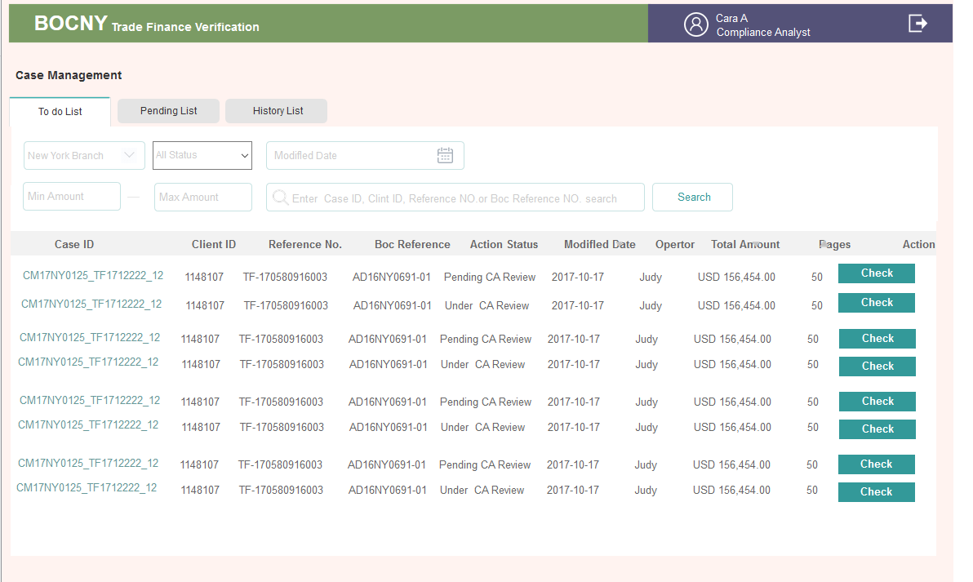

* **Detail Page**

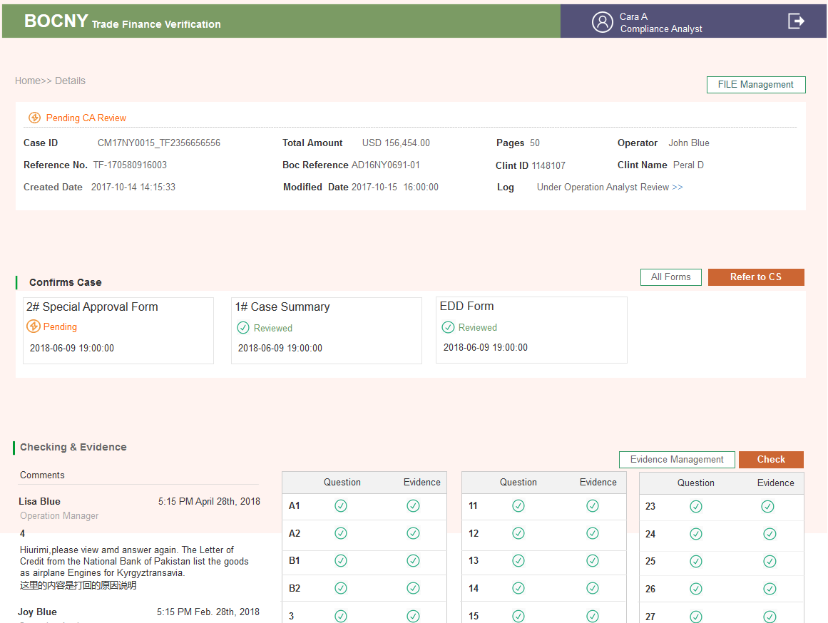

3.2.14 BSA Officer

3.2.14.1. Brief introduction to function



3.2.14.2. Detailed description

* **List**

|  |  |  |
| --- | --- | --- |
| List Label | Corresponding States | Remarks |
| TO DO LIST | 21-27 | * Receive CASE from CS for the first time * After return to CS, receive CASE from CS again |
| Pending List | Status after 28(included) | Refer to status list |
| History List |  | Refer to status list |

* **States Control**

24B

Step 1 BSA select Reject in #4 form, click submit

Step 2 The program finds that Reject was selected，

1）State changes to CLOSE REJECT

2）#5 form button appears in Details page (if Reject was changed to others, then this #5 form button will disppear)

Step 3 Manually input #5 form and click submit

Step 4 After #5 form is submitted, EXPORT PDF button appear

The previously completed 1#~5#, EDD, and 10# tables are all generated as the same PDF format as the template. Export to the desktop (offline process)

Step 5 But online operators still need to click Send to LCD button and status change from CLOSE REJECT to Pending LCD SAR Process. Case flows to the LCD

Step 6 After LCD receives the CASE, click the SAR button. LCD fills in some content in the SAR popup. Then click submit, the status changes to Close with SAR Control LOG# and all the processes of this CASE are finished.

| Step | Action | Location | Type | Content |
| --- | --- | --- | --- | --- |
| 21 | BSA Review | To Do List | Button | Check |
| Details>>Customer Information | State | Under BSA Officer Review |
| Content | Customer basic Information |
| Button | File Management |
| Details>>Confirms Case | Content | Yes |
| Button | All Forms  Approve |
| Details>> Checking & Evidence>> Comments | Content | If any |
| Details>> Checking & Evidence>> Alert Sign | Content | Yes |
| Button | Evidence Management (Editable)  Check(Editable) |
| 24B | BSA #4 (Rejected) | Details>>Confirms Case | Content | If form 5 was added, then there’s form 5 |
| Button | All Forms  Generate Reports (Export or print all forms from ALL FORMS Button)  5# Referral Form of Unusual  Refer to LCD |
| 26D | BSA #4 (Continue processing) | Details>>Confirms Case | Content | #4 |
|  | Button | All Forms  Return to CS |

3.2.14.3. Interface requirements

1. List page

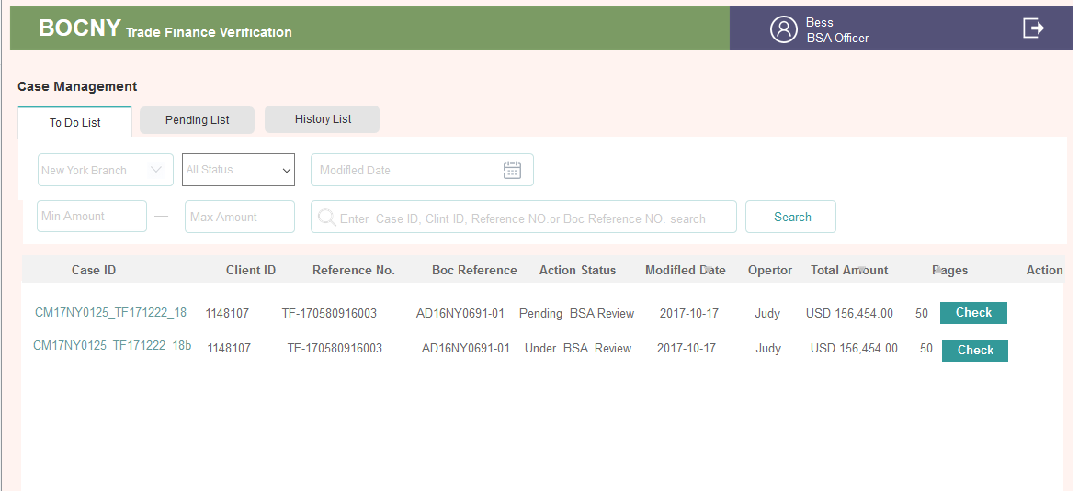

1. Detail Page

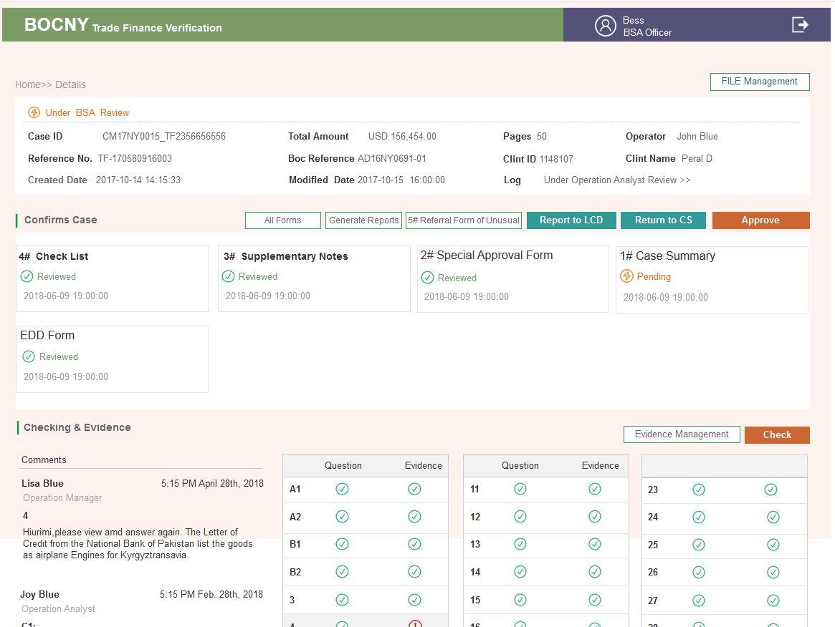

3.2.15 LCD Department

3.2.15.1. Brief introduction to function



3.2.15.2. Detailed description

* **List**

|  |  |  |
| --- | --- | --- |
| List Label | Corresponding State | Remarks |
| TO DO LIST | 13A, 13B  28, 29 | Receive from CS for the first time -- #2  Receive from BSA for the last time. |
| Pending List | States after 14A(included) | Check states table for detail |
| History List |  | Check states table for detail |

* **Status Control**

| Step | Action | Location | Type | Content |
| --- | --- | --- | --- | --- |
| 13A | LCD receive for the first time | To Do List | Tab | Check |
| Details>>Customer information | Status | Under LCD Department Review |
| Content | Customer Basic Information |
| Button | File Management |
| Details>>Confirms Case | Content | #2 |
| Button | All Forms  OFAC(Click and pop up a window, you need to select hit&miss to write the content, not required, and then click submit. The CA and the following roles will see it. If it’s not submitted, SEND TO CA button cannot be clicked  Send to CA |
| Details>> Checking & Evidence>> Comments | Content | If any |
| Details>> Checking & Evidence>>Alert Sign | Content | Yes |
| Button | Evidence Management(Not editable)  Check |
| 13B | After sent to CA | Pending List | Button | Details |
| Details>>Confirms Case | Button | All Forms |
| Others | Content & button | Not editable |
| 28 | Receive form for the last time | To Do List | Button | SAR |
| Details>>Customer Information | Status | Reject |
| Content | Customer Basic Information |
| Content | No |
| Details>>Confirms Case | Content | #5 |
| Button | Final Report (exported SAR PDF. All tables can be exported or printed )  SAR LOG# (Click and pop up a window to fill in the SAR results, which are visible in the status log.) After it’s submited, the process ends. |
| Details>> Checking & Evidence>> Comments | Content | If any |
| Details>> Checking & Evidence>>Alert sign | Content | Yes |
| Button | Evidence Management(Not editable)  Check(Not editable) |
| 29 | SAR is submitted | Details>>Confirms Case | Button | Final Report |
| Other fields |  | Not editable |

3.2.15.3. Interface requirements

* **To Do List**

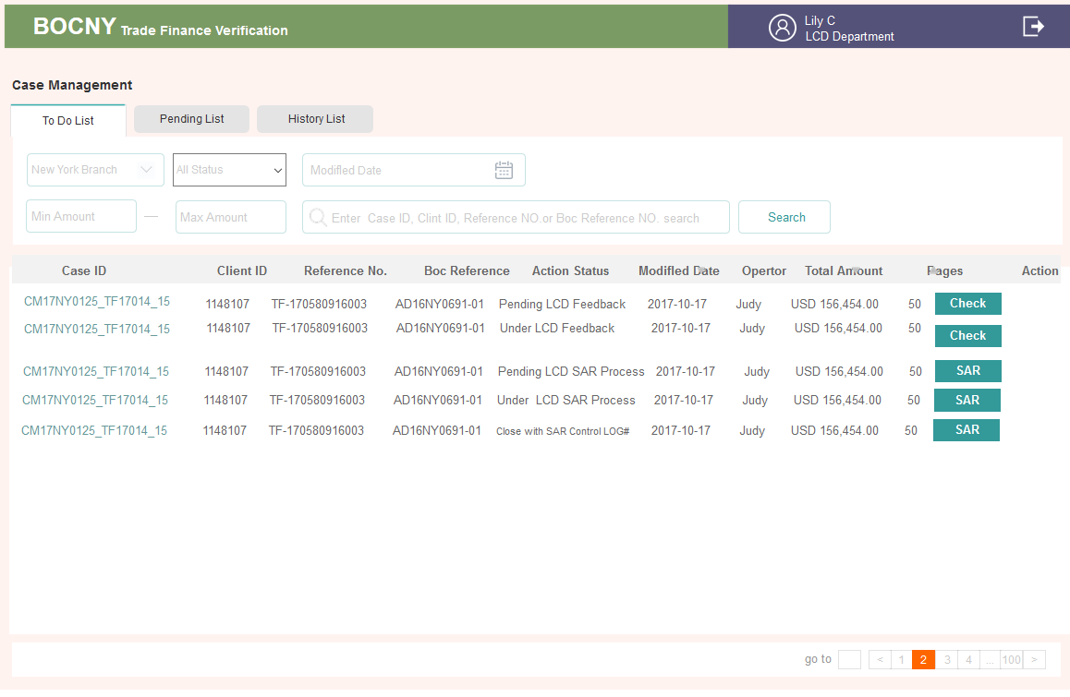

* **Detail Page**

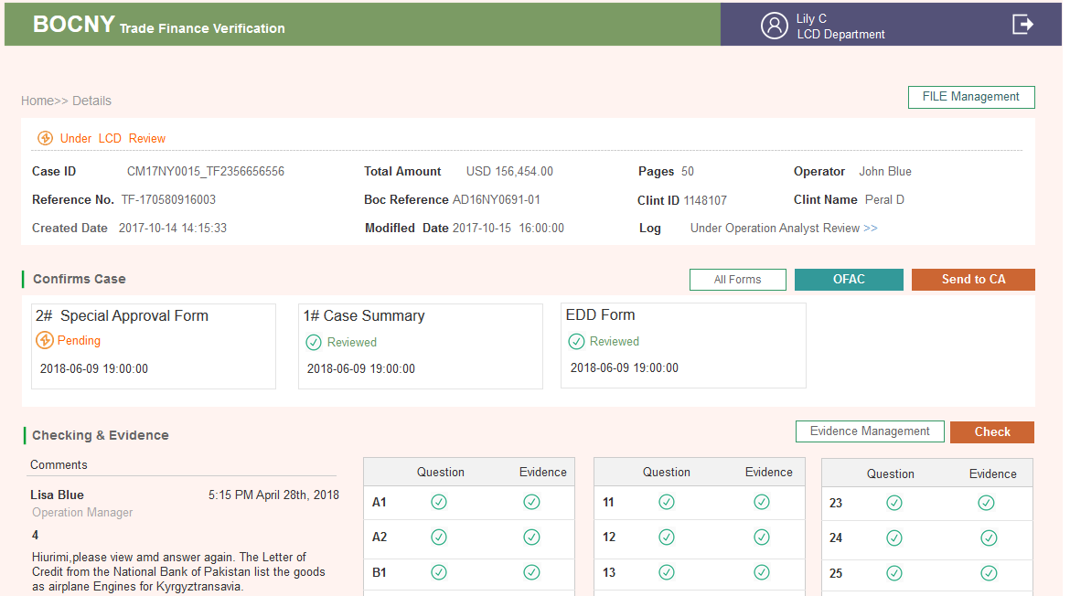

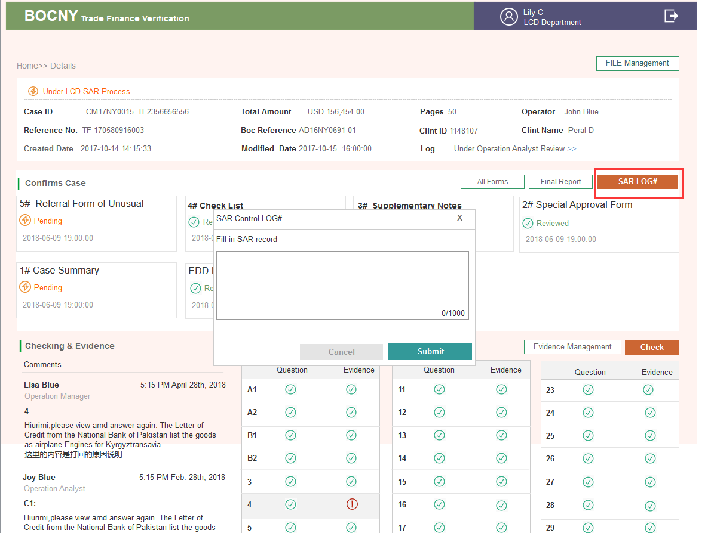

3.2.16 35Q logic

3.2.15.1. Brief introduction to function

According to rule requirement, checking data is obtained from T24&Graphen, and the system will display the content based on the acquired data.



3.2.15.2. Detailed description

* **Type**

1. New LC Import issuance/amendment

2. New LC Import drawing

3. New LC Export documents/Transfer/AOP

4. New Inward Collections Documents

5. New Outward Collections Documents

6. Funded/Unfunded Risk Participation

7. Forfeiting

8. Factoring/Supply Chain Financing

9. Short Term Financing Transaction

* **其它说明**

1. When search Invoice Number in T24, it is not case sensitive

2. L/C should search all the historical data

* **Store digital sample for transaction**

|  |  |
| --- | --- |
| 35 questions | Templates |
| A2_Custimer Anticipated Activity |  |
| A2_T24 Results_Factoring and so on |  |
| A2_T24 Results_LC Export |  |
| A2_T24 Results_Others |  |
| B1_Invoice&Industry Description |  |
| B1_US Google |  |
| B2_ Case’s Transaction Amount Drawing |  |
| B2_Factoring and so on |  |
| B2_Past Transactions for The Client |  |
| B4_Country of Origin_input |  |
| B4_Country of Origin_T24 |  |
| B5_Whether the transaction price is reasonable |  |
| B6_Invoice Number |  |
| B6_T24 Result |  |
| B7_Invoice & Lading Quantity check |  |
| B9_The transaction amount and currency in T24 |  |
| B11_ Invoice & Lading Quantity check |  |
| B16_Country List For Import LC Issuance |  |
| B16_Country List For Other Case |  |
| B16_Sanction Country List |  |
| B20_Country List For Import LC Issuance |  |
| B20_Country List For Other Case |  |

3.2.17 Future Development

### 1..2. Enhanced Due Diligence

* In a future development, Enhanced Due Diligence (“EDD”) will be applied to 4 types of products or commodities as follows:
  + Shipping
  + Service & Insurance
  + Metals
  + Oil & Gas
* After completing the review of the Transactions Risk Mitigation Checklist (“TRM Checklist”), the Operations Analyst will review the information to determine whether the facts of the transaction would trigger EDD. All transactions involving Shipping, Service & Insurance, Metals, and Oil & Gas will undergo EDD. The Operations Analyst will fill-in the appropriate form and determine whether a red flag is triggered by any of the answers in the form. If a red flag exists, the Operations Analyst will next review the Watch List to see if there is a match to the party involved in the transaction. If there is a match, the Operations Analyst will submit Special Approval Form #2 with the case and send it to the Operations Manager for review.
* When there is no Watch List match, the Operations Analyst sends the case to Operations Manager for review without the Special Approval Form #2. The Case then returns to the standard processing flow.

The EDD Forms (#6-9), are included in the Case Process section.

3.3. Requirements for customer information

blank

3.4. Requirements for channel

blank

3.5. Requirements related to the core system

3.5.1 Technical Enhancement

3.5.1.1. Workflow Control

The business cases submitted by Operations Analyst will be brought in the Case Management workflow for tracking management.

1. The workflow module of this system is required to reuse the source code and function of the workflow module of the AML system.
2. The work flow of reviewers/roles at each level around the business cases will be controlled and scheduled by the AML workflow module.
3. The TSD Trade Finance workflow will also use the consistent interface provided by the AML work module for configuration and maintenance management
4. TF AML should be able to generate email message alerting the relevant parties of the pending actions required (“Pending actions” refers to every time a case is sent/returned to another role in the flow chart). For e.g. an email will be sent to the assigned parties when the Operations Manager escalated new case, the Compliance Supervisor assigned a case to a Compliance Analyst, or when the Compliance Supervisor escalated a case to the BSA Officer, etc.

3.5.1.2. Add Audit Trail

The system will add the Audit Trail function and record the user's operations in the log repository.

Activities to be recorded include:

1. User log in and log out activity.
2. The activity caused TF case processing workflow status change.
3. The activity caused TF case data change (create/delete/content modify), meanwhile need to store previous data in history table.
4. If signature is needed for action owner， just record user id and date once approve or signature button.

In addition, records saved in the log repository can be exported by DB Data Export utility.

5、If changes are made to any of the thresholds in the system, record the threshold changes, user id and date of change.

3.5.1.3. File Management

The system will improve file management:

1. The directory structure in server

2. Improve the standardization of file name for search easily

Furthermore, considering the number of Case-related documents and the speed of increase, we also need to provide:

1. Backup requirements for Case files: Case-related file retention time is 1 year, compression packing backup for more than 1 year

Support the recovery of Case backup files, including restoring the files of the specified Cases.

3.5.2 Interface Requirements

3.5.2.1. Hardware

The following are components of hardware that are necessary for this Trade Finance Tool:

* Server with GPU
* PC
* Network

3.5.2.2. Access

The following are components for bank or vendor access within the Trade Finance Tool:

* T24
* Accuity Fircosoft
* Dow Jones (Negative news website)
* Lloyd’s Intelligence website
* Bloomberg.com
* Google.com
* Alibaba.com
* TSD Drive

3.6. Requirements for report and accounting

**Enhanced Due Diligence Forms (Future Development)**

### Form 1: Service & Insurance (#6)

To： Compliance Dept.

From: Trade Services Dept.

TSD Reference_______________ Date: ________________ Recorded by: ____________

ENHANCED DUE DILIGENCE(EDD) FOR CUSTOMERS

Underwriting services, Insurance or Reinsurance Sector

*(This Enhance Due Diligence Form is developed to cover account opening, trade settlements, loans transactions and credit facilities. The officer in charge is only required to complete those topics of search relevant and applicable to the underlying business activities.)*

|  |  |  |
| --- | --- | --- |
| Topics of Search | Information obtained | Remarks (if any) |
| EDD Party NAME and ADDRESS |  |  |
| EDD Party’s Affiliated Group of Companies (if any) |  |  |
| Country of Domicile of EDD Party’s Head Office (if any) |  |  |
| Types of the transaction (e.g. Account Opening; Trade Finance; Trade Services; Loans / Credit facility) |  |  |
| Purpose of the transaction |  |  |
| Does the Transaction involve Underwriting services, Insurance or Reinsurance Sector related to Iranian entities? |  |  |
| Amount of the transaction (e.g. Amount of Deposits, Loan Amount, Trade Settlement Amount etc.) |  |  |
| Description of Goods |  |  |

|  |  |  |
| --- | --- | --- |
| Country of Origin | Information obtained | Remarks(if any) |
| Port and Country of Loading |  |  |
| Port and Country of discharge |  |  |
| Final destination (Please also show county name) |  |  |
| Buyer / Seller Name & Country Location (you may circle either Buyer or Seller and put in info) |  |  |
| Supplier or Manufacturer & Location (if different than “Seller” above) |  |  |
| Name of End User & Country Location |  |  |
| Identify (through public information, e.g. Google, annual reports, news media etc,) if Customer or its affiliated group companies invest in or does business with the Iranian Shipbuilding Industry? |  |  |
| Identify if Customer or its affiliate group of companies conduct business activities with companies or financial institutions on the Sanction List |  |  |
| Other additional topics of search |  |  |

Prepared by: ___________________ Ext. ___________________ Date: _________

Reviewed by: ___________________ Ext. ___________________ Date: _________

Approved by: ___________________ Ext. ___________________ Date: _________

Approved by: Compliance: ____________ Ext.___________________ Date:________ _

### Form 2: Metal (#7)

To： Compliance Dept.

From: Trade Services Dept.

TSD Reference____________________ Date: ___________ Recorded by: _____________

ENHANCED DUE DILIGENCE(EDD) FOR CUSTOMERS

Commodities such as precious metals, graphite, raw or semi-finished metals (e.g., aluminum and steel)

*(This Enhance Due Diligence Form is developed to cover account opening, trade settlements, loans transactions and credit facilities. The officer in charge is only required to complete those topics of search relevant and applicable to the underlying business activities.)*

|  |  |  |
| --- | --- | --- |
| Topics of Search | Information obtained | Remarks (if any) |
| EDD Party NAME and ADDRESS |  |  |
| EDD Party’s Affiliated Group of Companies (if any) |  |  |
| Country of Domicile of EDD Party’s Head Office (if any) |  |  |
| Types of the transaction (e.g. Account Opening; Trade Finance; Trade Services; Loans / Credit facility) |  |  |
| Purpose of the transaction |  |  |
| Does the Transaction involve the investment in customers dealing in Commodities such as precious metals, graphite, raw or semi-finished metals (e.g., aluminum and steel), coal with Iranian entities? |  |  |
| Does the Transaction support the sale or purchase of Commodities such as precious metals, graphite, raw or semi-finished metals (e.g., aluminum and steel), coal with Iranian entities? |  |  |
| Amount of the transaction (e.g. Amount of Deposits, Loan Amount, Trade Settlement Amount etc.) |  |  |

|  |  |  |
| --- | --- | --- |
| Description of Goods |  | Remarks(if any) |
| Country of Origin |  |  |
| Port and Country of Loading |  |  |
| Port and Country of discharge |  |  |
| Final destination (Please also show country name) |  |  |
| Buyer / Seller Name & Country Location (you may circle either Buyer or Seller and put in info.) |  |  |
| Supplier or Manufacturer & Location (if different than “Seller” above) |  |  |
| Name of End User & Country Location |  |  |
| Identify (through public information, e.g. Google, annual reports, news media etc,) if Customer or its affiliated group companies dealing in Commodities such as precious metals, graphite, raw or semi-finished metals (e.g., aluminum and steel), coal with Iranian entities? |  |  |
| Identify if Customer or its affiliate group of companies conduct business activities with companies or financial institutions on the Sanction List |  |  |
| Other additional topics of search |  |  |

Prepared by: _____________________ Ext. ______________ Date: ________________

Reviewed by: _____________________ Ext. ______________ Date: ________________

Approved by: Compliance: ___________ Ext. ______________ Date: ________________

### Form 3: Oil & Petro (#8)

To： Compliance Dept.

From: Trade Services Dept.

TSD Reference________________ Area of Business: ___________ Recorded by: ___________

ENHANCED DUE DILIGENCE(EDD) FOR CUSTOMERR OF OIL, GAS AND PETROLEUM SECTORS

*(Some of the information may be duplicated or does not apply. Please just fill in the blanks that fit your area of business.)*

| Topics of Search | Information obtained | Remarks (if any) |
| --- | --- | --- |
| EDD Party NAME and ADDRESS |  |  |
| EDD Party’s Affiliated Group of Companies (if any) |  |  |
|  |  |  |
| Country of Domicile of EDD Party’s Head Office (if any) |  |  |
| Types of the transaction  This is to describe what kind of the transaction that belongs with.  Some examples: Import/Export |  |  |
| Purpose of the transaction |  |  |
| Does the Transaction involve the investment in the Iranian Petroleum Industry? |  |  |
| Does the Transaction support the development of Iranian Refined Petroleum Industry? |  |  |
| Does the Transaction involve the sale of Refined Petroleum Products to Iran |  |  |
| Amount of the transaction |  |  |
| Description of Goods |  |  |
| Country of Origin |  |  |
| Port of Loading (Please also show country name) |  |  |
| Port of discharge (Please also show country name) |  |  |
| Final destination (Please also show country name) |  |  |

|  |  |  |
| --- | --- | --- |
| Buyer / Seller Name & Country Location (you may circle either Buyer or Seller and put in info.) |  |  |
| Supplier or Manufacturer & Location (if different than “Seller” above) |  |  |
| Name of End User & Country Location |  |  |
| Number of transactions for the past one year |  |  |
| Volume of transactions for the past one year |  |  |
| Identify (through public information, e.g. Google, annual reports, news media etc,) if Customer or its affiliated group companies invest in Iran Petroleum Industry, provides support to the Refined Petroleum Industry, or sells Refined Petroleum to Iran? |  |  |
| Identify if Customer or its affiliate group of companies conduct business activities with companies or financial institutions on the Sanction List |  |  |
| Other additional topics of search |  |  |
| Note: This Enhance Due Diligence Form is developed to cover wire transfer activities, trade settlements, loan transactions and credit facilities. The officer in charge is only required to complete those topics of search relevant and applicable to the underlying business activities. | | |

Prepared by: _____________________ Ext. ______________ Date: ________________

Reviewed by: _____________________ Ext. ______________ Date: ________________

Approved by: Compliance: ___________ Ext. ______________ Date: ________________

### Form 4: Shipping & Ship Building (#9)

To： Compliance Dept.

From: Trade Services Dept.

TSD Reference________________ Area of Business: ___________ Recorded by: ___________

ENHANCED DUE DILIGENCE(EDD) FOR CUSTOMERR IN SHIPPING & SHIPBUILDING SECTORS

*(This Enhance Due Diligence Form is developed to cover wire transfer activities, trade settlements, loan transactions and credit facilities. The officer in charge is only required to complete those topics of search relevant and applicable to the underlying business activities..)*

|  |  |  |
| --- | --- | --- |
| Topics of Search | Information obtained | Remarks(if any) |
| EDD Party NAME and ADDRESS |  |  |
| EDD Party’s Affiliated Group of Companies (if any) |  |  |
| Country of Domicile of EDD Party’s Head Office (if any) |  |  |
|  |  |  |
| Types of the transaction （e.g. Account Opening; Trade Finance; Trade Services; Loans / Credit facility） |  |  |
| Purpose of the transaction |  |  |
| Does the Transaction involve the investment in the Iranian Shipping and Shipbuilding Industry? |  |  |
| Does the Transaction support the development of Iranian Shipping and Shipbuilding Industry? |  |  |
| Does the Transaction involve the sale of Shipping Services and/or Shipbuilding Services to Iran? |  |  |
| Amount of the transaction (e.g. Amount of Deposits, Loan Amount, Trade Settlement Amount etc.) |  |  |
| Description of Goods |  |  |

|  |  |  |
| --- | --- | --- |
| Country of Origin |  |  |
| Port and Country of Loading |  |  |
| Port and Country of discharge |  |  |
| Final destination (Please also show country name) |  |  |
| Buyer / Seller Name & Country Location (you may circle either Buyer or Seller and put in info.) |  |  |
| Supplier or Manufacture & Location (if different than “Seller” above) |  |  |
| Identify (through public information, e.g. Google, annual reports, news media etc, ) if Customer or its affiliate group companies invest in or does business with the Iranian Shipping or Shipbuilding Industry? |  |  |
| Identify if Customer or its affiliated group of companies conduct business activities with companies or financial institution on the Sanction List |  |  |
| Other additional topics of search |  |  |

Prepared by: _____________________ Ext. ______________ Date: ________________

Reviewed by: _____________________ Ext. ______________ Date: ________________

Approved by: Compliance: ___________ Ext. ______________ Date: ________________

3.7. Regulatory requirements

* N/A

3.8. Requirements for data downloading

* N/A

**Static Data Management**

### 1..1. AS-IS

On the current system, some static data / parameter lists exist in the form of Excel files or text files for use by Crawler and Logic, including:

|  |  |  |
| --- | --- | --- |
| # | File Name | File Format (Sample) |
| 1 | Sanctioned Countries List | Two fields:  1. Country Name  2. Abbreviation (two characters) |
| 2 | Common Tax Havens | One field:  1. Country Name/Region Name |
| 3 | Country Risk Classification and  Country Risk Rating | Three fields:  1. Country Name  2. Abbreviation (2 characters)  3. Link |
| 4 | Common Company Suffixes | Five fields:  1. Common company suffix  2. maximum four variations for each common company suffix |
| 5 | Top 10 Exports | Three fields:  1. Country Name  2. Abbreviation (2 characters)  3. Link |
| 6 | Branch Customer list | One file for per branch  Two fields:  1. Client ID  2. Client Name |
| 7 | Third party WEB URL list | text file format  Use for Crawler process. |

### 1..2. Enhancement

System will provide data configuration maintenance web page for TSD Compliance Analyst to input data of Sanction country, suffix, tax haven, third part website, customer List, As for high risk data, it will be updated by batch.

#### 1..2.1. Batch Import Excel File

In AS-IS system, there are seven types of parameter files. In the future, six types of parameter data will be pre-imported into the SQL Server database in batch mode. The 6 types of files are:

1. List of sanctions countries (Excel File)
2. National list of tax avoidance countries (Excel File)
3. Company name suffix list (Excel File)
4. List of TOP10 websites for countries exporting goods (Excel File)
5. Customer list of branches (Excel File)
6. List of third-party websites (Txt File)

When these data files are imported into the system in batch mode, the system will provide an online maintenance function for system administrator. Please ref to 4.14.2.2.

Upload Excel File Page

The "high risk country list" is provided by LCD department. In the future, LCD will provide full data when it is time to update. The system will provide file import function through front-end interface.

* **UI Elements**

|  |  |  |  |
| --- | --- | --- | --- |
| # | ITEM | NAME | DESCRIPTION |
| 1 | File Name | Excel file name | This information is echoed by the system and cannot be edited by the user, |
| 2 | Select File | Link/Button | Click to open the file selection dialog box, after the user selects the file (limited to excel file), the selected file name is automatically echoed in the "File Name" field |
| 3 | Upload | Button | Click to import the selected “High risk country list” file into the system.  When finished, prompt the user of the import results and return to the previous work page. |

3.9. Relevant computing methods and calculation formulas If there are special or complicated computing methods or calculation formulas in terms of transaction processing, please describe in details, and the background knowledge of computing methods or calculation formulas shall also be explained in details.

Chapter 4. Other Requirements

4.1. Post evaluation

4.1.1 Post evaluation

* *Post evaluation ″ The project involved include: XXX, XXX, XXX;*

4.1.2 Post evaluation data acquisition

* *If the post evaluation data of this project cannot be directly obtained, please propose a data application of post evaluation, in terms of identity, report, or other means.*
* *such as: XXX: XX taken in the field plus XX logo;*

*XXX: XX reports*

4.2. Data quality requirements

* *The new system should be clearly aware of the measurement standard and data quality requirements, including data indicators definition, measurement specifications, data integrity and consistency check rules, etc.*

4.3. Business indicators

|  |  |  |  |
| --- | --- | --- | --- |
| **Project type** | **Data item** | | **Description** |
| New system[1] | Number of system users (estimated quantity) | Business coverage | □Global □Domestic only □overseas only  □Affiliated institutions  *Please specify which domestic or oversea branches* |
| Volume of active customers |  |
| Forecast about the system for the next 3 years | Number of customers |  |
| Number of accounts |  |
| Volume of transactions |  |
| Requirements for service time of application system | Requirements for system runtime | *For example: 5*8, 7*8, 7*12 and 7*24, etc. Please describe respectively if it has daily runtime* |
| Start time and end time of business operation | *For example: 9:00-17:00 every day* |
| Online business rush hour | *For example: 9:00-11:00 and 15:00-17:00 every day* |
| Time for batch processing | *For example: 22:00-1:00 the next day* |
| Requirements for business data backup | Online retention period for business data(which determines data cleaning method) | Describe retention period in terms of data type, for example: for account data, in which active accounts must be stored permanently, and closed accounts will be retained for 1 year; transaction records data should be retained for 3 years. |
| Offline retention of business data in key time interval | *For example: Permanent retention of data at the end of month and on the interest accrual date.* |
| Available enquiry period for daily backup data. | *For example: Enquiry about data of all dates within a month* |
| Requirement for business recovery time | The maximum tolerated recovery time considering business importance or regulatory requirements | 1. *For example: X days, X hours* |
| Private line requirement | Whether need to connect to third party through private line |  |
| Whether need to connect offsite disaster recovery center(Shanghai) to keep business alive in case of disaster(communicate with third party first) |  |
| Requirements for client deployment | Counter-based terminals   * + 1. Whether it is necessary to deploy counter-based terminals?     2. BL terminals or non-BL terminals？     3. Number of counter-based terminals |  |
| Backstage management terminals   * + 1. Whether it is necessary to deploy backstage management terminals     2. Number of backstage management terminals |  |
| Requirements for application system transaction response time应用系统事务响应时间的需求 | | *For example: Transaction response time shall be kept within 0.5s.* |
| In the case of breakdown of the application system, what system functions are allowed to be closed temporarily to enhance system recovery speed and reduce correlative influence? | | *For example: Temporary closing of enquiry transactions or temporary disconnection with the e-banking system, etc.* |
| Optimization and modification of existing system | Business functions that need to be manually operated by operation & maintenance personnel of the information center due to defects of the current system (for branch) | |  |

4.4. Security indicator (for branch)

**

4.5. Suggestions on development mode

* *Make suggestions on purchase, outsourcing or independent research and development of product components, and indicate the reasons.*
* *Analyze corresponding risks.*

4.6. Requirements for time and resources

* *N/A*

4.7. Other requirements _Non-Functional Requirements

* *N/A*

4.7.1 Availability

* 7*15 (Seven days a week, 15 hours a day), including holidays.
* 52 Weeks per year
* 365 Days a year
* Recovery within 30-60 minutes.

4.7.2 Maintanance, Back-up and Recovery

* There should be a “Document Management System” which can manage archived data (refer to 7.2. File Management Structure Design).
  + The system should be able to support the continuous upload of additional documents into the appropriate folders throughout the lifecycle of a transaction.
* Provides daily data backup mechanisms and recover data rapidly during abnormal conditions as part of the department’s BCP.
* Supports recovery and query capabilities of archived data.
* The system must have regular data backup, archive and recovery functions and be able to recover data from backup quickly.
* Utilizes standard BoC Stand-By Architecture rather than regular database backup and recovery to insure availability requirements are met
* Provide data and documents storage and management functions for uploaded transactions documents and forms, case verification evidences, all business workflows forms, etc.
* The system’s capacity must be able to support archive and retrievability of full set of trade finance documents, including invoice, B/L, P/L, C/O, various certificates, LC copies, correspondences, SWIFT messages, accounting entries, compliance evidences, replacement documentations, and etc.

4.7.3 Capacity Planning

* The system shall be able to handle up to 300 concurrent users.
* Average business cases processed per hour: 50 cases
* 1 year estimated business volume：
  + Operations Unit processing volume is 20,000
  + Compliance Unit processing volume (red flag) is 10,000
* 3 year estimated business volume：
  + Operations Unit processing volume is 60,000
  + Compliance Unit processing volume (red flag) is 30,000
* Average processing time per case：30-60 minutes
* Estimated operating time, from scanning transaction documents to the generation of the Transaction Risk Mitigation Check List: 1 minute
* Maximum tolerance of response time: 1-2 minutes
* System user interface interaction time lag < 3 seconds
* Query Operations response time < 6 seconds
* Input saving response time < 3 seconds
* Statistic Operations response time < 10 seconds
* API average processing time per entity 5 seconds
* Training time required for normal/advanced users: 1 day

4.7.4 Data Retention

* 8 years - Historical case data and related evidences in the system.
* Archive records (Historical case data and related evidences) after 8 years.
  + Archived records must be retrievable quickly.
* The system must have historical document search and recovery functions.

4.7.5 Disaster Recovery

* Incorporates BoC Disaster Recovery Plan specifications *(Need Details from BoC)
* Includes standard ETL database disaster recovery plan

4.7.6 Reliability and Stability

* No ETL failure shall result in irrecoverable data loss
* Reprocessing/restart capabilities are categorized as either System, Data Integrity, or Data Quality and handled accordingly.

4.7.7 Regulatory Compliance

* All regulatory compliance components from each of the upstream data sources will be maintained

4.7.8 Security Requirements

* The system should enforce users to change their passwords the first time they login.
* Any passwords stored in the system (including database) should be encrypted.
* Login Time out is configurable.
* User administration such as disabling, modifying, enabling, creating, deleting and etc. requires authorization from another user administrator.
* Users are not allowed to change their email address information by themselves, only user administrator can change that.
* The system should lock the user account after 3 failed login attempts, and the number of failed attempts is configurable.
* The system should be able to generate an Excel which enables the user to export user list. The Excel should include at least the following information: First Name, Last Name, Department, Status, Last Logon, Role, Creation Date, Password Expiration, Last Modified, Permission
* User is not allowed to login on two or more different computers at the same time
* The system should support https and ssl to ensure the data communication security.
* The system should grant different accessibilities to different user roles to ensure the segregation of data and authorities. The accessibilities to different data and modules should be configurable by the user administrators. The roles are configured through functions.
* The system must keep a record log of user activities, such as login, logout and etc. The information should include IP address, time stamp, Operations, and etc.
* The system must keep a record of all system and application logs. These logs must provide enough information for the application and system maintenance personals to conduct analysis, monitoring, and malfunction remediation and etc.
* Password history - Last 5 passwords cannot be used in application system. Last 24 passwords cannot be used in Windows system.
* Passwords must be changed no greater than every 90 days. The system should notify the user his/her password expiration date every day starting from 10 days before the expiration date.
* *Password Rules:*
* Be at least 8 characters in length
* Contain at least 3 of the 4 following password complexity requirements:
  + Lowercase letters (e.g., a – z)
  + Uppercase letters (e.g., A – Z)
  + Numbers (e.g., 1 – 9)
  + Special Characters (e.g., (!@#$%^&*)

4.7.9 System Management Requirements

* During Implementation and testing DEVELOPMENT TEAM will monitor servers and applications to determine if they are up and running based on standard service model
* Version control must use the BoC standard configuration management tools

4.7.10 User Management Requirements

* The User Group will be the TSD Operations & Compliance Units and the LCD (Legal and Compliance Department)
* Configurable Company organizational structure and structure map, including add/modify/delete “company-department-team-user” and etc.
* Configurable user information management, including adding, modifying, deleting user information, changing password, getting forgot password, reset password, sending email and etc. Configurable relations between the users and the company-department-team that the users belong to. Configurable different company/department/team’s data access permission and default data access permission of each company/department/team.
* The user management should work as the unified user management, authority management and function permission management platform, it need to provide API Interfaces to support unified login authorization and API Interfaces for “managed systems” to get “permitted function list” (e.g. the interface return json containing the function permission list and the company/department/team the user belongs to and “company/department/team” default permission and etc.) according to different user roles and different “managed systems”, so as to centrally configure and control the accessibility of each different roles to each different functions in the “managed systems”.
* Configurable Role management, including adding/modifying/deleting roles. Configurable “function permission” of each roles。Roles can be grouped and the group “function permission” is configurable. Roles can have sub-roles, the “function permission list” of the role should automatically include all the “function permission” of its sub-roles.
* Configurable “managed system” and system functions, including adding/modifying/deleting “managed system” and the functions that the “managed system” contains.
* Complete audit log, recording and support the query of all the users’ action of login, logout, Operations, and Operations in all “managed systems” and etc. Provide the API interface for “managed systems” to record all users Operations of all “managed systems” into the user management platform.
* Configurable Time-out mechanism, automatically log-out when time-out. The time-out limit is configurable.
* Refer to security requirements for User password complexity and password management requirements.

4.7.11 Coding Standards

* Below is a sample of general BoC Coding Standards. Please see appendix 5.4 BoC Development Coding Standards
* The code should be readable, with clear comments, standardized naming and formatting, and general-purpose encapsulation
* The code should have maintainability, modular development, configurable parameters, clear interface definition between modules, module reusability, high cohesion, low coupling
* The code should be changeable, apply common design patterns, and the relevant documentation is in place
* The code should have good error handling, take full account of error data input, network delay, slow database access, slow association system calls and other exception handling mechanisms and friendly information prompts.
* The attached document details the BoC Coding Standards:

4.7.12 Monitoring

Description needed from Bank of China ADC department

References

* Approval and signed reports of superior institutions
* Business-related rules & regulations or operation procedure.
* Original of business-related voucher
* Available report forms
* Market analysis & research report or feasibility analysis report
* Proposals on new product development
* Materials quoted in the document

Appendices

4.8. Business Workflow Forms

4.8.1. #1 Transaction Risk Mitigation Check List

|  |  |  |  |
| --- | --- | --- | --- |
|  | | | |
| **Transaction Risk Mitigation Check List** | | | |
| **This Risk Mitigation Check List must be completed for all Trade Services and Trade Finance transactions.**  **All the “NO” checked** must be further reviewed by First Line of Defense Compliance Section.  **All the “NO” and “NA” checked** must have a notation to explain in detail. | | | |
| **Type of Transaction:**  ( ) New LC Import issuance/amendment  ( ) New LC Import drawing  ( ) New LC Export documents/Transfer/AOP  ( ) New Inward Collections Documents  ( ) New Outward Collections Documents  ( ) Funded/Unfunded Risk Participation  ( ) Forfeiting  ( ) Factoring/Supply Chain Financing  ( ) Short Term Financing Transaction  Customers Name: ______________________________________________________________________  Reference No: ________________________________________________________________________  Transaction Amount: __________________________________________________________________  Type of Transaction single choice, the content above is derived from the information to creating a case | | | |
| **A) Customer Due Diligence** | | | |
| 1. Has customer folder been created? (LC Issuance must create a customer folder before processing.) | ( )YES | ( )NO | ( )N/A |
| 2. If customer folder is created, is this transaction consistent with customer’s anticipated activity? (Transactions that are not consistent with customer’s anticipated activity require an investigation and potential updates to the customer folder before processing). | ( )YES | ( )NO | ( )N/A |
| **B) Red Flag Review** | | | |
| 1. Are the goods/services consistent with the nature of the businesses of the seller and buyer (i.e., applicant and beneficiary)? | ( )YES | ( )NO | ( )N/A |
| 2. Is the size of the transaction and shipment consistent with the scale of the exporter or importer’s business activities and manufacturing capacity? | ( )YES | ( )NO | ( )N/A |
| 3. Are the delivery dates known and set to commence in the next 12 months? | ( )YES | ( )NO | ( )N/A |
| 4. Is the country of origin of the commodity or goods consistent with commodities or manufacturing capacity produced in that country? | ( )YES | ( )NO | ( )N/A |
| 5. Is the pricing of the goods/services reasonable compared to the fair market value?  a) What source was used to review the pricing?  b) Transaction Price:____ FMV:_____ Difference:_______ | ( )YES  ( )Seller | ( )NO  ( )Blmbg | ( )N/A  ( )____ |
| 6. Has the invoice number covering this shipment not been used for previous shipments? | ( )YES | ( )NO | ( )N/A |
| 7. Is the shipped quantity and quality of the goods consistent with the invoice? | ( )YES | ( )NO | ( )N/A |
| 8. Does the invoice clearly state the type or brand of goods, their value and unit or metric price? | ( )YES | ( )NO | ( )N/A |
| 9. Is the transaction amount an installment payment for partial delivery or in non-round dollar amounts? | ( )YES | ( )NO | ( )N/A |
| 10. Does the transaction provide reasonable payment terms and schedules rather than offering terms that are “too good to be true” like advanced payments or terms unlikely to require payment (e.g., very delayed payment)? | ( )YES | ( )NO | ( )N/A |
| 11. Is the documentation of the value, cost or weight of the goods consistent with customs declarations, invoices and transportation documents? | ( )YES | ( )NO | ( )N/A |
| 12. Does the documentation appear authentic and consistent with commercial invoicing, bill of lading documents or documents previously received involving the seller? | ( )YES | ( )NO | ( )N/A |
| 13. If required, were original documents provided or did the customer provide a reasonable explanation as to waive the requirement for original documents? | ( )YES | ( )NO | ( )N/A |
| 14. If the Bill of Lading described containerized cargo, were the container numbers listed and non-sequential? | ( )YES | ( )NO | ( )N/A |
| 15. Are the goods/services themselves not subject to export control restrictions, require an OFAC licenses to export or are U.S. made goods that may be of dual-use or involve parties in high-risk activities (e.g., equipment for military or police organizations, weapons, ammunition, nuclear materials, classified defense articles, chemical mixtures, sensitive technical equipment, precious gems, and certain natural resources, such as metals, ore, and crude oil).? | ( )YES | ( )NO | ( )N/A |
| 16. Are there no legal or economic sanctions restrictions involved in the transaction? | ( )YES | ( )NO | ( )N/A |
| 17. Is the buyer or a related third party responsible for payment to the seller? | ( )YES | ( )NO | ( )N/A |
| 18. If the LC was amended or extended, was it done so with reasonable justification? | ( )YES | ( )NO | ( )N/A |
| 19. Do the number of parties and countries involved in the transaction make economic sense? | ( )YES | ( )NO | ( )N/A |
| 20. Are the origin of the goods, their final destination and all points of transshipment all non-high-risk jurisdictions? | ( )YES | ( )NO | ( )N/A |
| 21. Is it correct that the transaction does not involve a shell company in a tax-evasion jurisdiction and the applicant, beneficiary and assignee are not using account with a bank in a tax-evasion jurisdiction? | ( )YES | ( )NO | ( )N/A |
| 22. Were the goods transshipped only through jurisdictions previously disclosed on the LC and the vessel did not take a circuitous route? | ( )YES | ( )NO | ( )N/A |
| 23. Was the type and size of the vessel appropriate for the type of cargo? | ( )YES | ( )NO | ( )N/A |
| 24. Were OFAC screening and negative news search results negative for all parties to the transaction or otherwise non-material? | ( )YES | ( )NO | ( )N/A |
| 25. Were there no debarred parties or parties under export restrictions involved in the transaction (as listed by the U.S. State Department, U.S. Customs and Border Protection, or the Bureau of Industry and Security)? | ( )YES | ( )NO | ( )N/A |
| 26. Was the transaction free of any anti-boycott language? | ( )YES | ( )NO | ( )N/A |
| 27. Was the customer cooperative in providing information, delivering documents and did not make any unusual requests? | ( )YES | ( )NO | ( )N/A |
| 28. Did the documentation for the import and export legs, LC, Bill of Lading conform to normal business practices? | ( )YES | ( )NO | ( )N/A |
| 29. Was a form of collateral other than cash used to finance the transaction? | ( )YES | ( )NO | ( )N/A |
| 30. Was the Operations Section’s review otherwise free of Red Flags? | ( )YES | ( )NO | ( )N/A |
| **C) Letter of Credit Specific Risks:** | | | |
| 1. Is the actual transaction consistent with the letter of credit? (e.g., shipment locations of the goods, shipping terms, or descriptions of the goods)? If not, summarize the discrepancy in the Remarks section. | ( )YES | ( )NO | ( )N/A |
| 2. Is there a reasonable justification for any amendments to a letter of credit?  The comments by Operations Analyst about this question is shown here XXXXXXXX | ( )YES | ( )NO | ( )N/A |
| **D) Other Red Flags:** | | | |
| 1. No other Red Flags involved in the transaction?  If other Red Flag involved – Please describe:  < Manually entered here by Operations Analyst > | | ( )YES | ( )NO |
| **E) Remarks:** | | | |
| < Manually entered by Operations Analyst, this is the main input of Operations Analyst > | | | |
| **NYB TSD Operations Section**  Handled by (Signature): <name of Opr Analyst> Date: <data submit to Operations Manager> | | | |
| **If red flags identified, Operations Manager Review and Concur by Signing below. Then pass to Compliance Section for Investigation.**  <Signing when Operations Manager Refer to Supervisor>  Reviewed by: name of Operations Manager Date: | | | |
| **If no red flags identified, Operations Manager / Officer Review and Sign off here and Process the Transaction.**  <Operations Manager Sign-Off>  Reviewed by: name of Operations Manager Date: | | | |

4.8.2. #2 Special Approval Form

|  |
| --- |
| Bank of China USA |
| **Special Approval Form** |
| TO: Legal & Compliance Dept.  From: Trade Services Department Date: ______________ |
| Approval of single choice  [ ] L/C Issuance & Documentations  [ ] Export L/C Advising, Transfer, AOP & Documentations  [ ] Trade Finance items  [ ] Documentary Collections  [ ] Other ______________________________  Party to be approved：_______________________  **Our Ref No:** ________________________________ Amount: ____________________ |
| **Reasons of Approval:** Multiple choice  [ ] Bridger Insight/EDD hit on the above party  [ ] Other, please specify: ___________________________________________________ |
| **Remarks:** Single choice  [ ] Import [ ] Export From ________________ To _________________  Description of Goods: _________________________________________________________ |
| **Comments by T/S Dept:(if applicable):**  The party is a customer of Bank of China, ______________________ Branch.  A review of the goods and related documentations did not reveal any unusual activity or conditions to the transaction.  <The above content is pre-filled by Operations Analyst.> |
| **Handled by: ________ Ext. ____ Date: _______**  name of Operations Analyst， Date of submission date |
| **Reviewed by TSD Compliance Section: __________ Date: ___________**  **__________ Date: ___________**  < Compliance Analyst & Supervisor’s Signature >  name of Compliance Analyst, Date is submission date  name of Compliance Supervisor, Date is submission date |
| **Legal & Compliance Dept. Remarks:** |
| **Approved by: ___________________ Legal & Compliance Dept.**  <The above area marked yellow is filled by LCD> ， name of LCD name，Date is submission date |

4.8.3. #3 Compliance Section Supplementary Notes

|  |
| --- |
| **Compliance Section Supplementary Notes** |
| **Customer Name:**  **Reference No.:** |
| **Transaction Risk Mitigation Check List:  All questions on the Check List have been answered**  **Types of Red Flags Identified:  Bridger Insight  Negative News**  **High Risk Country  Price Check**  **Miscellaneous** multiple choice |
| **Red Flag Analysis:**  <There will be a lot of text description here> |
| **Transaction Disposition: (** ) Non-Productive Case ( ) Productive Case  The above content is filled by Compliance Analyst. |
| **NYB TSD Compliance Section**  Reviewed by: ____ Compliance Analyst ____ Date: __________________  ____ Compliance Supervisor ____ Date: __________________  name of Compliance Analyst， Date is submission date  name of Compliance Supervisor， Date is submission date |

4.8.4. #4 TSD Case Review Check List

|  |  |
| --- | --- |
| **TSD Case Review Check List** | |
| **Customer**  **Information** | TSD Transaction Number: ___________  Customer Name: _____________________________________________________  Address (if applicable): ________________________________________________ |
| **Source of**  **Referral** | □ Operations Section identified Red Flag  □ Discrepancy Compliance Section identified Red Flag  □ Discrepancy Legal Compliance Department  □ Other (e.g., 314(b) referral, internal audit referral) Describe: _________________ multiple choice  Describe Red Flag/Discrepancy: _________________________________________  ___________________________________________________________________  ___________________________________________________________________  ___________________________________________________________________  ___________________________________________________________________  Date of Referral: ___________________ |
| **Compliance Section Reviewer** | Staff Name: __________________  Date: _________________  < The above three white areas are filled in by Compliance Analyst>  name of Compliance Analyst  Date is submission date |
| **Further Action(s) Required**  (*Complete by Head of Compliance section) | ( )Potential OFAC Match-Escalate to LCD  ( )Dow Jones Negative News Match – Escalate to LCD  ( )Follow up vessel movement or transshipment  ( )Additional due diligence on price verification  ( )Seek additional information from account officer  ( )Additional due diligence on transaction details  ( )Resolution of Red Flags (Describe): <multiple choice>，Other ______________  ____________________________________________________________________  ____________________________________________________________________  ____________________________________________________________________  ____________________________________________________________________ |
| **Assigned to**  (*Complete by Head of Compliance Section) | **Remarks: ____________________________________________________________**  **Staff Name: _________________**  **Date: _________________**  name of Compliance Supervisor  Date is submission date |
| **Referral Conclusion**  (*Complete by Head of Compliance Section) | □ Transaction Activity Deemed Reasonable (No Further Action At This Time)  □ No Unusual Activity During the Period the Investigation Covered  □ Transaction Activity Deemed Inexplicable and Possibly Suspicious  <Single choice>  **Remarks: _____________________________________________________________**  **Head of Compliance Section Signature: __________________**  **Date: ___________________**  <The above three blue areas are filled in by Compliance Supervisor>  name of Compliance Supervisor  Date is submission date |
| **Approval of Case Disposition**  (*Complete by NYB TSD BSA Officer or Tier II Branch BSA Officer) | **Action:**  □ Waive Case – Continue Process Transaction  □ Further Investigate – Special Due Diligence Report  □ Reject Transaction  Single choice  Remarks:  ________________________________________________________________  ________________________________________________________________  ________________________________________________________________  NYB TSD BSA Officer or Tier II Branch BSA Officer:  Date: ______________________  <The yellow area is filled in by BSA Officer>  name of BSA officer  Date is submission date |

4.8.5. #5 Referral Form of Unusual /Suspicious Activities (offline)

|  |  |  |  |  |
| --- | --- | --- | --- | --- |
| A | REFERRAL DATE { } | | REFERRAL  DEPARTMENT { } | CONTACT PERSON IN REFERRAL  DEPT. { } |
| B | CUSTOMER NAME (IF ANY): | |  | |
| C | ACCOUNT NO. (IF ANY): | |  | |
| D | RELATED ACCOUNTS (IF ANY): | |  | |
| E | HAS THIS ACTIVITY BEEN REPORTED BEFORE | |  | |
| F | DOLLAR AMOUNT OF ACTIVITY | |  | |
| G | DATE(S) OF THE ACTIVITY | | STATE DATE { } END DATE { } | |
| □ UNUSUAL OR UNEXPLAINED OUTGOING WIRES  □ UNUSUAL OR UNEXPLAINED INWARD WIRES  □ OUT-OF-PROFILE ACCOUNT ACTIVITIES  □ FREQUENT CHECKS DRAWN ON INSUFFICIENT  FUND  □ SUSPICIOUS FRAUDULENT TRANSACTION  OR SCHEMES  □ VIOLATION OG THE DAILY OR ANNUAL  $LIMIT FOR REMITTANCES  □ INSIDER ACTIVITY CONCERNS  □ COUNTERFEIT OR FORGED ITEMS  □ CUSTOMER IDENTIFICATION ISSUES  <Multiple choice> | | | □ CASH DEPOSITS IMMEDIATELY FOLLOWED BY  OUTGOING WIRES  □ OUT-OF-PROFILE CASH TRANSACTIONS  □ STRUCTURING TO BYPASS BSA REPORTING  REQUIREMENT  □ ANTIBOYCOTT,OFAC,OR US SANCTIONS CONCERNS OR  ISSUES  □ SUSPICIOUS CASH EXCHANGE(SMALL BILLS  FOR LARGE BILLS ETC…)  □ SUSPICIOUS SCAM E-MAIL/LETTER  □ UNEXPLAINED OR SUSPICIOUS ACTIVITY BETWEEN  RELATED PARTIES  □ TRAVELER’S CHECKS IN SEQUENTIAL ORDER  □ OTHERS (PLEASE SPECIFY BELOW):  ___________________________________ | |
| PLEASE PROVIDE A BRIEF DESCRIPTION  OF UNUSUAL ACTIVITIES: | | <The above areas are filled in by BSA Officer> | | |
| INVESTIGATION CONTROL LOG #: | | <add> comment and INVESTIGATION CONTROL LOG #:  For LCD  [Number is Assigned by Compliance Office] | | |

4.8.6. #10 Case-by-case transaction worksheet (online for inward collection & offlin for export L/C collection)



4.9. Transaction Documents Fields

1、AS-IS Fields:



2、To-be Documents Fields Requirement:



3、Fircosoft Screening Fields:



4.10. File Management Structure Design



4.11. New Function & Enhancement List

| **No.** | **Function Category** | **Function Description** | **New or Enhancement?** |
| --- | --- | --- | --- |
| 1 | Case Process | Case list for Review | New |
| 2 | Case Process | Case review | New |
| 3 | Case Process | Case Assignment | New |
| 4 | Case Process | Case Sign-off | New |
| 5 | Case Process | Case Return | New |
| 6 | Case Process | Case Refer to Next Role | New |
| 7 | Case Process | Upload Evidence | New |
| 8 | Case Process | Operations Analyst: Special Approval Form | New |
| 9 | Case Process | Compliance Analyst: Supplementary Notes | New |
| 10 | Case Process | Compliance Analyst: TSD Case Review Check List Form | New |
| 11 | Case Process | Compliance Supervisor: TSD Case Revie Check List Form | New |
| 12 | Case Process | BSA Officer: TSD Case Review Check List Form | New |
| 13 | Case Process | BSA Officer: Unusual/Suspicious Activities Form | New |
| 14 | Case Process | LCD Officer: Review & Feedback | New |
| 15 | Case Process | Administrator: Exception Process | New |
| 16 | Logic Check | 8 issues, reference to 3.11.2 | Enhancement |
| 17 | Login | Password wordings should be improved：Delete wording "Already have login and password?" | Enhancement |
| 18 | Login | User could Change Branch with a drop-down option for Company selection when user logins in system. Only 3 branches included in this phase: New York Branch, Chicago branch, and Los Angeles branch. NYB user will handle NYB and Chicago branch business data，LAB user will handle LA branch business data. No user id should be created in Chicago branch. | Enhancement |
| 19 | Login | User could also switch difference branches without logout. Click “Change Branch” and select company. | Enhancement |
| 20 | Login | The activities of user login/logout should be tracking, | Enhancement |
| 21 | Home Page | Increase user Home page | Enhancement |
| 22 | Home Page | Provide function components in Home Page | Enhancement |
| 23 | Home Page | Adding “Change Branch” Function | Enhancement |
| 24 | Operations Analyst: ID Configuration | IF ANY ID CONFIGURATION FAILED, IT SHOULD BE BIG ALERT TO DRAW OUR ATTENTION | Enhancement |
| 25 | Operations Analyst: Create Case | Price input should include 2 sections:  - Currency section, default value is USD, Currency list: USD;CNY;EUR,JPY,GBP,KRW,CHF - All the amount numbers should be verified and add thousands of separators in amount. For example, if I manually input 250000, it should be adjusted as 250,000.00 automatically (or there could be more digit after the decimal). | Enhancement |
| 26 | Operations Analyst: Create Case | For cases with the same reference number, Reference number will be unique code, system could block out and alert users once case create. | Enhancement |
| 27 | Operations Analyst: Case Verification | When 'shipment date' in blank, no alert, the shipment date is necessary for Lloyds search. | Enhancement |
| 28 | Operations Analyst: Case Verification | Operations Analyst could select type template which template have created. | Enhancement |
| 29 | Operations Analyst: Case Verification | Once one page added, the new page will be default marked “others”. Operations Analyst could correct type for this page if needed, and input template after adjustment. | Enhancement |
| 30 | Operations Analyst: Case Verification | New API to the new Lloyds website. | Enhancement |
| 31 | Operations Analyst: Case Verification | Adjust Verify Page: split PDF edit function (add page, delete page, change page sequence, rotate page， Operations Analyst could zoom-in or zoom-out or rotate for view) from original page and add new page for these edit functions; keep PDF view function (Operations Analyst could zoom-in, zoom-out, page up, page down, page restore) in original page | Enhancement |
| 32 | Operations Analyst: Case Verification | Split screen (A) to two screens. (Left side separate to screen B). Screen (B) focuses on PDF modifications. Screen (A) focuses on Data input and left side keeping PDF view function. Switch to screen-B from screen-A if needs | Enhancement |
| 33 | Operations Analyst: Case Summary Report | Alert before quit summary page without saving content. | Enhancement |
| 34 | Operations Analyst: Case Summary Report | In the interface of Case Summary, information of the case (such as client ID, client name, reference no. and so on) can be modified and the system doesn't start or ask the Operations Analyst to recheck the case using new information. | Enhancement |
| 35 | Operations Analyst: Case Summary Report | For stringency of the whole due diligence process, such information should ONLY be allowed to modify before checking begins, and once such information modified, re-checking of the whole case should automatically start. | Enhancement |
| 36 | Operations Analyst: Case Summary Report | Show user name (*name*) and action date for Operations Analyst & operations manager. （operations analysis *name* once submit #1 report，operations manager *name* click “**approve”** for no red flag section，click “**refer to”** for red flag section） | Enhancement |
| 37 | Operations Analyst: Evidence Management | Evidence management-not organize and categorize 1) Name standard of file which download is Reference No. (e.g. TFxxxxxxxxxx.zip) 2) There are 6 sub-folders under this zip file. (5 API evidence + 1 logic) | Enhancement |
| 38 | Operations Analyst: Evidence Management | Evidence file should have naming standard which can contain ownership, movement and vessel information. | Enhancement |
| 39 | Operations Analyst: Evidence Management | All evidence should be internally linked: once an evidence is deleted under certain question, the same evidence will automatically disappear under other questions at the same time. | Enhancement |
| 40 | Operations Analyst: Evidence Management | If BI rationale is over 80%, Operations Analyst should input comments, otherwise system should alert. | Enhancement |
| 41 | Operations Analyst: Evidence Management | Establish database for commodity and unit price，establish database for invoice no. | Enhancement |
| 42 | Operations Analyst: Evidence Management | If Dow Jones RATIONALE OVER 80% (manually judge). Operations Analyst could select an evidence, and it will trigger and pop out a window for comment input. Once Operations Analyst complete comments input and save, the highlighted comments will appear in left PDF. The input comment will be added at the end of the PDF. And a PDF could be created which is including original DJ result and input comments. The PDF name should be original name+ identified stamp. The PDF file could upload as evidence via manually. | Enhancement |
| 43 | Operations Analyst: Evidence Management | Operations Analyst could select an evidence in Bloomberg/Google, and it will trigger and pop out a window for comment input. Once Operations Analyst complete comments input and save, the highlighted comments will appear in left PDF. The input comment will be added at the end of the PDF. And a PDF could be created which is including original result and input comments. The PDF name should be original name+ identified stamp. The PDF file could upload as evidence via manually. | Enhancement |
| 44 | Static Data Management | provide data configuration maintenance page for TSD Compliance Analyst input: Sanction country, suffix, tax haven, third part website, custom List. For high risk will be updated by batch which data from LCD | New |
| 45 | Workflow Control | Workflow Control | New |
| 46 | Audit Trail | User log in and log out activity. | New |
| 47 | Audit Trail | The activity caused TF case processing workflow status change. | New |
| 48 | Audit Trail | The activity caused TF case data change (create/delete/content modify), meanwhile need to store previous data in history table. | New |
| 49 | Audit Trail | If signature is needed for action owner， just record user id and date once approve or signature button. | New |
| 50 | File Management | The directory structure in server | Enhancement |
| 51 | File Management | Improve the standardization of file name for search easily | Enhancement |
| 52 | File Management | Case related file backup & restore | New |

4.13. Trade Finance User Requirements Specifications

1. Besides the New system, the form is also applicable to new E-banking business or function.